**JEE - Application Server**

Installation- and Setup-Guide

Last Changes: Luca Longo / April 20th 2018 / 09:00

F:\_Daten\Hochschule Zurich\Meine_SlideSammlung_Golden_Source\ApplicationServerSetUp.docx

Index

Dowloads 4

Java Setup 4

Download JDK (Java Development Kit) 4

Install JDK 5

Glassfish Server Setup 8

Download Glassfish 8

Install Glassfish 8

Eclipse for JEE Developers Setup 9

Download Eclipse 9

First Start 11

Install JDK in Eclipse 12

Add Glassfish Tools for Eclipse 15

Setup Glassfish with Eclipse 16

Start Glassfish Admin Console 20

Deploy whenever you press CTRL-S to your source file 22

Testing JEE installation 23

Test the Installation: Create first Servlet and JSP, deploy and run it 23

First Servlet Code 27

Testing FirstServlet.java 28

JEE development 29

EJB (stateless and stateful) gets called from Servlet / JSP (in same Web-App) 29

EJB (stateless and stateful) gets called from **Servlet** remotely 40

EJB (stateless and stateful) gets called from a **Java-Client (POJO)** 46

Create Bean to get called from Servlet / JSP in the “FirsServletProject” 52

Call Bean-method from Servlet (same web-App): 54

Testing Servlet calling local bean 55

Call Bean-method from JSP (same web-App) 56

Testing JSP calling EJB local 56

Create an EJB (Enterprise Java Bean) in another project (Remote) 57

First EJB Code 59

Deploy EJB 60

Call EJB Methode from “FirstServlet” 61

Fixen der Projektübergreifenden Interfaces 62

Testen des Servlets mit EJB local and remote call 62

Java-client calls EJB-Methode 63

Create own WEB-Service 68

Create Java-Client calling WEB-Service 71

Create a Java Client which calls a public Web-Service 75

Create TCP/IP Server-Client 75

Create TCP/IP Server-Client advanced 78

Create RMI Client-Server 81

Troubleshooting “DeploymentException” on Glassfish startup 89

MySql 92

Visual C++ 2013 Runtime: Preparation for MySql Installation 92

Tutorials 95

Download MySql 95

Install MySql 95

Create local User in MySQL Workbench 107

Test MySQL 111

Give a Remote Computer access to MySQL 113

Download MySQL JDBC driver 116

Create a new MySQL Connection 118

Create DB-Connection with DBeaver 120

Basic MySql commands 125

Setup a DB Connection via JNDI on the Application Server 126

Javadoc 130

Generating Javadoc 130

Junit 131

Create Junit Test 131

Coverage - Install EclEmma Plugin 132

Coverage - Run Test with coverage report 132

Common Help 133

Finden der aktuelle IP eines Computers 133

Helpful Links for EJB / Web-Service 134

Tips and Tricks for Eclipse 135

Obsolete: Download and Install MySQL Eclipse Plugin – Toad extension 135

Add MySQL JDBC driver 136

Add MySQL connection 138

New jar to eclipse project 140

Shortcuts in Eclipse 141

Automated publishing when source has been saved 142

Import Project in eclipse 143

# Dowloads

This is the list of package downloads

* Java JDK: <http://www.oracle.com/technetwork/java/javase/downloads/jdk8-downloads-2133151.html>
* Glassfish: <https://javaee.github.io/glassfish/download>
* Eclipse: <https://www.eclipse.org/downloads/eclipse-packages/>
* Visual C++: <https://www.microsoft.com/en-US/download/details.aspx?id=48145>.
* MySQL: <https://downloads.mysql.com/archives/get/file/mysql-installer-community-5.7.10.0.msi>
* JDBC Connector: <https://dev.mysql.com/downloads/connector/j/>

# Java Setup

## Download JDK (Java Development Kit)

Download the latest JDK from <http://www.oracle.com/technetwork/java/javase/downloads/jdk8-downloads-2133151.html>(January 2018: version 8u152)

Accept their License Agreement after carefully reading it by selecting the left radio-button. Choose the Windows version from the List and download it.

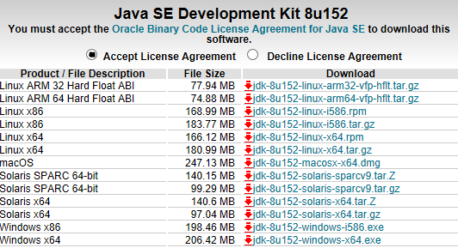

## Install JDK

Run the previously downloaded file and follow the instructions. The JDK includes the JRE so you have to specify both installation paths. Both of them shouldn’t be changed so they’re installed to

**C:\Java\jdk1.8.0_152**.

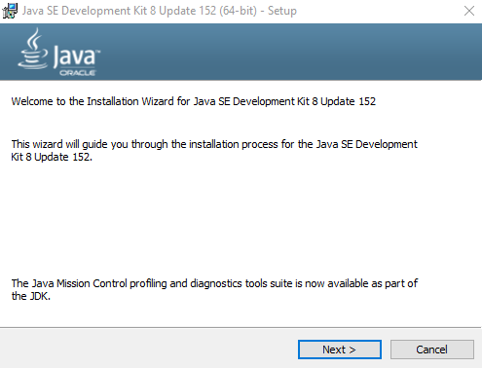

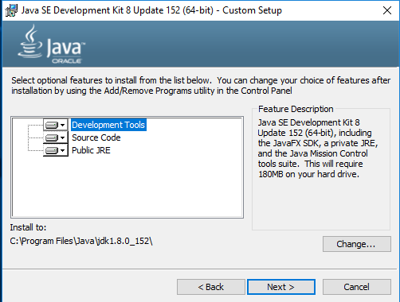

**C:\Java\jdk1.8.0_152**

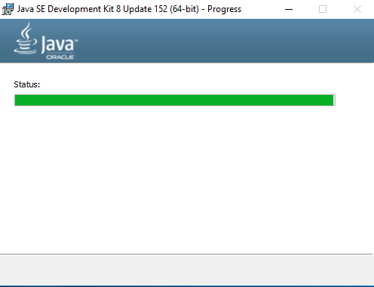

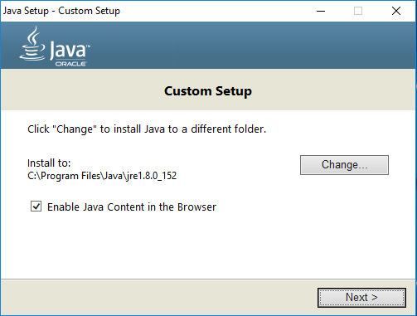

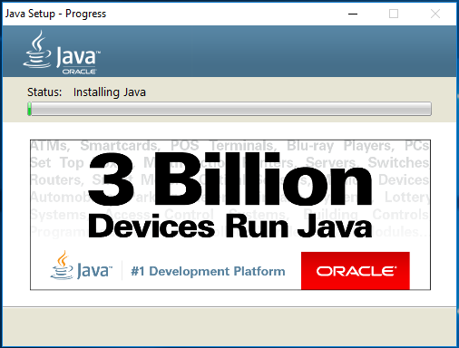

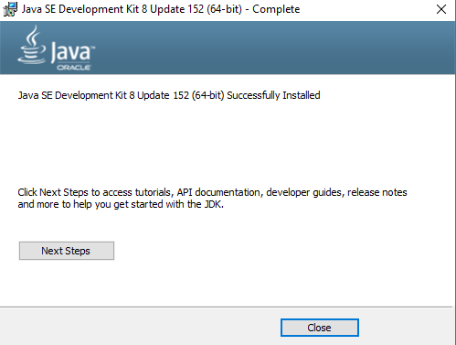

# Glassfish Server Setup

## Download Glassfish

Download the latest Full Platform Server from <https://javaee.github.io/glassfish/download>.

(January 2018: version 4.1.2)

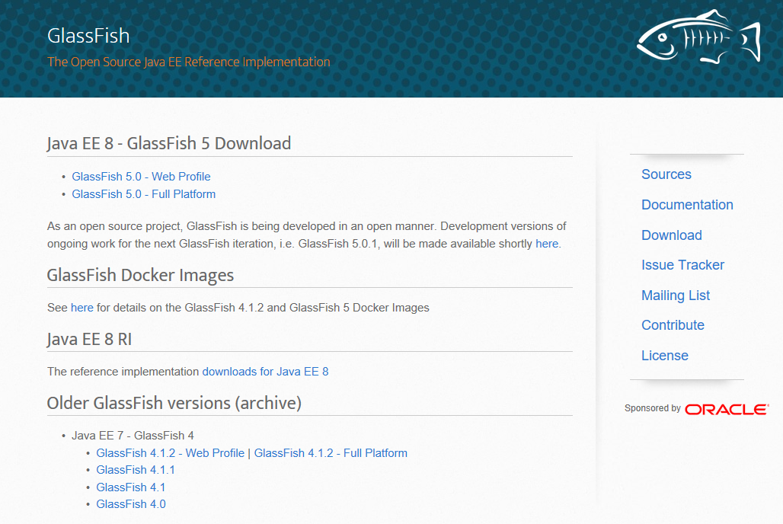

## Install Glassfish

Extract the compressed zip-file to C: (it gets extracted to C:\glassfish4).

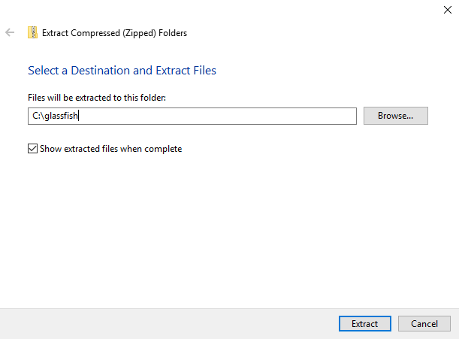

**C:**

Further Steps to Setup the Glassfish Server will be taken after eclipse is installed (next chapter).

# Eclipse for JEE Developers Setup

## Download Eclipse

Download the latest 64-bit version of Eclipse for JEE from <https://www.eclipse.org/downloads/eclipse-packages/>.

*(January 2018: Eclipse Oxygen)*

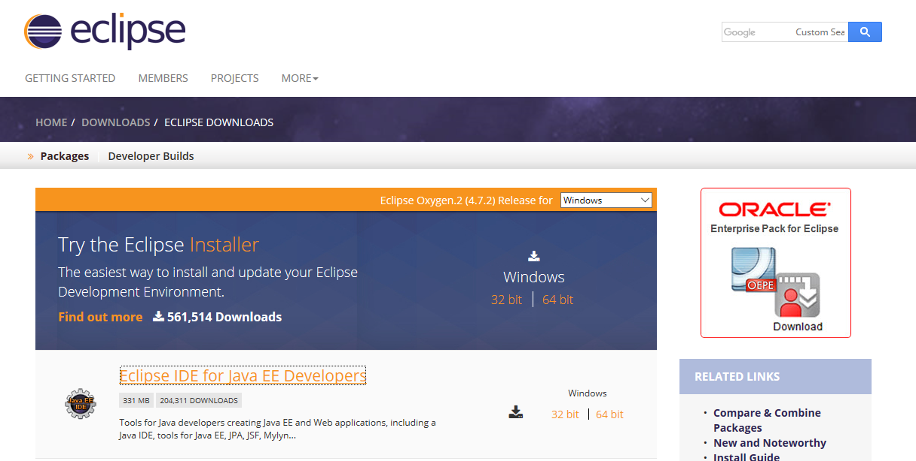

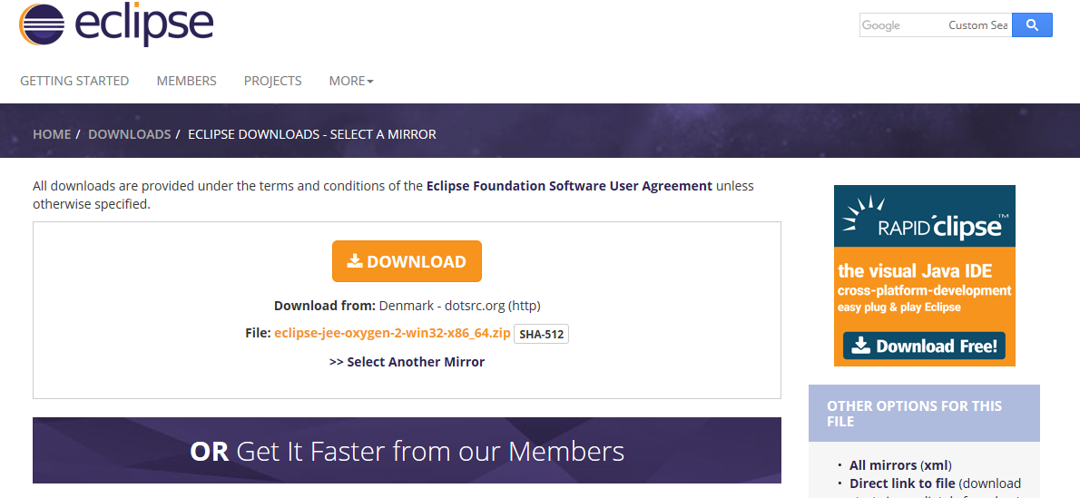

Then simply unzip in C:(it gets extracted to C:\eclipse) and run Eclipse.

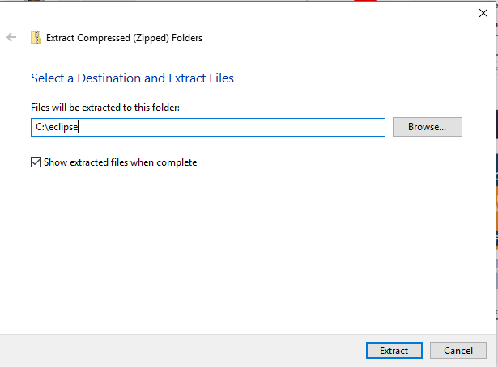

**C:**

For convenience: **Right click** eclipse.exe -> send to -> desktop (create shortcut)

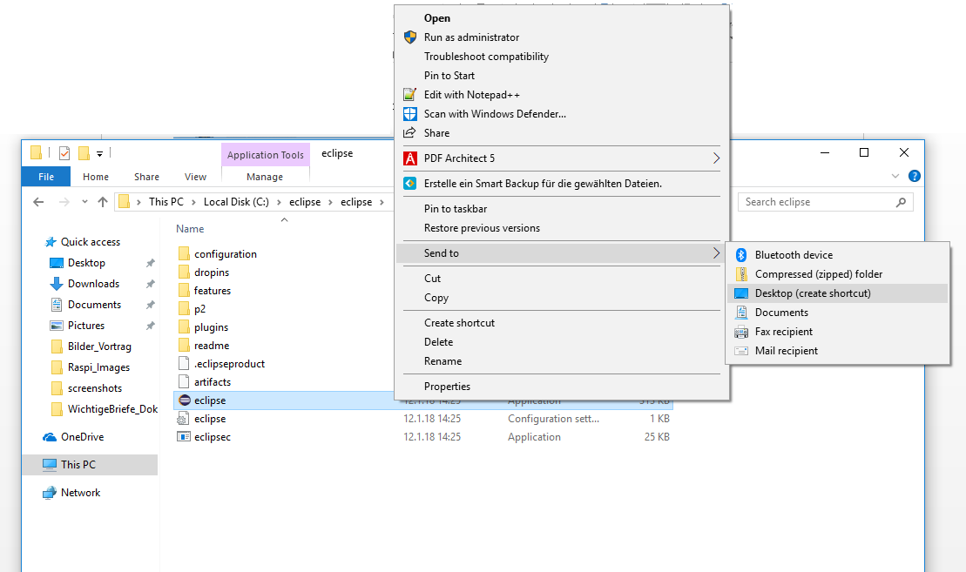

## First Start

You can select now any directory you want, but to keep it simple just leave it how it is.

Tick “use this as default and do not ask again” and press “OK”.

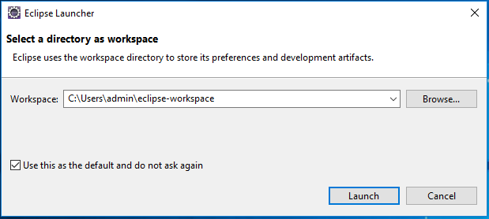

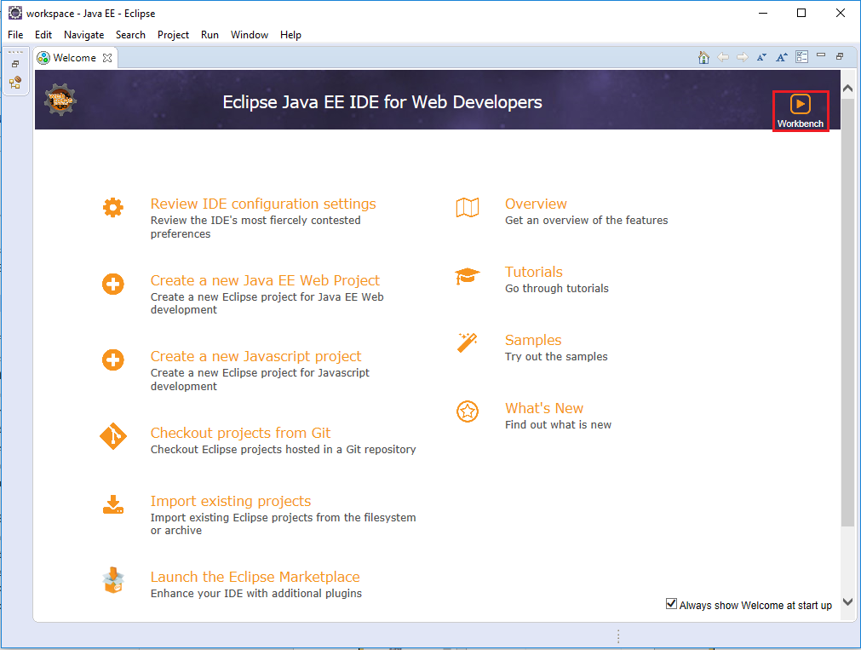

## Install JDK in Eclipse

Window -> Preferences -> Java -> Installed JREs

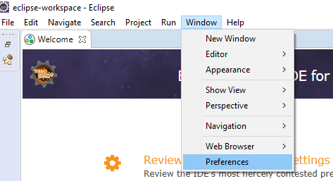

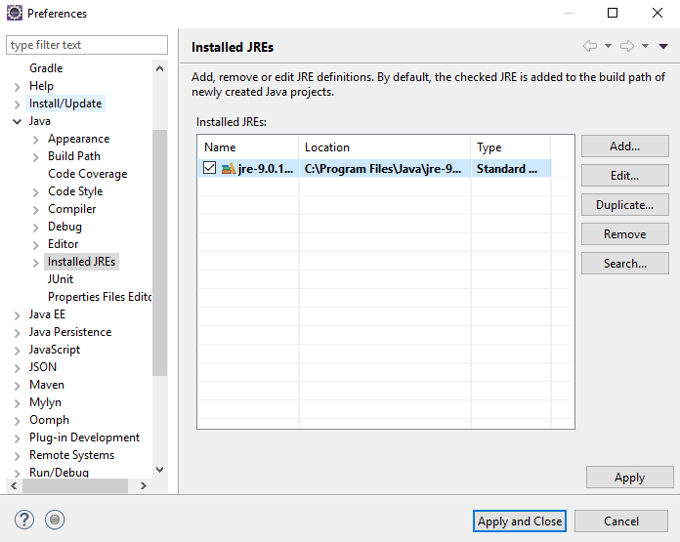

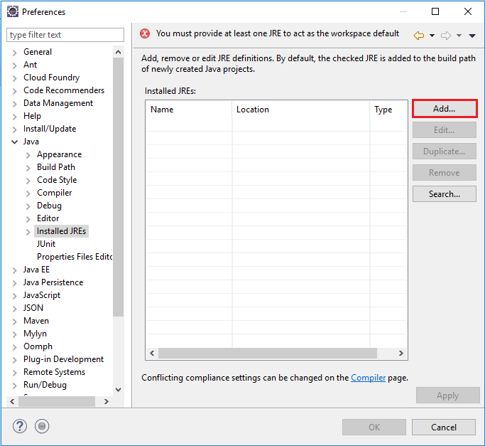

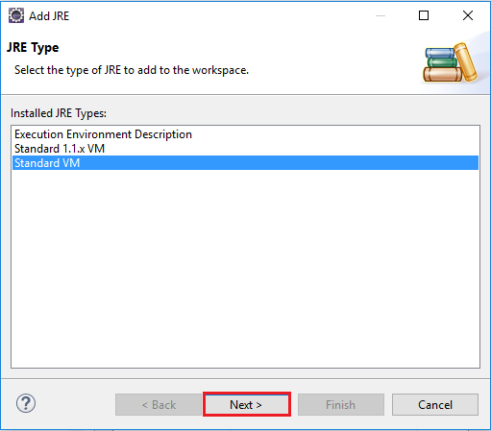

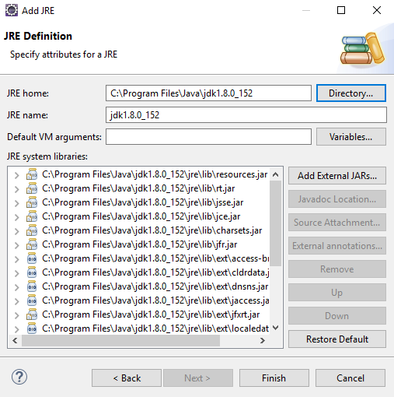

**C:\Java\jdk1.8.0_152**

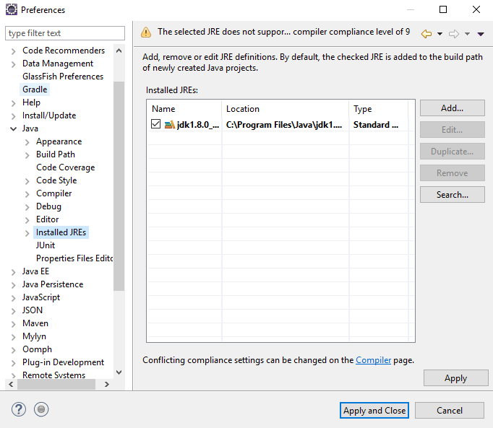

## Add Glassfish Tools for Eclipse

Help -> Eclipse Marketplace -> search for “glassfish”

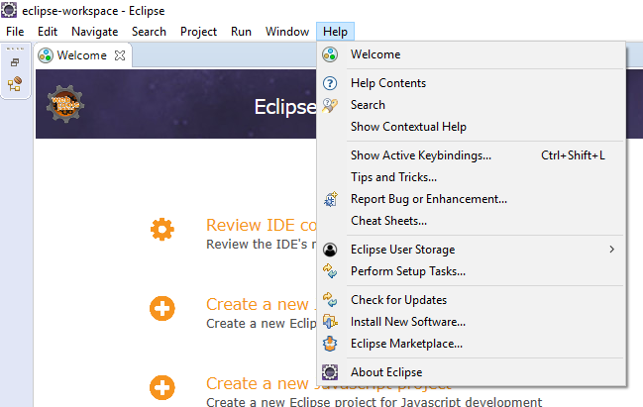

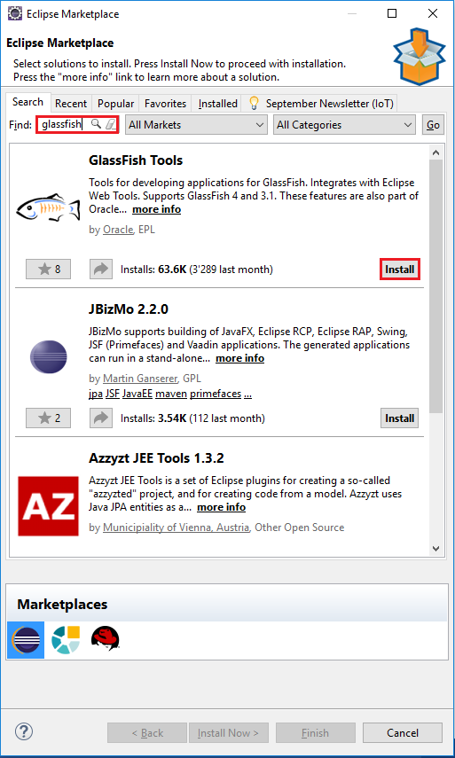 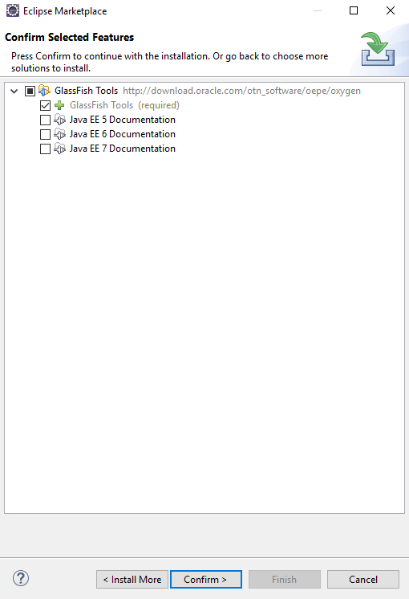

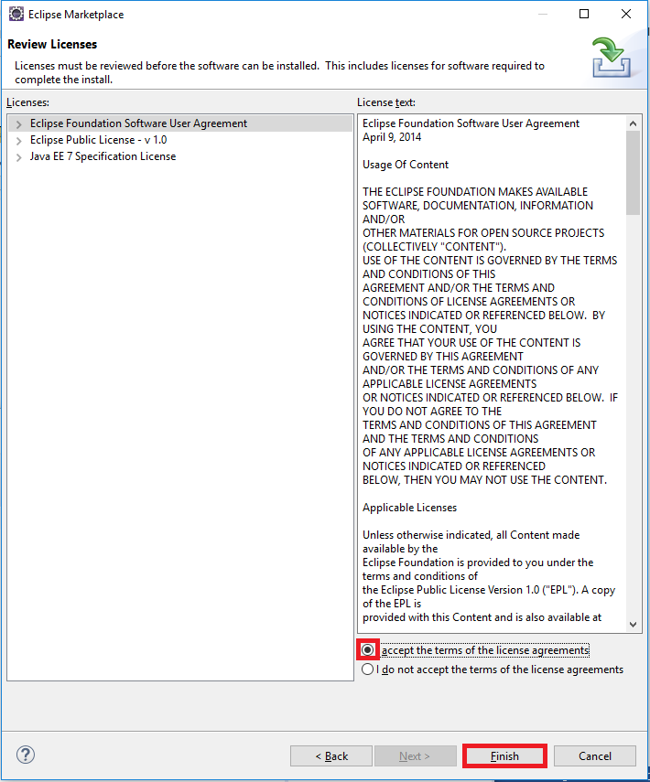

## Setup Glassfish with Eclipse

After the software has finished installing restart Eclipse.

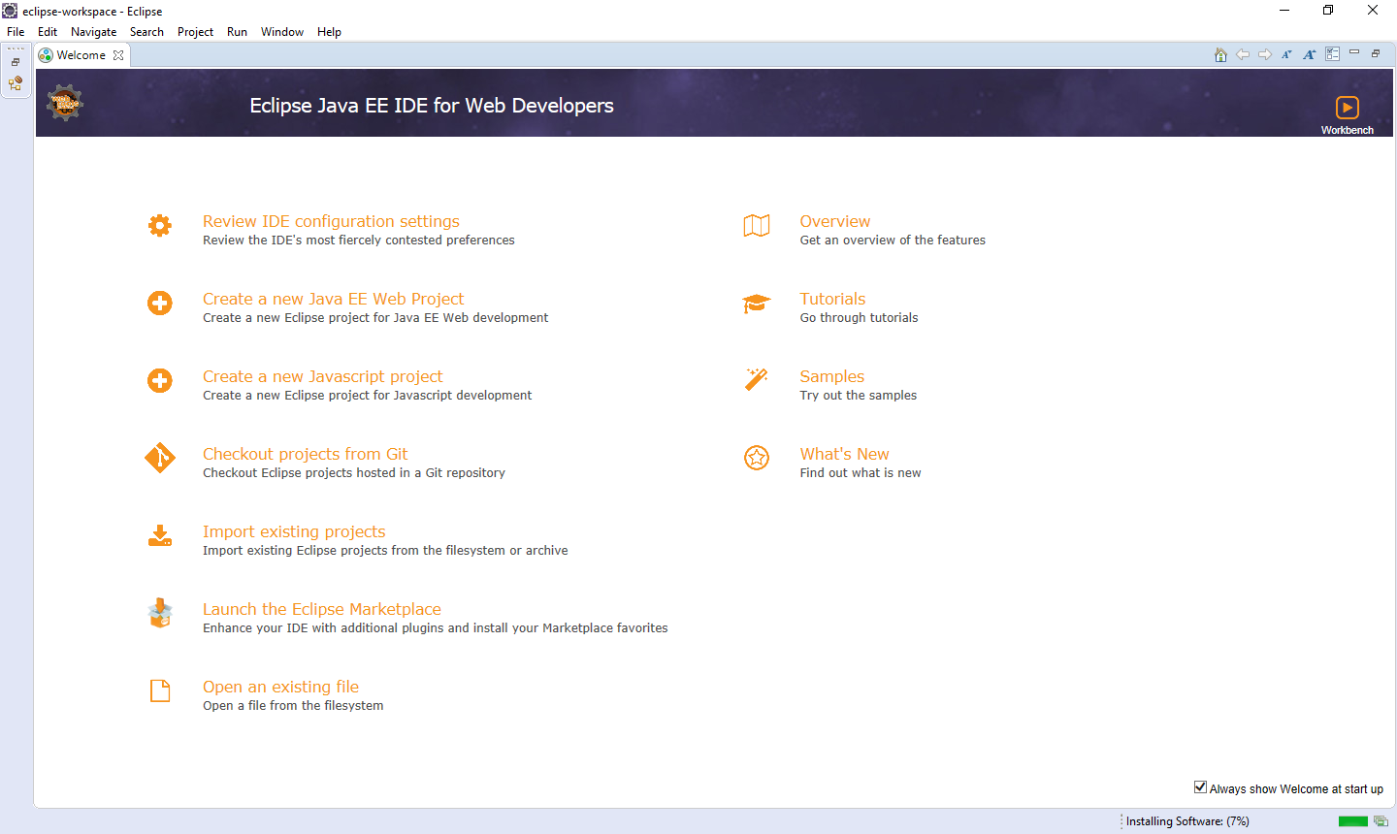



Change your view in the top right corner to Java EE.







Then click on the Servers-tab which should be at the bottom area. Afterwards click on the blue underlined text to setup a new one.

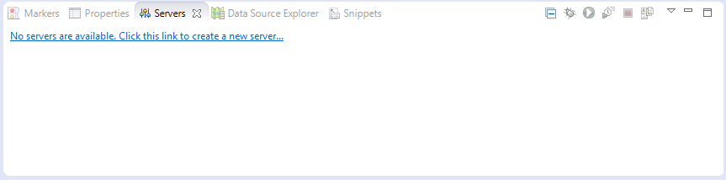

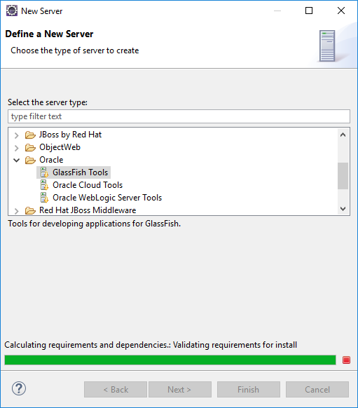

Falls kein Glassfish Eintrag gefunden wird, diesen Schritt zuerst durchführen and Reboot.

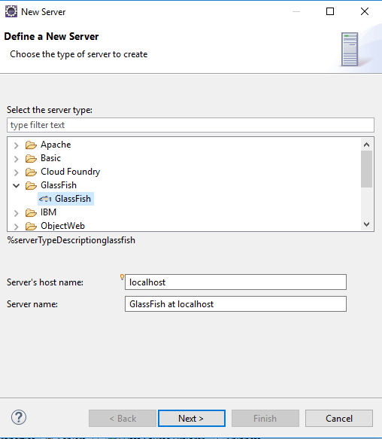

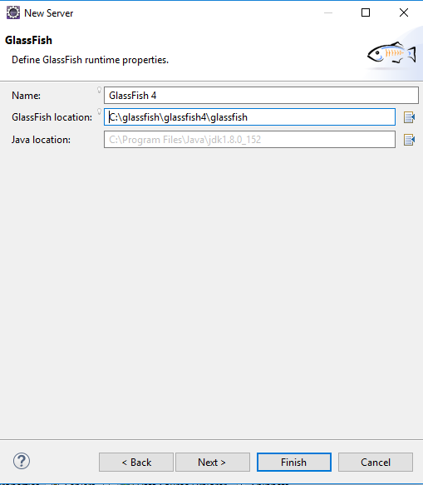

**C:\glassfish4\glassfish**

**C:\Java\jdk1.8.0_152**

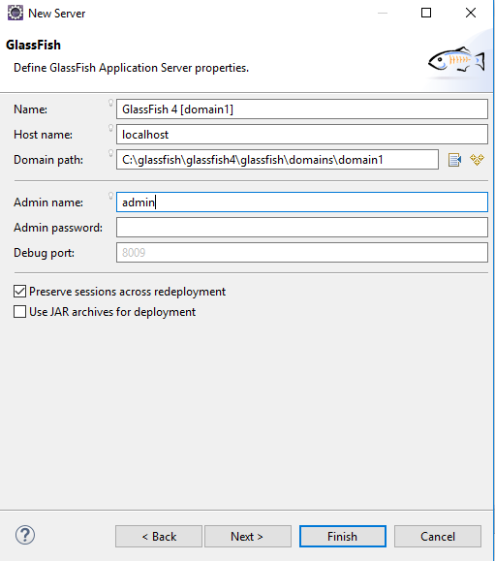

## Start Glassfish Admin Console

**Right click** the server and start it.

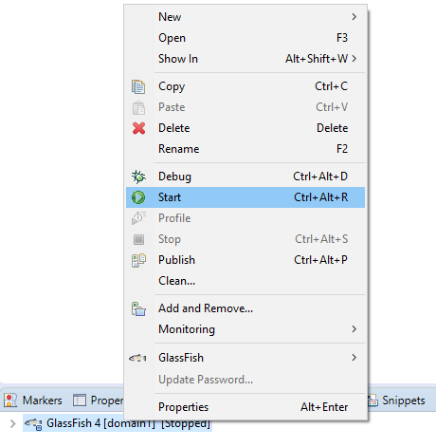

Then you have to allow the access of the Server when you are prompted.

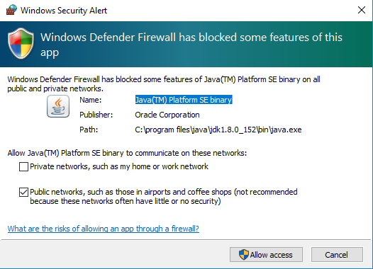

After that **right click** on Glassfish Select Glassfish -> View Admin Console

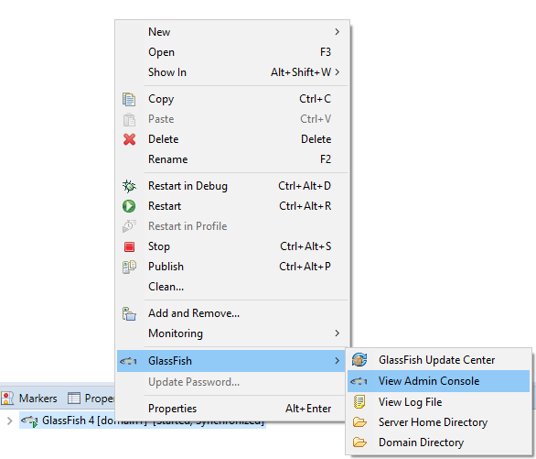

And then (after a while) you will see the picture down below.

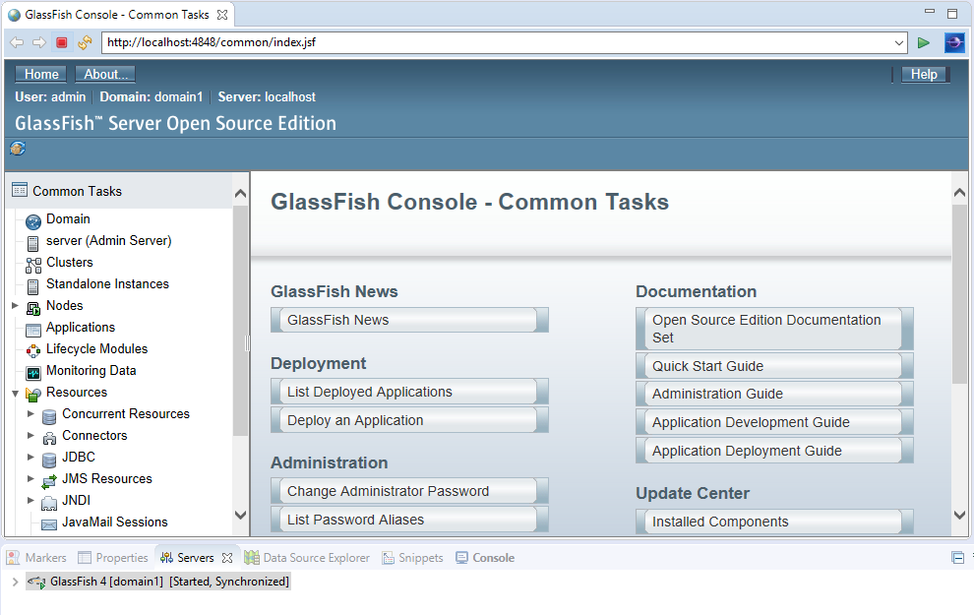

## Deploy whenever you press CTRL-S to your source file

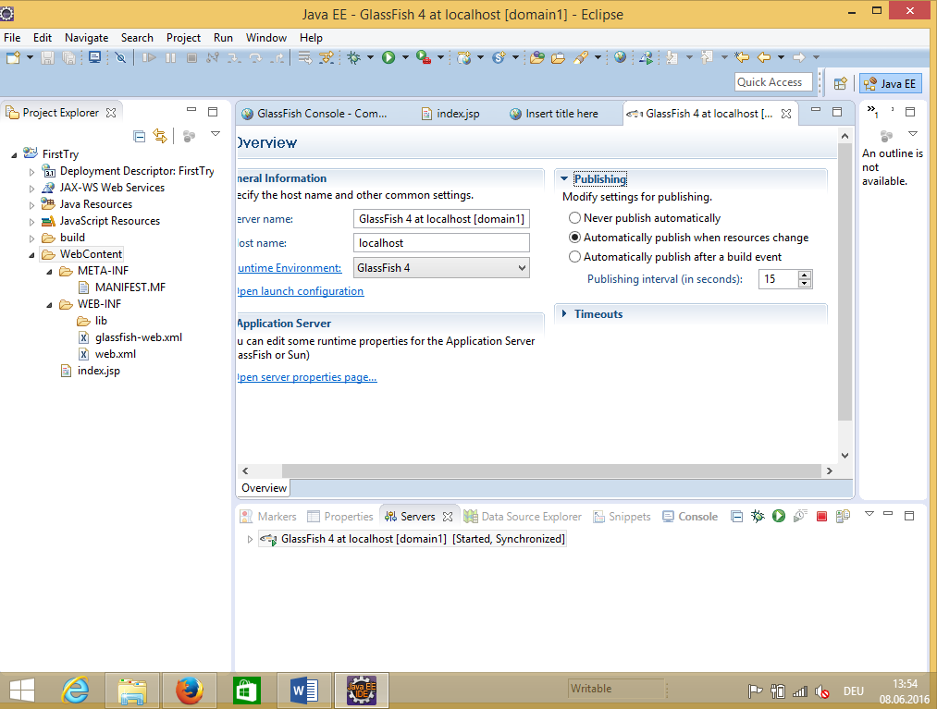

3.Enable here

2.Expand Publishing

1. Double click on server

**Ctrl-S (Save)** to save the changes!

# Testing JEE installation

## Test the Installation: Create first Servlet and JSP, deploy and run it

Right click in Project section of eclipse:

File -> New -> Dynamic Web Project

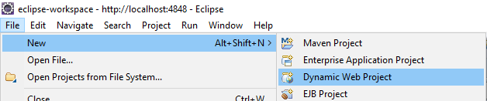

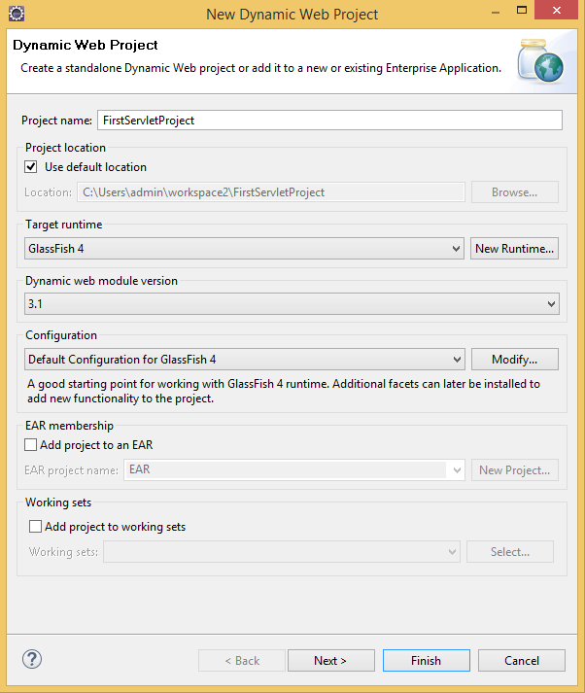 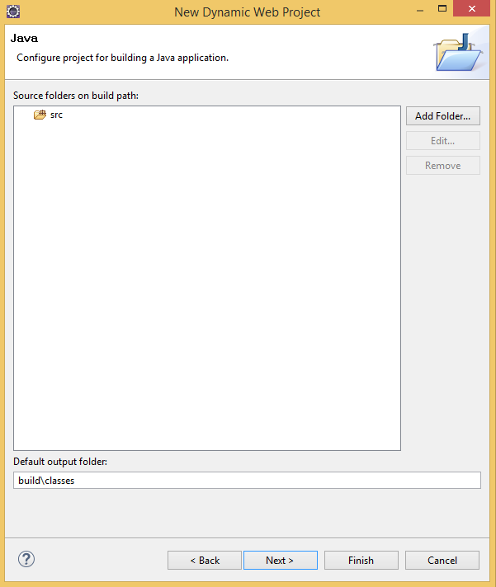

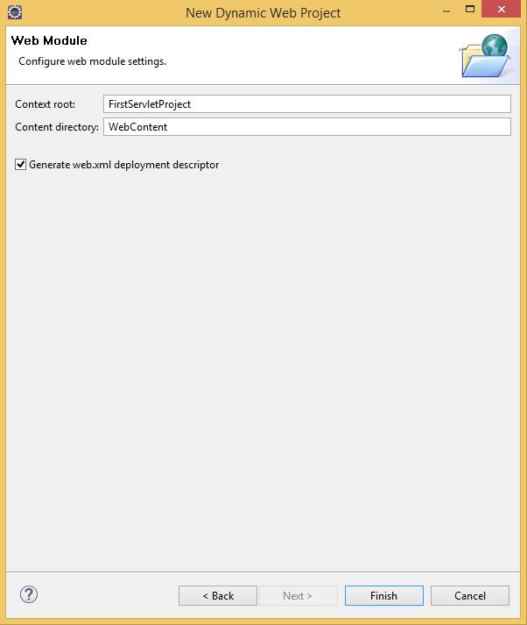

**Right click** the newly created Project -> Run As -> run on server

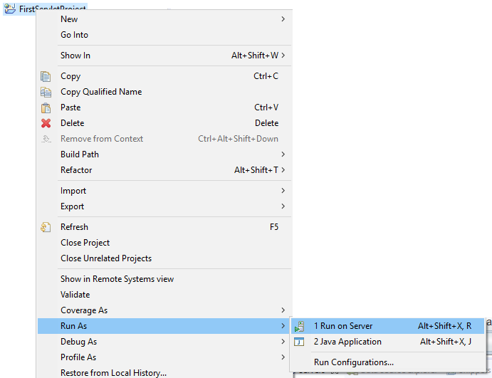

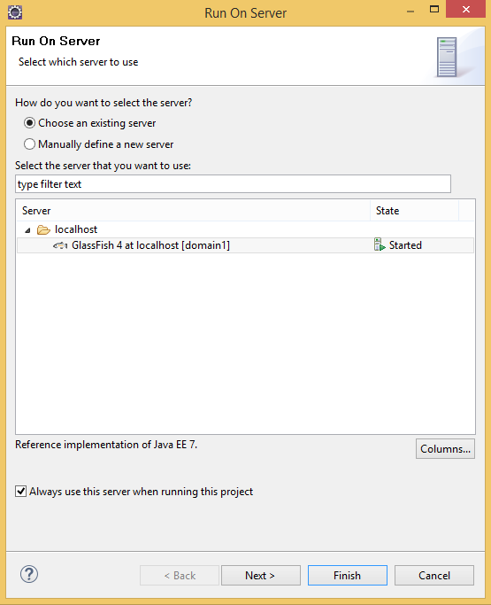

An **index.jsp** has been created in the WebContent folder of the project. Double-Click on **index.jsp** to open it in editor.

If you can’t find the **index.jsp** file, then **right click** on:

WebContent-> New -> JSP File. (if you can’t find JSP File then go: New -> Other -> Web -> JSP File) and change the filename to **index.jsp**. Now open it.

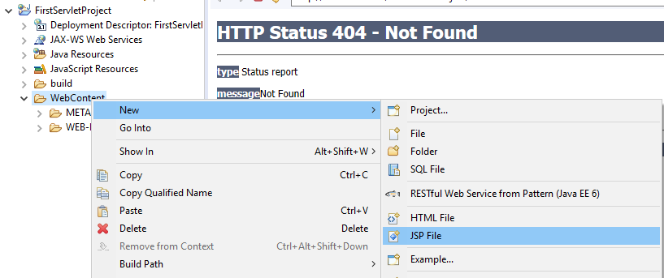

When you go to your **index.jsp** opened in the editor, replace its code with the code below and run it.

<%@page contentType=*"text/html"* pageEncoding=*"UTF-8"*%>

<!DOCTYPE HTML PUBLIC "-//W3C//DTD HTML 4.01 Transitional//EN"

"http://www.w3.org/TR/html4/loose.dtd">

<html>

<head>

<meta http-equiv=*"Content-Type"* content=*"text/html; charset=UTF-8"*>

<title>GlassFish JSP Page</title>

</head>

<body>

<h1>Hello World!</h1>

</body>

</html>

You should now see a big Hello World! If not, you probably did something wrong in the previous steps or you need to fully reload the page. Just press CTRL+F5 and give it a bit of time.

Hint: Just press CTRL-S (to save the changes in the source code) and eclipse will automatically deploy the changes to the application-server.

File -> New -> Other -> Web -> Servlet

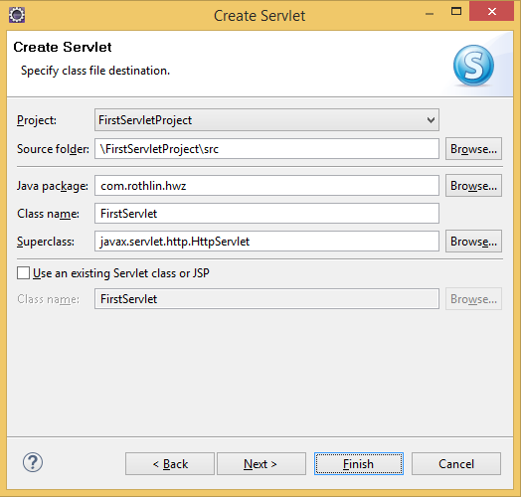

Your project structure should look like this:

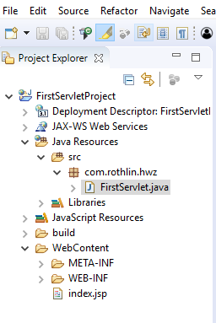

## First Servlet Code

Replace in the generated Servlet-Class all methods with the code from below, press Crtl+Shift+O and save it.

**package com.rothlin.hwz;**

**import java.io.IOException;**

**import javax.servlet.ServletConfig;**

**import javax.servlet.ServletException;**

**import javax.servlet.annotation.WebServlet;**

**import javax.servlet.http.HttpServlet;**

**import javax.servlet.http.HttpServletRequest;**

**import javax.servlet.http.HttpServletResponse;**

**@WebServlet("/FirstServlet")**

**public class FirstServlet extends HttpServlet {**

**private static final long serialVersionUID = 1L;**

**public FirstServlet() {**

**super();**

**System.out.println("FirstServlet ctr is called! Object created!!!");**

**}**

**public void init(ServletConfig servletConfig) throws ServletException {**

**System.out.println("FirstServlet init() is called!");**

**}**

**public void destroy() {**

**System.out.println("FirstServlet destroy() is called!");**

**}**

**private void serveRequest(HttpServletRequest request, HttpServletResponse response, String methode)**

**throws ServletException, IOException {**

**response.setContentType("text/html");**

**StringBuffer sb = new StringBuffer("<html>\n<head>\n</head>\n<body>\n");**

**sb.append("<H1>Hallo HWZ!</H1> Methode:<B>" + methode + "</B><br/>\n");**

**sb.append("</body>\n</html>\n");**

**response.getWriter().print(sb);**

**}**

**protected void doGet(HttpServletRequest request, HttpServletResponse response)**

**throws ServletException, IOException {**

**serveRequest(request, response, "doGet");**

**}**

**protected void doPost(HttpServletRequest request, HttpServletResponse response)**

**throws ServletException, IOException {**

**serveRequest(request, response, "doPost");**

**}**

**}**

## Testing FirstServlet.java

Run the project on server…

<http://localhost:8080/FirstServletProject/FirstServlet> should show you this:

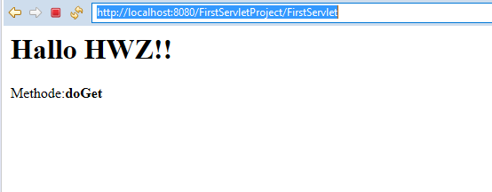

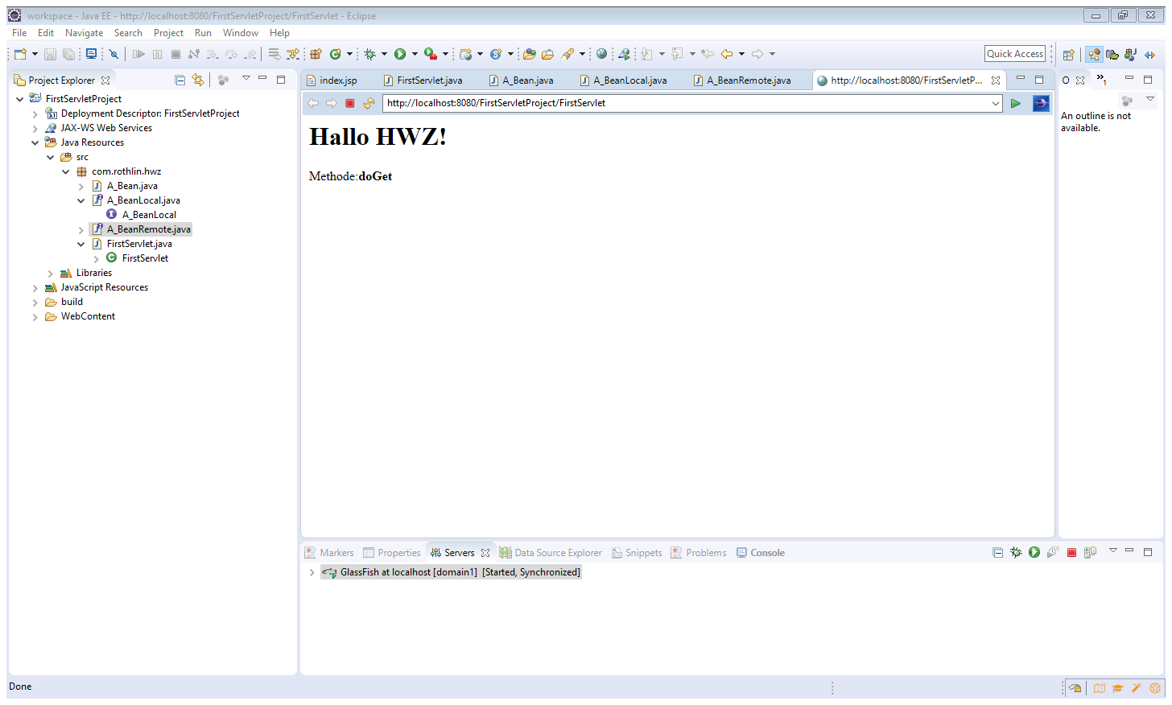

# JEE development

## EJB (stateless and stateful) gets called from Servlet / JSP (in same Web-App)

File -> New -> Dynamic Web Project

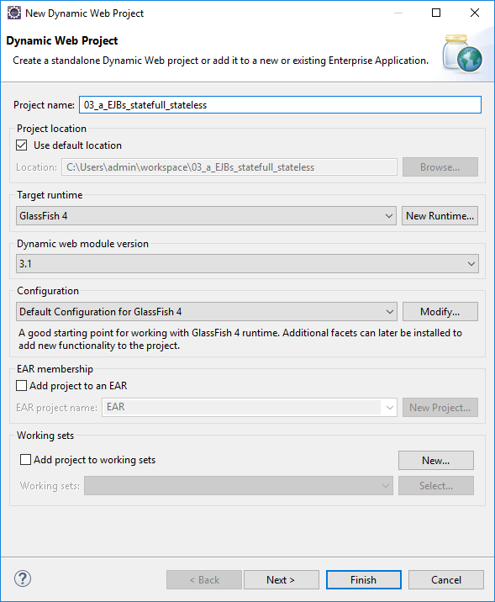

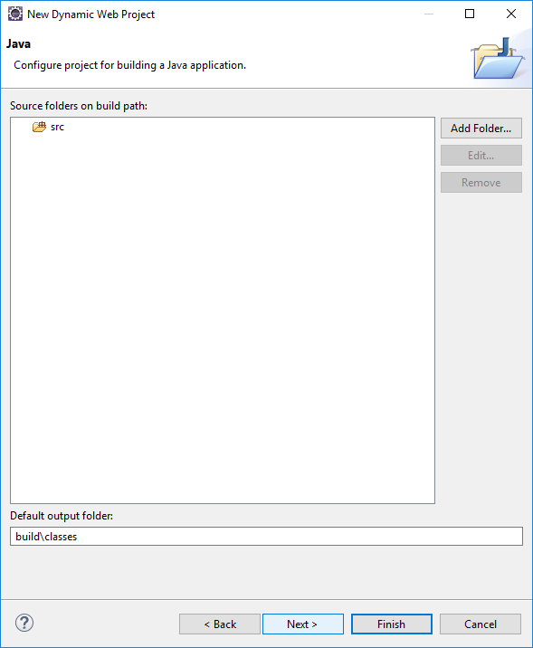 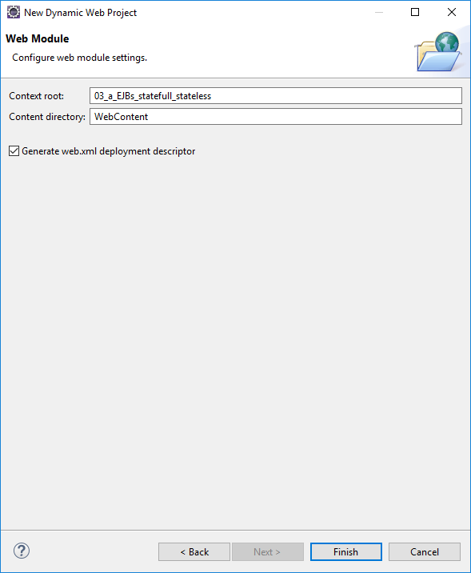

Right click the newly created Project -> Run As -> Run on Server



Create a JSP to test project set-up:

Right click on project:

New -> JSP File (if you can’t find JSP File then go: New -> Other -> Web -> JSP File)

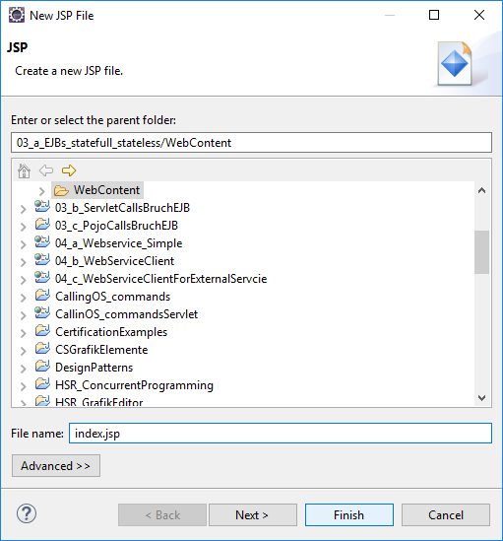

When you go your **index.jsp** opened in the editor, replace its code with the code below and run it.

You should now see a big Hello World! If not, you probably did something wrong in the previous steps.

<%@page contentType=*"text/html"* pageEncoding=*"UTF-8"*%>

<!DOCTYPE HTML PUBLIC "-//W3C//DTD HTML 4.01 Transitional//EN"

"http://www.w3.org/TR/html4/loose.dtd">

<html>

<head>

<meta http-equiv=*"Content-Type"* content=*"text/html; charset=UTF-8"*>

<title>GlassFish JSP Page</title>

</head>

<body>

<h1>Hello World!</h1>

</body>

</html>

Save and run it:

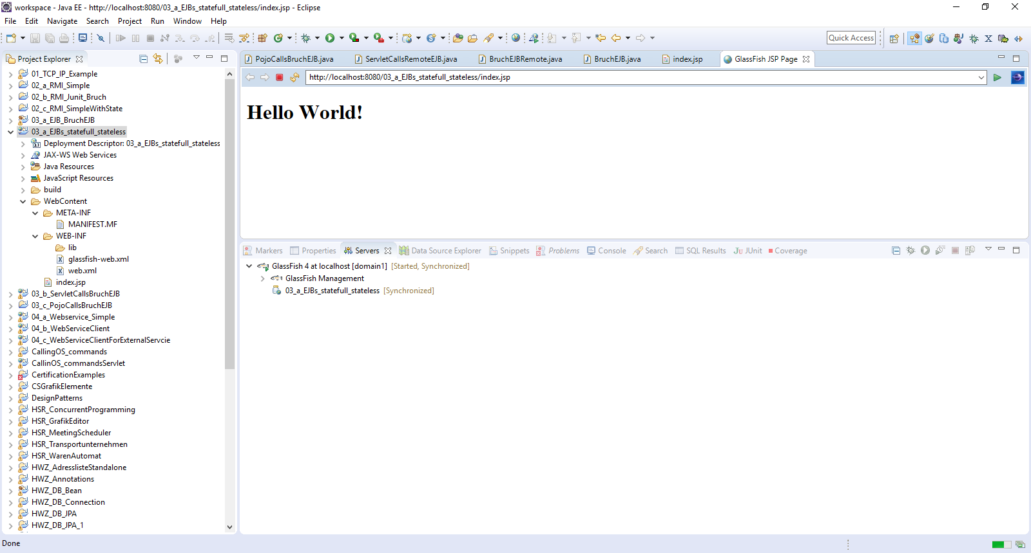

Right click on project:

New -> Servlet

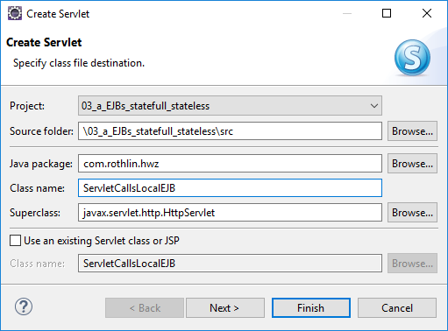

Replace in the generated Servlet-Class all methods with this code:

**// ServletCallsLocalEJB belongs to 03_a_EJBs_statefull_stateless**

**// -------------------- -----------------------------**

**package** com.rothlin.hwz;

**import** java.io.IOException;

**import** javax.servlet.ServletConfig;

**import** javax.servlet.ServletException;

**import** javax.servlet.annotation.WebServlet;

**import** javax.servlet.http.HttpServlet;

**import** javax.servlet.http.HttpServletRequest;

**import** javax.servlet.http.HttpServletResponse;

@WebServlet("/ServletCallsLocalEJB")

public class ServletCallsLocalEJB extends HttpServlet {

private static final long serialVersionUID = 1L;

public ServletCallsLocalEJB() {

super();

System.out.println("ServletCallsLocalEJB::ctr() is called! Object created!!!");

}

public void init(ServletConfig servletConfig) throws ServletException {

System.out.println("ServletCallsLocalEJB::init() is called!");

}

public void destroy() {

System.out.println("ServletCallsLocalEJ::destroy() is called!");

}

private void serveRequest(HttpServletRequest request, HttpServletResponse response, String methode)

throws ServletException, IOException {

response.setContentType("text/html");

StringBuffer sb = new StringBuffer("<html>\n<head>\n</head>\n<body>\n");

sb.append("<H1>Hallo from ServletCallsLocalEJB!</H1> Methode:<B>" + methode + "</B><br/>\n");

sb.append("</body>\n</html>\n");

response.getWriter().print(sb);

}

protected void doGet(HttpServletRequest request, HttpServletResponse response)

throws ServletException, IOException {

serveRequest(request, response, "doGet");

}

protected void doPost(HttpServletRequest request, HttpServletResponse response)

throws ServletException, IOException {

serveRequest(request, response, "doPost");

}

}

Save and run it:

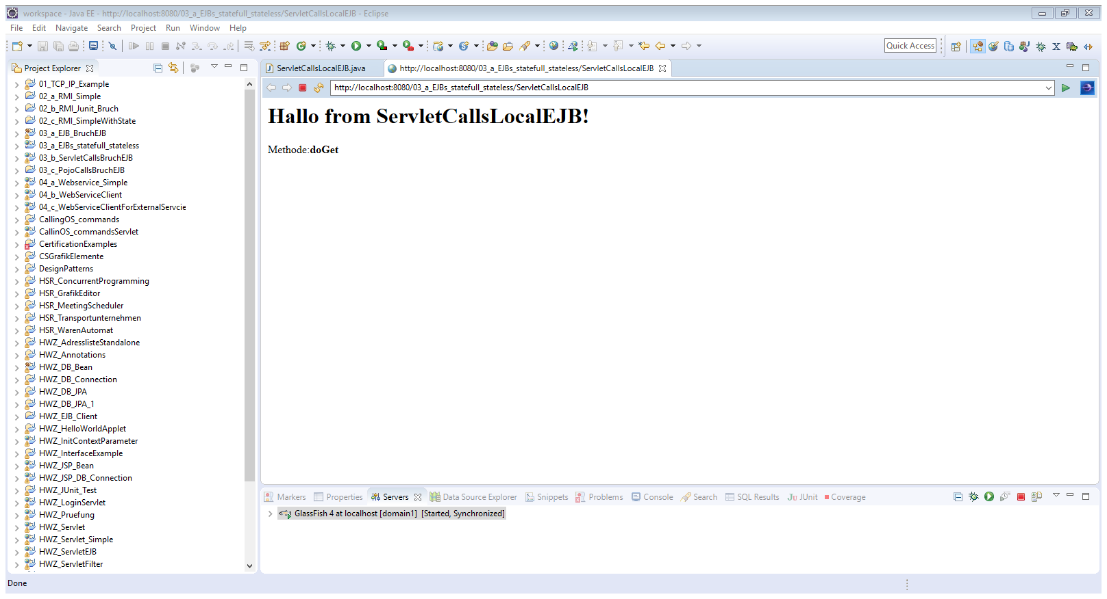

Create **stateless** EJB in the same project (Web-App):

Right click on project:

New -> Other -> EJB -> Session Bean (EJB 3.x)

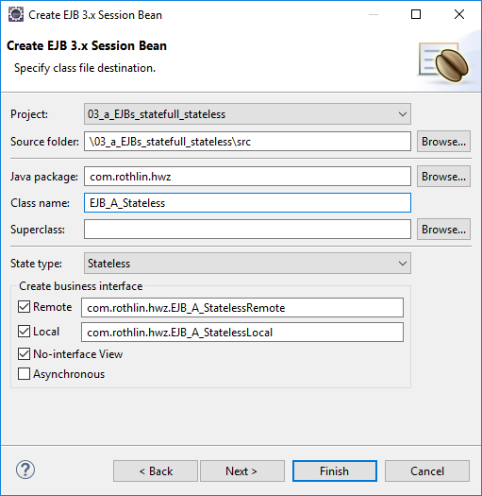

Code for **stateless** EJB:

EJB_A_StatelessRemote.java

// EJB_A_StatelessRemote belongs to 03_a_EJBs_statefull_stateless

// --------------------- -----------------------------

**package** com.rothlin.hwz;

**import** javax.ejb.Remote;

@Remote

**public** **interface** EJB_A_StatelessRemote {

**public** String pingRemote();

}

EJB_A_StatelessLocal.java

// EJB_A_StatelessLocal belongs to 03_a_EJBs_statefull_stateless

// -------------------- -----------------------------

**package** com.rothlin.hwz;

**import** javax.ejb.Local;

@Local

**public** **interface** EJB_A_StatelessLocal {

**public** String pingLocal();

**public** String pingRemote();

}

EJB_A_Stateless.java

// EJB_A_Stateless belongs to 03_a_EJBs_statefull_stateless

// --------------- -----------------------------

**package** com.rothlin.hwz;

**import** javax.annotation.PostConstruct;

**import** javax.annotation.PreDestroy;

**import** javax.ejb.LocalBean;

**import** javax.ejb.Stateless;

@Stateless

@LocalBean

**public** **class** EJB_A_Stateless **implements** EJB_A_StatelessRemote, EJB_A_StatelessLocal {

**private** **int** counter;

**public** EJB_A_Stateless() {

System.***out***.println("EJB_A_Stateless::ctr() called!");

}

@PostConstruct

**public** **void** startup() {

System.***out***.println("EJB_A_Stateless::startup() called!");

counter = 10;

}

@PreDestroy

**public** **void** cleanup() {

System.***out***.println("EJB_A_Stateless::cleanup() called!");

}

@Override

**public** String pingRemote() {

counter++;

**return** "EJB_A_Stateless::pingRemoteOnly(): counter: " + counter;

}

@Override

**public** String pingLocal() {

counter++;

**return** "EJB_A_Stateless::pingLocal(): counter: " + counter;

}

}

}

Create **stateful** EJB in the same project (Web-App):

Right click on project:

New -> Other -> EJB -> Session Bean (EJB 3.x)

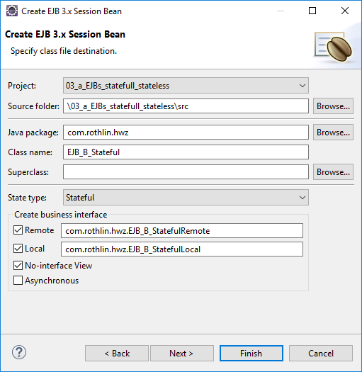

Code for **stateful** EJB:

EJB_B_StatefulRemote.java

// EJB_B_StatefulRemote belongs to 03_a_EJBs_statefull_stateless

// -------------------- -----------------------------

**package** com.rothlin.hwz;

**import** javax.ejb.Remote;

@Remote

**public** **interface** EJB_B_StatefulRemote {

**public** String pingRemote();

}

EJB_B_StatefulLocal.java

// EJB_B_StatefulLocal belongs to 03_a_EJBs_statefull_stateless

// ------------------- -----------------------------

**package** com.rothlin.hwz;

**import** javax.ejb.Local;

@Local

**public** **interface** EJB_B_StatefulLocal {

**public** String pingLocal();

**public** String pingRemote();

}

EJB_B_Stateful.java

// EJB_B_Stateful belongs to 03_a_EJBs_statefull_stateless

// -------------- -----------------------------

**package** com.rothlin.hwz;

**import** javax.annotation.PostConstruct;

**import** javax.annotation.PreDestroy;

**import** javax.ejb.LocalBean;

**import** javax.ejb.Stateful;

@Stateful

@LocalBean

**public** **class** EJB_B_Stateful **implements** EJB_B_StatefulRemote, EJB_B_StatefulLocal {

**private** **int** counter;

**public** EJB_B_Stateful() {

System.***out***.println("EJB_B_Stateful::ctr() called!");

}

@PostConstruct

**public** **void** startup() {

System.***out***.println("EJB_B_Stateful::startup() called!");

counter = 10;

}

@PreDestroy

**public** **void** cleanup() {

System.***out***.println("EJB_B_Stateful::cleanup() called!");

}

@Override

**public** String pingRemote() {

counter++;

**return** "EJB_B_Stateful::pingRemoteOnly(): counter: " + counter;

}

@Override

**public** String pingLocal() {

counter++;

**return** "EJB_B_Stateful::pingLocal(): counter: " + counter;

}

}

Extend your Servlet-Code with the yellow lines:

**// ServletCallsLocalEJB belongs to 03_a_EJBs_statefull_stateless**

**// -------------------- -----------------------------**

**package** com.rothlin.hwz;

import javax.ejb.EJB;

**import** java.io.IOException;

**import** javax.servlet.ServletConfig;

**import** javax.servlet.ServletException;

**import** javax.servlet.annotation.WebServlet;

**import** javax.servlet.http.HttpServlet;

**import** javax.servlet.http.HttpServletRequest;

**import** javax.servlet.http.HttpServletResponse;

@WebServlet("/ServletCallsLocalEJB")

public class ServletCallsLocalEJB extends HttpServlet {

private static final long serialVersionUID = 1L;

@EJB

EJB_A_Stateless aLocalEJB;

@EJB

EJB_B_Stateful bLocalEJB;

public ServletCallsLocalEJB() {

super();

System.out.println("ServletCallsLocalEJB::ctr() is called! Object created!!!");

}

public void init(ServletConfig servletConfig) throws ServletException {

System.out.println("ServletCallsLocalEJB::init() is called!");

}

public void destroy() {

System.out.println("ServletCallsLocalEJ::destroy() is called!");

}

private void serveRequest(HttpServletRequest request, HttpServletResponse response, String methode)

throws ServletException, IOException {

response.setContentType("text/html");

StringBuffer sb = new StringBuffer("<html>\n<head>\n</head>\n<body>\n");

sb.append("<H1>Hallo from ServletCallsLocalEJB!</H1> Methode:<B>" + methode + "</B><br/>\n");

sb.append("<BR/>" + aLocalEJB.pingLocal() + "\n");

sb.append("<BR/>" + aLocalEJB.pingRemote() + "<BR/>\n");

sb.append("<BR/>" + bLocalEJB.pingLocal() + "\n");

sb.append("<BR/>" + bLocalEJB.pingRemote() + "\n");

sb.append("</body>\n</html>\n");

response.getWriter().print(sb);

}

protected void doGet(HttpServletRequest request, HttpServletResponse response)

throws ServletException, IOException {

serveRequest(request, response, "doGet");

}

protected void doPost(HttpServletRequest request, HttpServletResponse response)

throws ServletException, IOException {

serveRequest(request, response, "doPost");

}

}

Save and run it. After a while you will see the following:

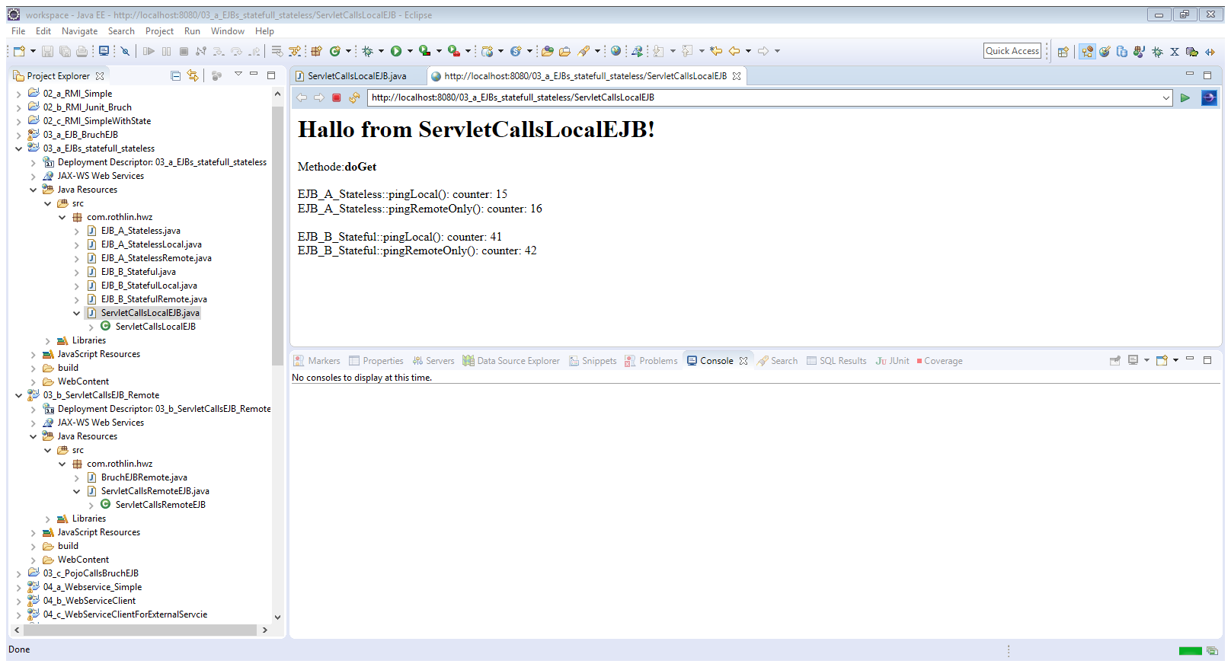

## EJB (stateless and stateful) gets called from **Servlet** remotely

File -> New -> Dynamic Web Project

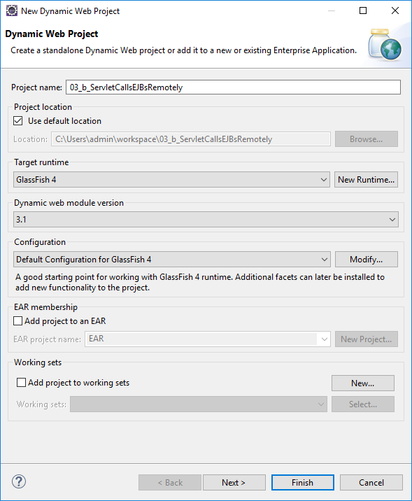

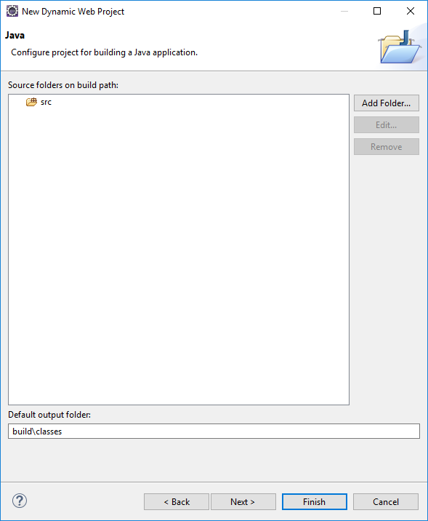 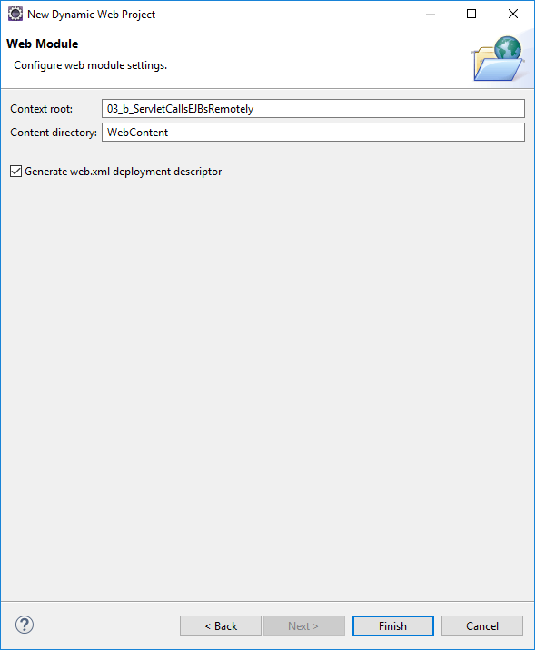

Right click on project:

New -> Servlet

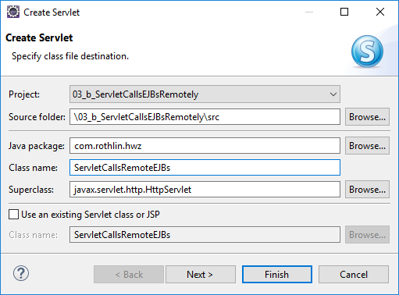

Replace in the generated Servlet-Class all methods with this code:

// ServletCallsRemoteEJBs belongs to 03_b_ServletCallsEJBsRemotely

// ---------------------- -----------------------------

**package** com.rothlin.hwz;

**import** java.io.IOException;

**import** javax.servlet.ServletConfig;

**import** javax.servlet.ServletException;

**import** javax.servlet.annotation.WebServlet;

**import** javax.servlet.http.HttpServlet;

**import** javax.servlet.http.HttpServletRequest;

**import** javax.servlet.http.HttpServletResponse;

@WebServlet("/ServletCallsRemoteEJBs")

**public** **class** ServletCallsRemoteEJBs **extends** HttpServlet {

**private** **static** **final** **long** ***serialVersionUID*** = 1L;

**public** ServletCallsRemoteEJBs() {

System.***out***.println("ServletCallsRemoteEJBs::ctr() is called! Object created!!!");

}

**public** **void** init(ServletConfig servletConfig) **throws** ServletException {

System.***out***.println("ServletCallsRemoteEJBs::init() is called!");

}

**public** **void** destroy() {

System.***out***.println("ServletCallsRemoteEJBs::destroy() is called!");

}

**private** **void** serveRequest(HttpServletRequest request, HttpServletResponse response, String methode)

**throws** ServletException, IOException {

response.setContentType("text/html");

StringBuffer sb = **new** StringBuffer("<html>\n<head>\n</head>\n<body>\n");

sb.append("<H1>Hallo from ServletCallsRemoteEJBs!</H1><BR/>\n");

sb.append("Methode:<B>" + methode + "</B><br/>\n");

sb.append("</body>\n</html>\n");

response.getWriter().print(sb);

}

**protected** **void** doGet(HttpServletRequest request, HttpServletResponse response)

**throws** ServletException, IOException {

serveRequest(request, response, "doGet");

}

**protected** **void** doPost(HttpServletRequest request, HttpServletResponse response)

**throws** ServletException, IOException {

serveRequest(request, response, "doPost");

}

}

Save and run it.

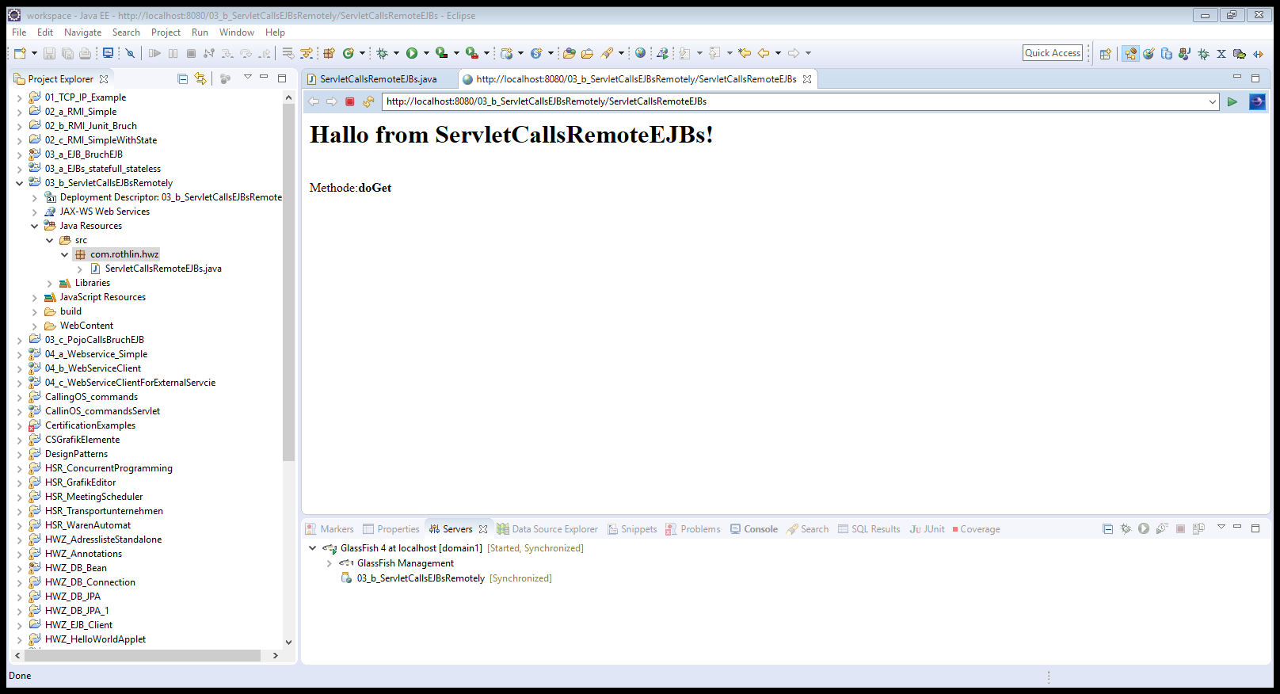

Extend your Servlet-Code with the yellow lines:

// ServletCallsRemoteEJBs belongs to 03_b_ServletCallsEJBsRemotely

// ---------------------- -----------------------------

**package** com.rothlin.hwz;

**import** java.io.IOException;

**import** javax.naming.InitialContext;

**import** javax.servlet.ServletConfig;

**import** javax.servlet.ServletException;

**import** javax.servlet.annotation.WebServlet;

**import** javax.servlet.http.HttpServlet;

**import** javax.servlet.http.HttpServletRequest;

**import** javax.servlet.http.HttpServletResponse;

@WebServlet("/ServletCallsRemoteEJBs")

**public** **class** ServletCallsRemoteEJBs **extends** HttpServlet {

**private** **static** **final** **long** ***serialVersionUID*** = 1L;

**private** **static** **final** String ***jndiHost*** = "127.0.0.1";

**private** **static** **final** String ***jndiPort*** = "3700";

**private** **static** **final** String ***jndiName__EJB_A_StatelessRemote*** = "java:global/03_a_EJBs_statefull_stateless/EJB_A_Stateless!com.rothlin.hwz.EJB_A_StatelessRemote";

**private** **static** **final** String ***jndiName__EJB_B_StatefulRemote*** = "java:global/03_a_EJBs_statefull_stateless/EJB_B_Stateful!com.rothlin.hwz.EJB_B_StatefulRemote";

**private** EJB_A_StatelessRemote ejbA = **null**;

**private** EJB_B_StatefulRemote ejbB = **null**;

**public** ServletCallsRemoteEJBs() {

System.***out***.println("ServletCallsRemoteEJBs::ctr() is called! Object created!!!");

}

**public** **void** init(ServletConfig servletConfig) **throws** ServletException {

System.***out***.println("ServletCallsRemoteEJBs::init() is called!");

System.*setProperty*("org.omg.CORBA.ORBInitialHost", ***jndiHost***);

**try** {

InitialContext ctx = **new** InitialContext();

ctx.addToEnvironment("org.omg.CORBA.ORBInitialHost", ***jndiHost***);

ctx.addToEnvironment("org.omg.CORBA.ORBInitialPort", ***jndiPort***);

ejbA = (EJB_A_StatelessRemote) ctx.lookup(***jndiName__EJB_A_StatelessRemote***);

ejbB = (EJB_B_StatefulRemote) ctx.lookup(***jndiName__EJB_B_StatefulRemote***);

}

**catch** (Exception ex) {

System.***out***.println("Could not get remote-object bean!" + ex);

}

}

**public** **void** destroy() {

System.***out***.println("ServletCallsRemoteEJBs::destroy() is called!");

}

**private** **void** serveRequest(HttpServletRequest request, HttpServletResponse response, String methode)

**throws** ServletException, IOException {

response.setContentType("text/html");

StringBuffer sb = **new** StringBuffer("<html>\n<head>\n</head>\n<body>\n");

sb.append("<H1>Hallo from ServletCallsRemoteEJBs!</H1><BR/>\n");

sb.append("Methode:<B>" + methode + "</B><br/>\n");

sb.append("ejbA.pingRemote():<B>" + ejbA.pingRemote() + "</B><br/>\n");

sb.append("ejbB.pingRemote():<B>" + ejbB.pingRemote() + "</B><br/>\n");

sb.append("</body>\n</html>\n");

response.getWriter().print(sb);

}

**protected** **void** doGet(HttpServletRequest request, HttpServletResponse response)

**throws** ServletException, IOException {

serveRequest(request, response, "doGet");

}

**protected** **void** doPost(HttpServletRequest request, HttpServletResponse response)

**throws** ServletException, IOException {

serveRequest(request, response, "doPost");

}

}

Copy the two Remote-Interface to your project (**EJB_A_StatelessRemote, EJB_B_StatefulRemote**)

Save and run it.

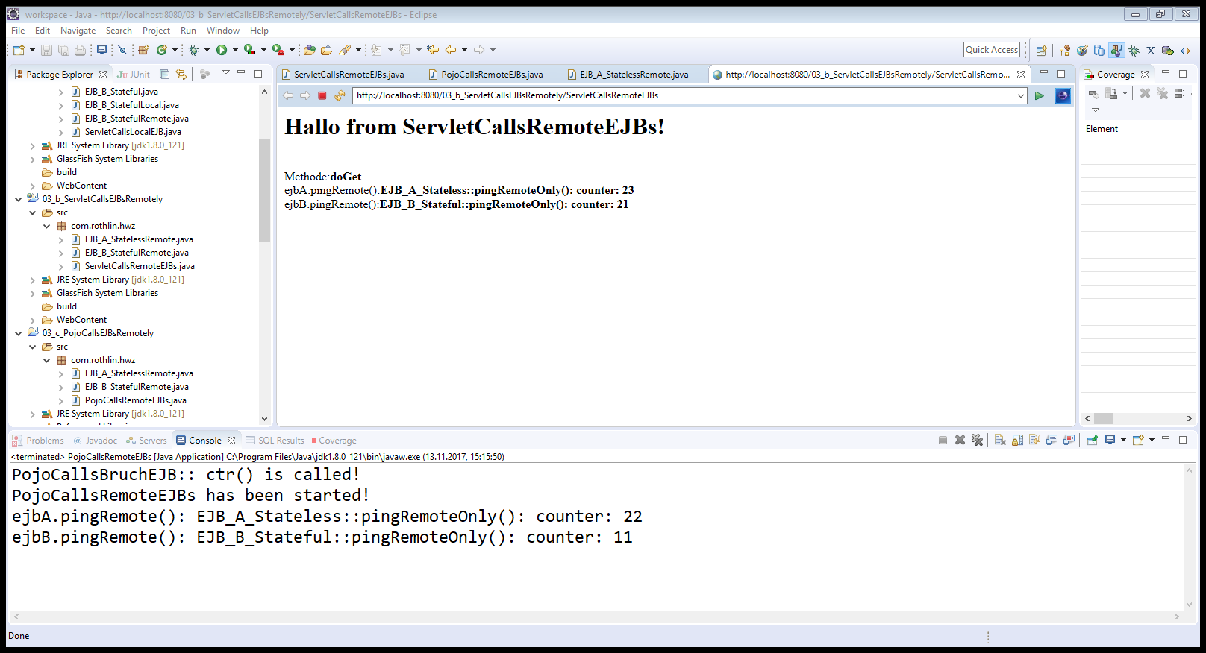

## EJB (stateless and stateful) gets called from a **Java-Client (POJO)**

Right click on project:

New -> Java Project

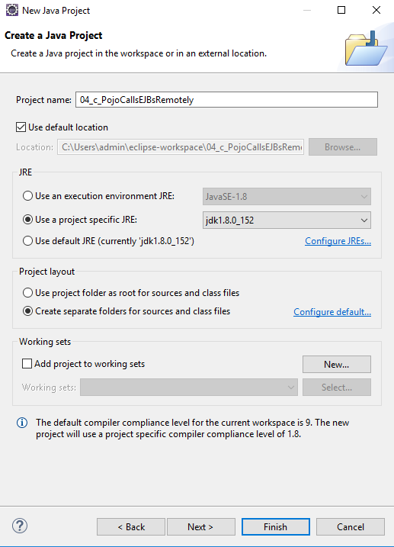

Set it up as an Glassfish-Client

Right click -> Properties -> Project Facets -> Runtimes -> Glassfish 4

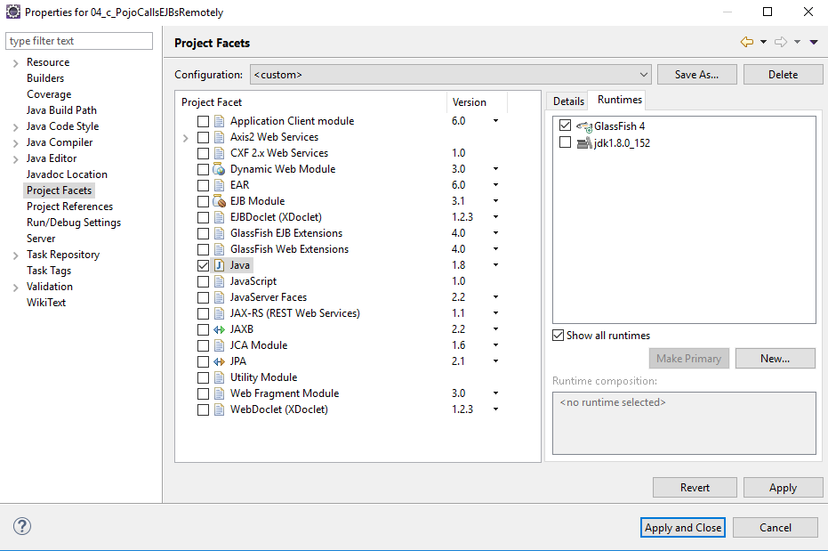

If you don’t see this view right away just press this.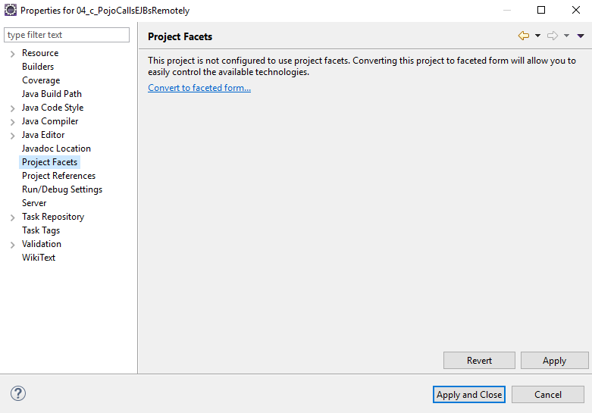

Right click -> Properties -> Java Build Path -> Libraries

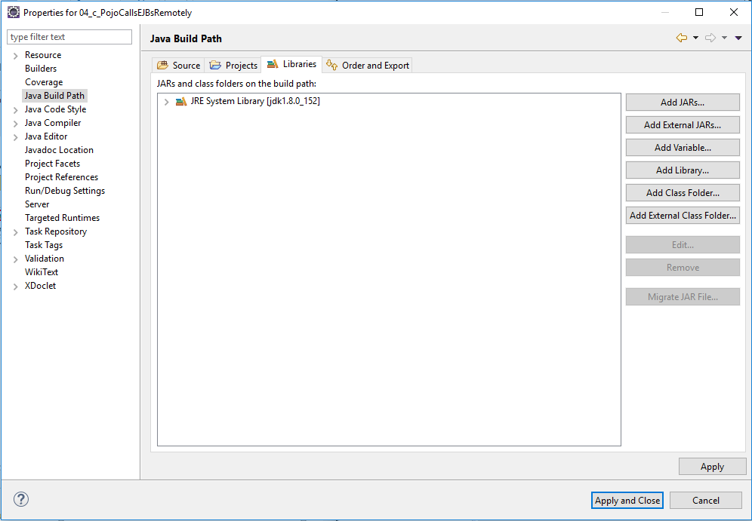

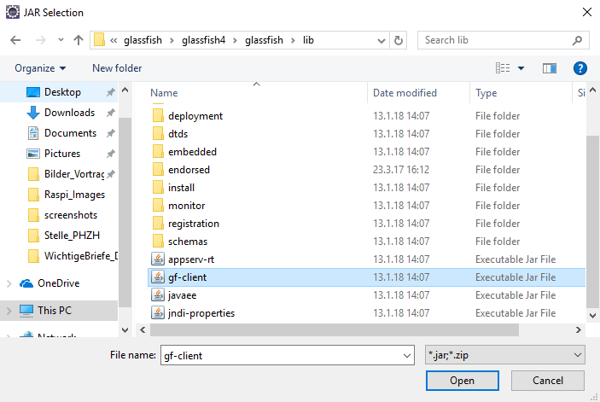

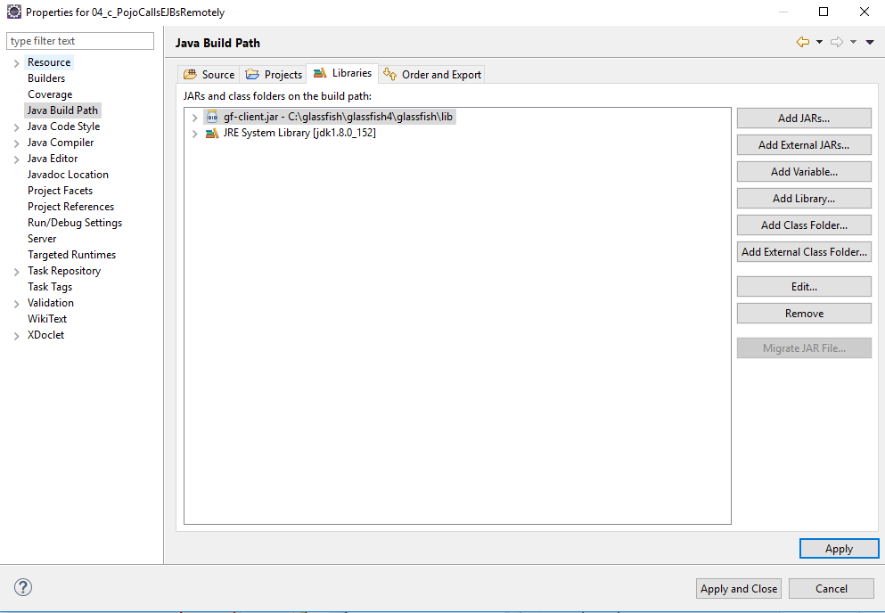

File -> New -> Other -> Java -> Class

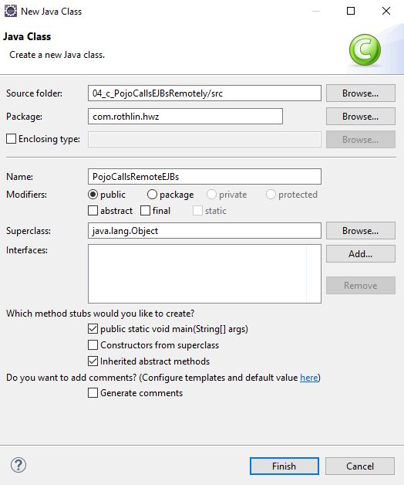

Copy the two Remote-Interface to your project (**EJB_A_StatelessRemote, EJB_B_StatefulRemote**)

Replace in code in the generated Java-Class with this code:

// PojoCallsRemoteEJBs belongs to 03_c_PojoCallsEJBsRemotely

// ------------------- --------------------------

**package** com.rothlin.hwz;

**import** javax.naming.InitialContext;

**public** **class** PojoCallsRemoteEJBs {

**private** **static** **final** String ***jndiHost*** = "127.0.0.1";

**private** **static** **final** String ***jndiPort*** = "3700";

**private** **static** **final** String ***jndiName__EJB_A_StatelessRemote*** = "java:global/03_a_EJBs_stateful_stateless/EJB_A_Stateless!com.rothlin.hwz.EJB_A_StatelessRemote";

**private** **static** **final** String ***jndiName__EJB_B_StatefulRemote*** = "java:global/03_a_EJBs_stateful_stateless/EJB_B_Stateful!com.rothlin.hwz.EJB_B_StatefulRemote";

**private** EJB_A_StatelessRemote ejbA = **null**;

**private** EJB_B_StatefulRemote ejbB = **null**;

**public** PojoCallsRemoteEJBs() {

System.***out***.println("PojoCallsBruchEJB:: ctr() is called!");

System.*setProperty*("org.omg.CORBA.ORBInitialHost", ***jndiHost***);

**try** {

InitialContext ctx = **new** InitialContext();

ctx.addToEnvironment("org.omg.CORBA.ORBInitialHost", ***jndiHost***);

ctx.addToEnvironment("org.omg.CORBA.ORBInitialPort", ***jndiPort***);

ejbA = (EJB_A_StatelessRemote) ctx.lookup(***jndiName__EJB_A_StatelessRemote***);

ejbB = (EJB_B_StatefulRemote) ctx.lookup(***jndiName__EJB_B_StatefulRemote***);

}

**catch** (Exception ex) {

System.***out***.println("Could not get remote-object bean!" + ex);

}

}

**public** **void** runClient() {

System.***out***.println("PojoCallsRemoteEJBs has been started!");

System.***out***.println("ejbA.pingRemote(): " + ejbA.pingRemote());

System.***out***.println("ejbB.pingRemote(): " + ejbB.pingRemote());

}

**public** **static** **void** main(String[] args) {

PojoCallsRemoteEJBs cli = **new** PojoCallsRemoteEJBs();

**try** {

cli.runClient();

} **catch** (Exception e) {

e.printStackTrace();

}

}

}

Save and run it.



## Create Bean to get called from Servlet / JSP in the “FirsServletProject”

File -> New -> Other -> EJB -> Session Bean (EJB 3.x)

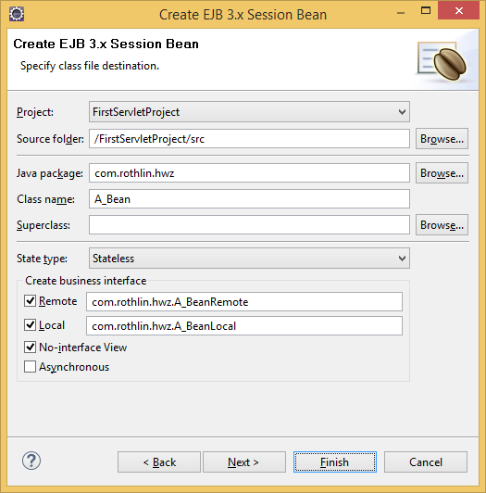

Code for bean:

A_Bean.java

**package** com.rothlin.hwz;

**import** javax.ejb.LocalBean;

**import** javax.ejb.Stateless;

@Stateless

@LocalBean

**public** **class** A_Bean **implements** A_BeanRemote, A_BeanLocal {

**private** **int** counter;

**public** A_Bean() {

System.*out*.println("Konstruktor von A_Bean aufgerufen!");

counter = 10;

}

**public** String sayHello(String name) {

counter++;

**return** "HALLO " + name + ": Der Counter ist: " + counter;

}

}

A_BeanLocal.java

**package** com.rothlin.hwz;

**import** javax.ejb.Local;

@Local

**public** **interface** A_BeanLocal {

**public** String sayHello(String name);

}

A_BeanRemote.java

**package** com.rothlin.hwz;

**import** javax.ejb.Remote;

@Remote

**public** **interface** A_BeanRemote {

**public** String sayHello(String name);

}

## Call Bean-method from Servlet (same web-App):

Add the following code to **FirstServlet.java**:

**package** com.rothlin.hwz;

**import** java.io.IOException;

**import** javax.ejb.EJB;

**import** javax.servlet.ServletConfig;

**import** javax.servlet.ServletException;

**import** javax.servlet.annotation.WebServlet;

**import** javax.servlet.http.HttpServlet;

**import** javax.servlet.http.HttpServletRequest;

**import** javax.servlet.http.HttpServletResponse;

@WebServlet("/FirstServlet")

**public** **class** FirstServlet **extends** HttpServlet {

**private** **static** **final** **long** ***serialVersionUID*** = 1L;

@EJB

A_Bean myBean;

**public** FirstServlet() {

**super**();

System.***out***.println("FirstServlet ctr is called! Object created!!!");

}

**public** **void** init(ServletConfig servletConfig) **throws** ServletException {

System.***out***.println("FirstServlet init() is called!");

}

**public** **void** destroy() {

System.***out***.println("FirstServlet destroy() is called!");

}

**private** **void** serveRequest(HttpServletRequest request, HttpServletResponse response, String methode)

**throws** ServletException, IOException {

response.setContentType("text/html");

StringBuffer sb = **new** StringBuffer("<html>\n<head>\n</head>\n<body>\n");

sb.append("<H1>Hallo HWZ!</H1> Methode:<B>" + methode + "</B><br/>\n");

sb.append("<H2>" + myBean.sayHello("Walti") + "</H2>\n");

sb.append("</body>\n</html>\n");

response.getWriter().print(sb);

}

**protected** **void** doGet(HttpServletRequest request, HttpServletResponse response)

**throws** ServletException, IOException {

serveRequest(request, response, "doGet");

}

**protected** **void** doPost(HttpServletRequest request, HttpServletResponse response)

**throws** ServletException, IOException {

serveRequest(request, response, "doPost");

}

}

Testing Servlet calling local bean

Remove deployment before you deploy the FirstServletProject, or you will get an internal server error.

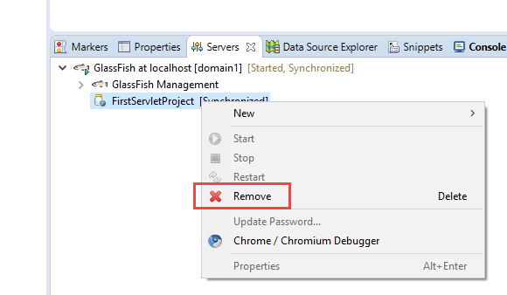

After you deployed your project again, your servlet is running and if you test in a browser, you see

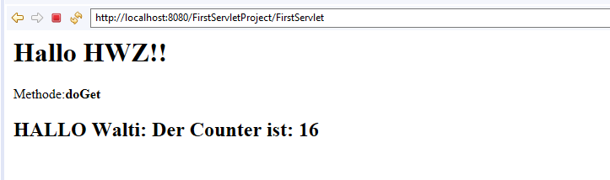

The counter starts with 11.

Call Bean-method from JSP (same web-App)

Add the following code to index.jsp:

<%@page contentType=*"text/html"* pageEncoding=*"UTF-8"*%>

<!DOCTYPE HTML PUBLIC "-//W3C//DTD HTML 4.01 Transitional//EN"

"http://www.w3.org/TR/html4/loose.dtd">

<%@page import =*"com.rothlin.hwz.A_Bean"* %>

<jsp:useBean id =*"userBean"* class=*"com.rothlin.hwz.A_Bean"* scope=*"session"*/>

<html>

<head>

<meta http-equiv=*"Content-Type"* content=*"text/html; charset=UTF-8"*>

<title>GlassFish JSP Page</title>

</head>

<body>

<h1>Hello World!</h1>

<%= userBean.sayHello("HWZ") %><HR/>

</body>

</html>

## Testing JSP calling EJB local

Example output after redeploy:

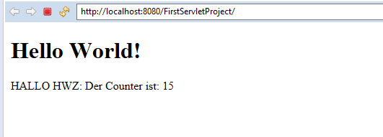

## Create an EJB (Enterprise Java Bean) in another project (Remote)

File -> New -> Other -> EJB Project

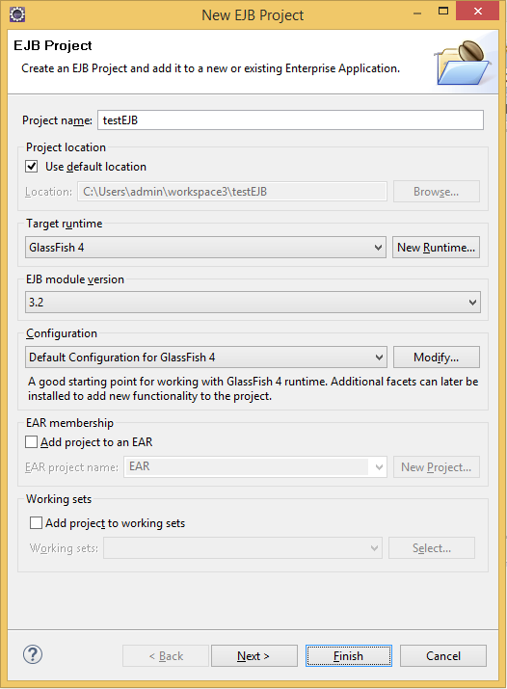 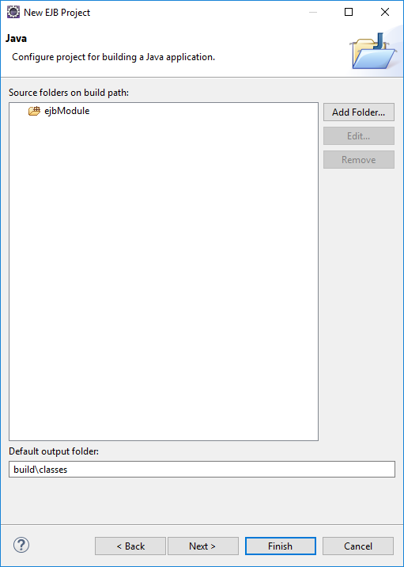

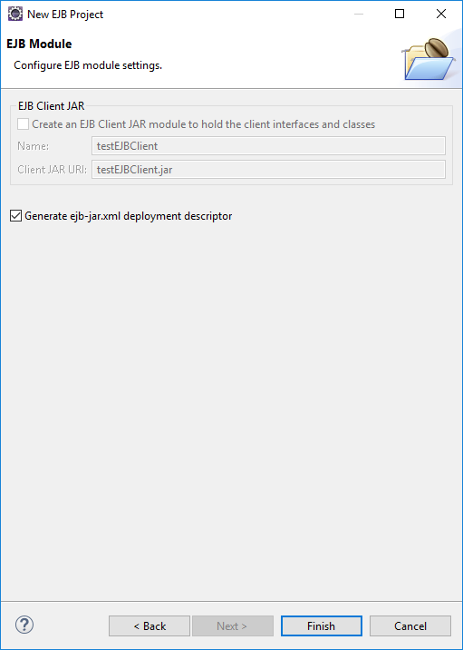

File -> New -> Other -> EJB -> Session Bean (EJB 3.x)

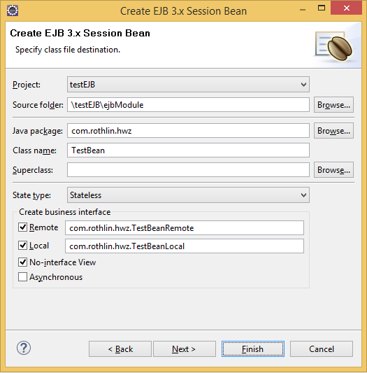

First EJB Code

Replace the existing code of the following classes with these:

TestBean.java:

**package** com.rothlin.hwz;

**import** javax.annotation.PostConstruct;

**import** javax.annotation.PreDestroy;

**import** javax.ejb.LocalBean;

**import** javax.ejb.Stateless;

@Stateless

@LocalBean

**public** **class** TestBean **implements** TestBeanRemote, TestBeanLocal {

@PostConstruct

**private** **void** startup() {

System.***out***.println("TestBean: PostConstruct!!");

}

@PreDestroy

**public** **void** cleanup() {

System.***out***.println("TestBean: cleanup!");

}

**public** String ping() {

**return** "TestBean V1.0";

}

**public** TestBean() {

System.***out***.println("TestBean: ctr called!");

}

}

TestBeanLocal.java

**package** com.rothlin.hwz;

**import** javax.ejb.Local;

@Local

**public** **interface** TestBeanLocal {

**public** String ping();

}

TestBeanRemote.java

**package** com.rothlin.hwz;

**import** javax.ejb.Remote;

@Remote

**public** **interface** TestBeanRemote {

**public** String ping();

}

Deploy EJB

Select the EJB Project and click on Run as -> Run on Server

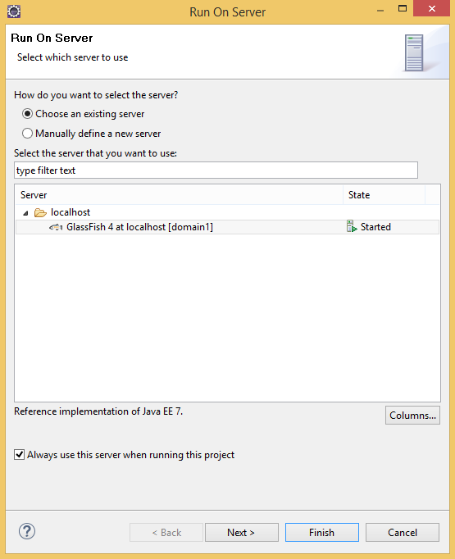

A Portable JNDI name will be created (check serverlog):

2017-04-03T14:11:42.223+0200|Info: Portable JNDI names for EJB TestBean: [java:global/testEJB/TestBean!com.rothlin.hwz.TestBeanLocal, java:global/testEJB/TestBean!com.rothlin.hwz.TestBean, **java:global/testEJB/TestBean!com.rothlin.hwz.TestBeanRemote**]

Call EJB Methode from “FirstServlet”

Modify the servlet-code as following:

**package** com.rothlin.hwz;

**import** java.io.IOException;

**import** javax.ejb.EJB;

**import** javax.naming.InitialContext;

**import** javax.servlet.ServletConfig;

**import** javax.servlet.ServletException;

**import** javax.servlet.annotation.WebServlet;

**import** javax.servlet.http.HttpServlet;

**import** javax.servlet.http.HttpServletRequest;

**import** javax.servlet.http.HttpServletResponse;

@WebServlet("/FirstServlet")

**public** **class** FirstServlet **extends** HttpServlet {

**private** **static** **final** **long** ***serialVersionUID*** = 1L;

@EJB

A_Bean myBean;

TestBeanRemote aTestBean = **null**;

**public** FirstServlet() {

**super**();

System.***out***.println("FirstServlet ctr is called! Object created!!!");

}

**public** **void** init(ServletConfig servletConfig) **throws** ServletException {

System.***out***.println("FirstServlet init() is called!");

System.*setProperty*("org.omg.CORBA.ORBInitialHost", "127.0.0.1");

**try** {

InitialContext ctx = **new** InitialContext();

ctx.addToEnvironment("org.omg.CORBA.ORBInitialHost", "127.0.0.1");

ctx.addToEnvironment("org.omg.CORBA.ORBInitialPort", "3700");

aTestBean = (TestBeanRemote) ctx.lookup

("java:global/testEJB/TestBean!com.rothlin.hwz.TestBeanRemote");

}

**catch** (Exception ex) {

System.***out***.println("Couldn’t create converter bean!" + ex);

}

}

**public** **void** destroy() {

System.***out***.println("FirstServlet destroy() is called!");

}

**private** **void** serveRequest(HttpServletRequest request,

HttpServletResponse response, String methode)

**throws** ServletException, IOException {

response.setContentType("text/html");

StringBuffer sb = **new** StringBuffer("<html>\n<head>\n</head>\n<body>\n");

sb.append("<H1>Hallo HWZ!</H1> Methode:<B>" + methode + "</B><br/>\n");

sb.append("<H2>" + myBean.sayHello("Walti") + "</H2>\n");

sb.append("<H2>" + aTestBean.ping() + "</H2>\n");

sb.append("</body>\n</html>\n");

response.getWriter().print(sb);

}

**protected** **void** doGet(HttpServletRequest request, HttpServletResponse response)

**throws** ServletException, IOException {

serveRequest(request, response, "doGet");

}

**protected** **void** doPost(HttpServletRequest request, HttpServletResponse response)

**throws** ServletException, IOException {

serveRequest(request, response, "doPost");

}

}

Fixen der Projektübergreifenden Interfaces

Um den Fehler des vermissten **TestBeanRemote** zu fixen, kopieren sie das gleichnamige File vom **testEJB**-Projekt in das **FirstServletProject**

Es gibt auch die Möglichkeit die Resourcen im **testEJB** im **FirstServletProject** bekannt zu machen:

Add testEJB Project to FirstServletProject

File -> Properties -> Java Build Path

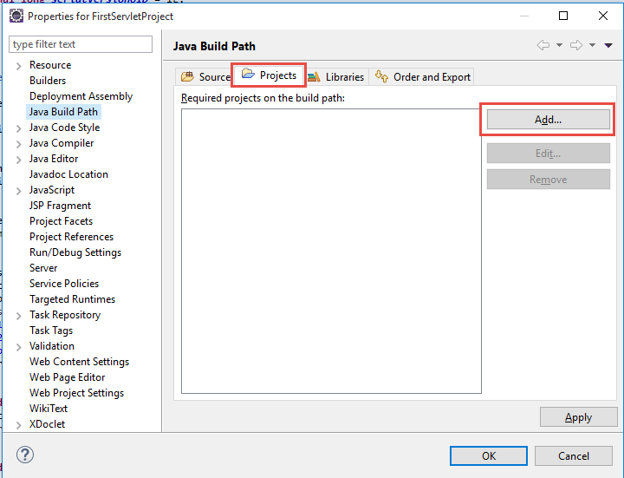 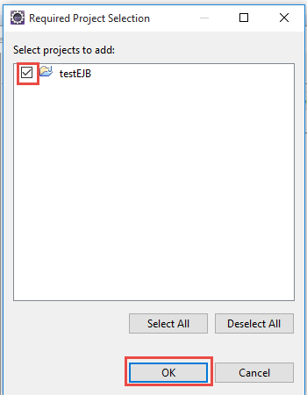

If the project testEJB is visible as build path, close the window.

## Testen des Servlets mit EJB local and remote call

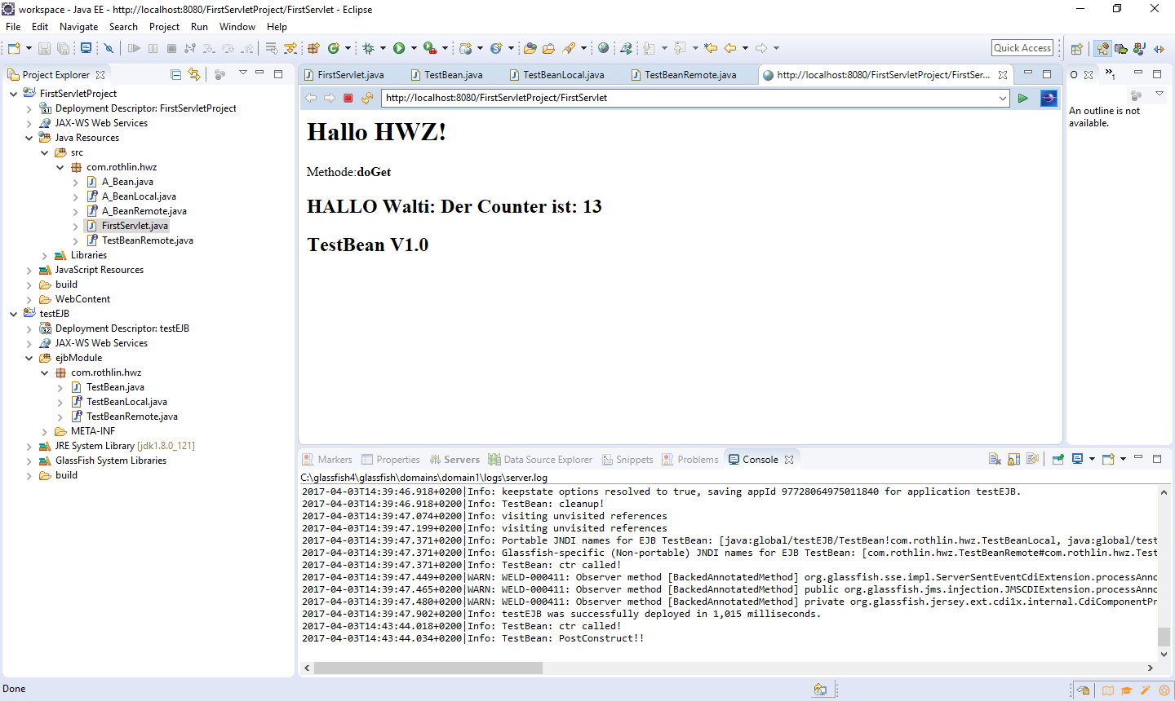

Wichtig: wird nun der Code des EJB geändert und deployed, muss auch das Servlet neu geladen werden (die init() function muss aufgerufen werden und eine neue Remote-Referenz via JNDI geholt werden). Am einfachsten macht man das, indem der Servlet Code geändert wird und wieder abgespeichert, so wird das Servlet ebenfalls neu deployed und init() aufgerufen.

Java-client calls EJB-Methode

File -> New -> Other -> Java -> Java Project

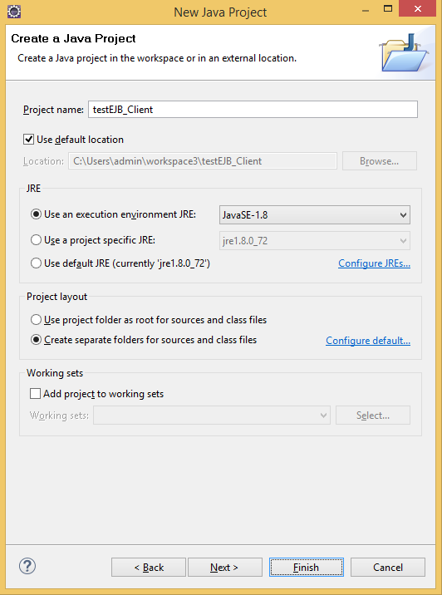

Right click -> Properties -> Project Facets -> Runtimes -> Glassfish 4

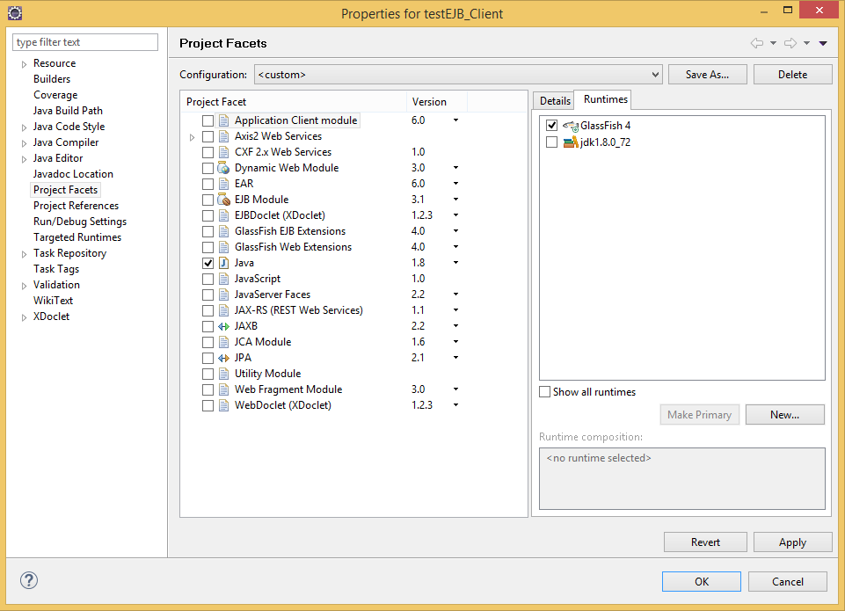

Right click -> Properties -> Java Build Path -> Libraries

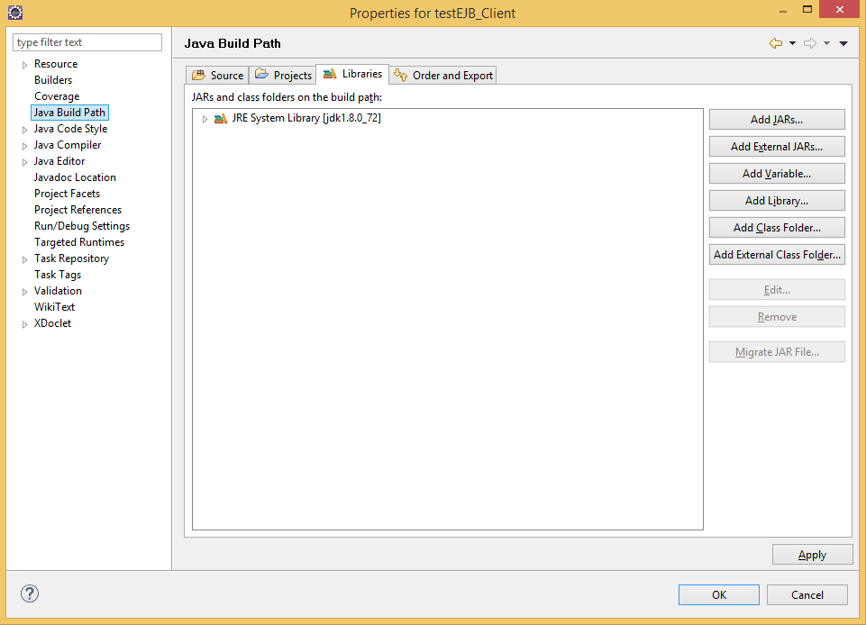

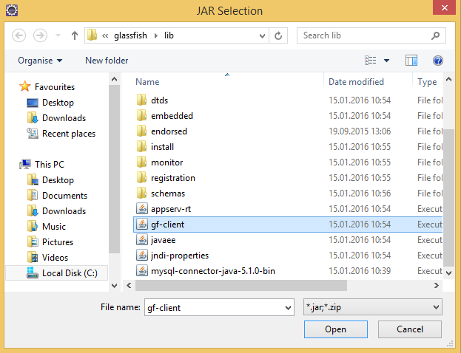

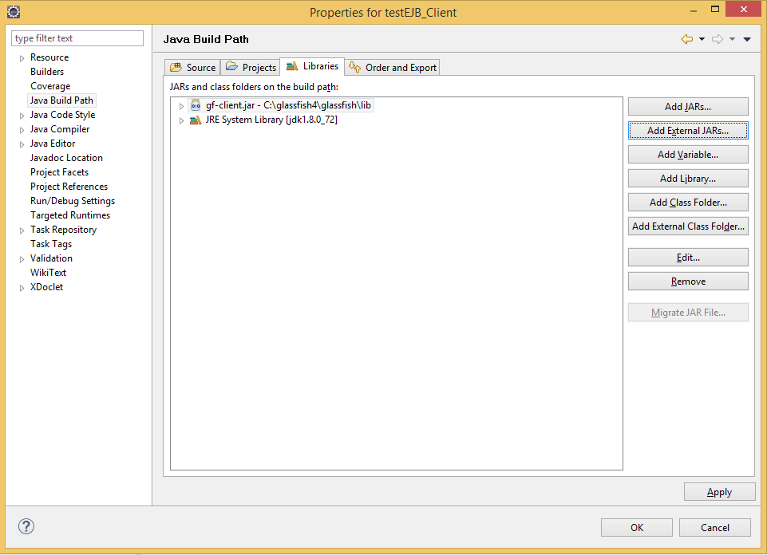

File -> New -> Other -> Java -> Class

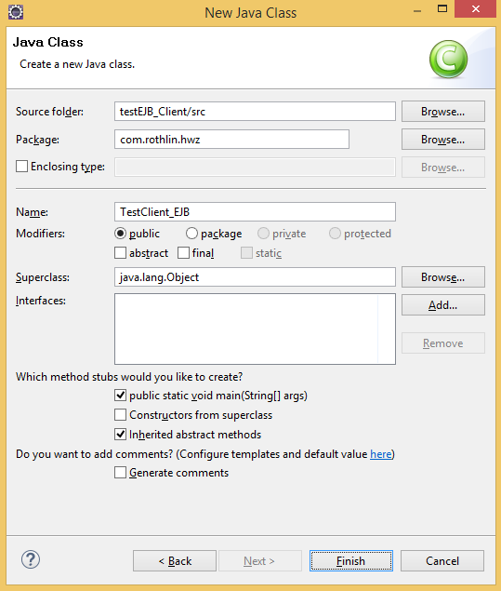

TestClient_EJB.java

**package** com.rothlin.hwz;

**import** javax.naming.InitialContext;

**public** **class** TestClient_EJB {

**public** **void** runTest() **throws** Exception {

System.*setProperty*("org.omg.CORBA.ORBInitialHost", "127.0.0.1");

InitialContext ctx = **new** InitialContext();

/* calling stateless session bean */

System.***out***.println("Calling TestBean (Session stateless)");

ctx.addToEnvironment("org.omg.CORBA.ORBInitialHost", "127.0.0.1");

ctx.addToEnvironment("org.omg.CORBA.ORBInitialPort", "3700");

TestBeanRemote bean = (TestBeanRemote) ctx.lookup

("java:global/testEJB/TestBean!com.rothlin.hwz.TestBeanRemote");

System.***out***.println(bean.ping());

}

**public** **static** **void** main(String[] args) {

TestClient_EJB cli = **new** TestClient_EJB();

**try** {

cli.runTest();

} **catch** (Exception e) {

e.printStackTrace();

}

}

}

File -> New -> Other -> Java -> Java Interface

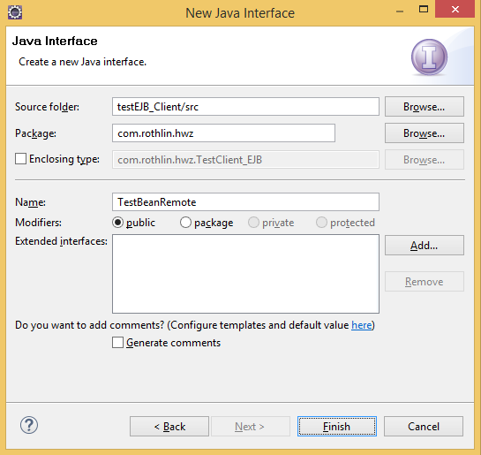

TestBeanRemote.java

**package** com.rothlin.hwz;

**public** **interface** TestBeanRemote {

**public** String ping();

}

This is how the Package Explorer should look like:

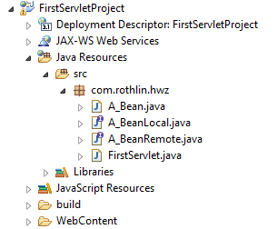

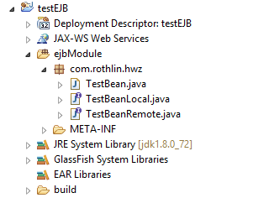

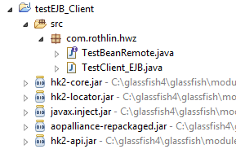

## Create own WEB-Service

File -> New -> Other -> Web -> Dynamic Web Project

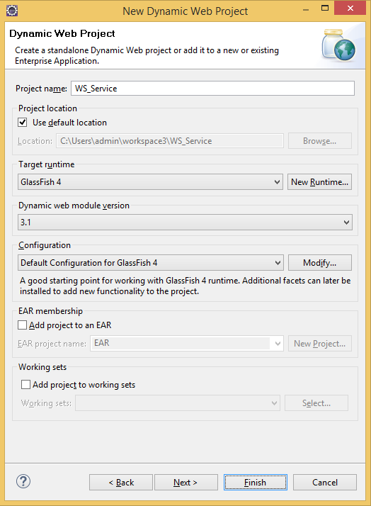

File -> New -> Other -> Java -> Class

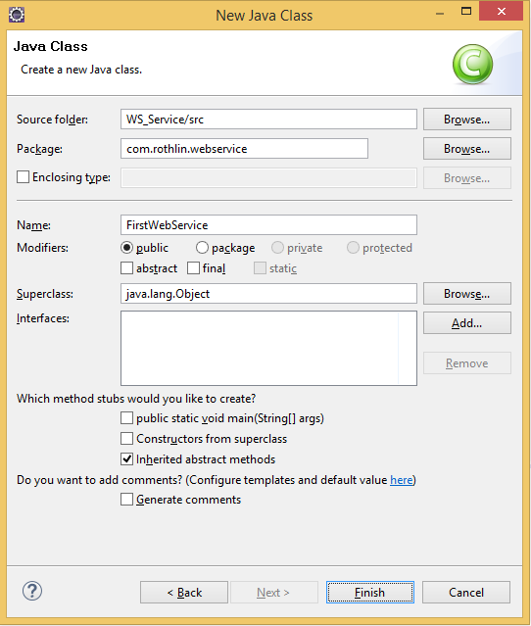

Add the following code:

**package** com.rothlin.webservice;

**import** javax.jws.WebMethod;

**import** javax.jws.WebService;

@WebService

**public** **class** FirstWebService {

// Methodes in a web-Service are called Operations

// Operation names can not be overloaded (

@WebMethod

**public** String sayHello() {

**return** "Hello HWZ";

}

@WebMethod() // ctrl-space shows you the options

**public** String sayHelloName(String name) {

**return** "Hello " + name;

}

@WebMethod(exclude=**false**)

**public** String sayAnredeName(String anrede, String name) {

**return** anrede + " " + name;

}

}

Run java class on Server and check Admin Console

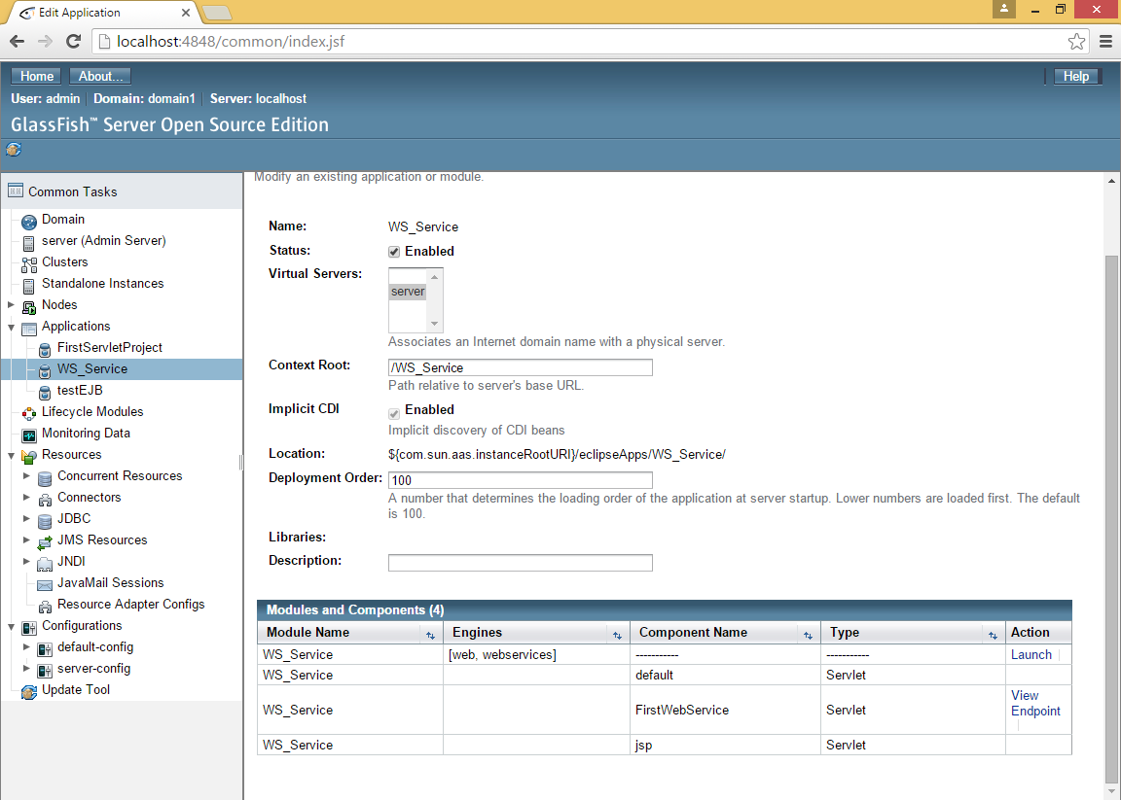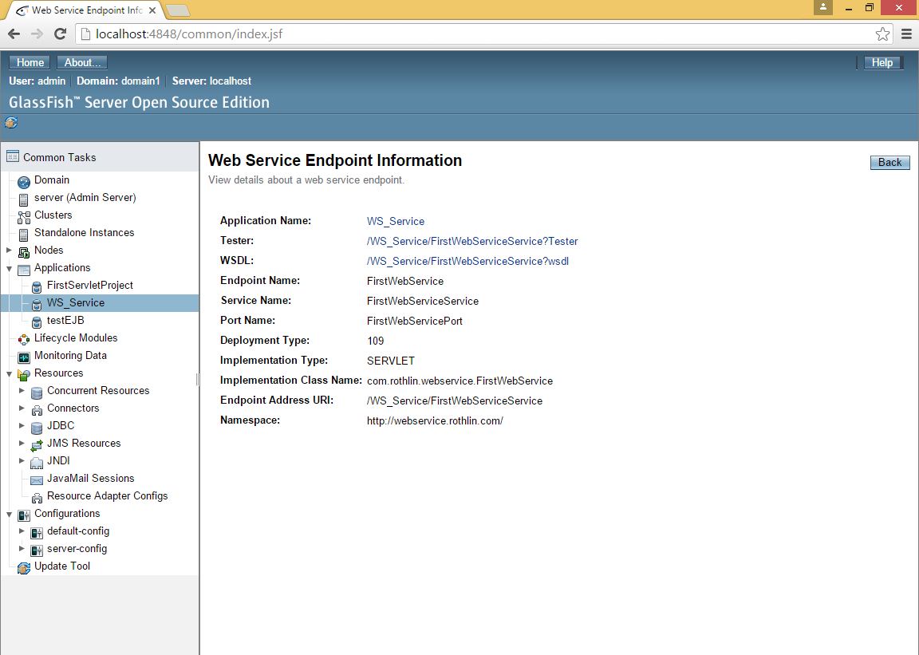

Tester To test the operation. When you want to test the Web-Service without writing a client, click on the Tester-Link which is given in the Web Service Endpoint Information.

WSDL To get the generated WSDL.

## Create Java-Client calling WEB-Service

File -> New -> Java Project

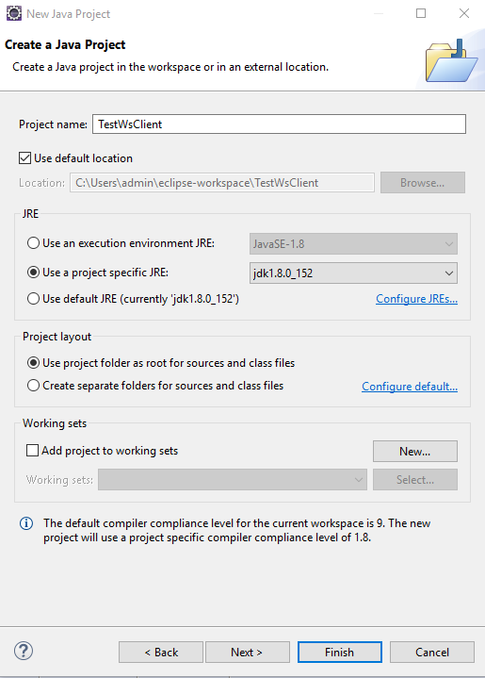

Create the stub-classes from wsdl-file:

New -> Other… -> Web Service -> Web Service Client

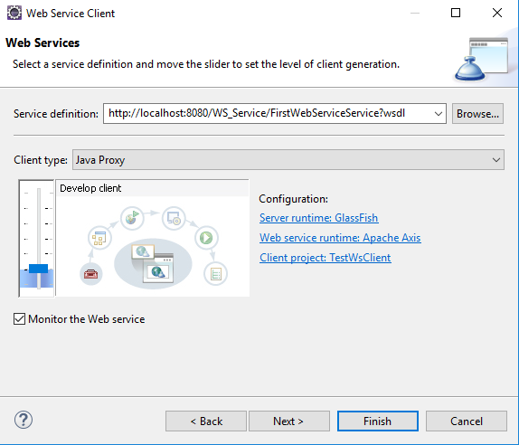

http://localhost:8080/WS_Service/FirstWebServiceService?wsdl

Other way to create stub-classes:

Generate Client Stub from WSDL in dos-prompt:

mkdir sei

cd sei

mkdir src

wsimport –keep –s src http://DESKTOP-0ORFPM9:8080/04_a_Webservice_Simple/FirstWebServiceService?wsdl

Created stub-classes:

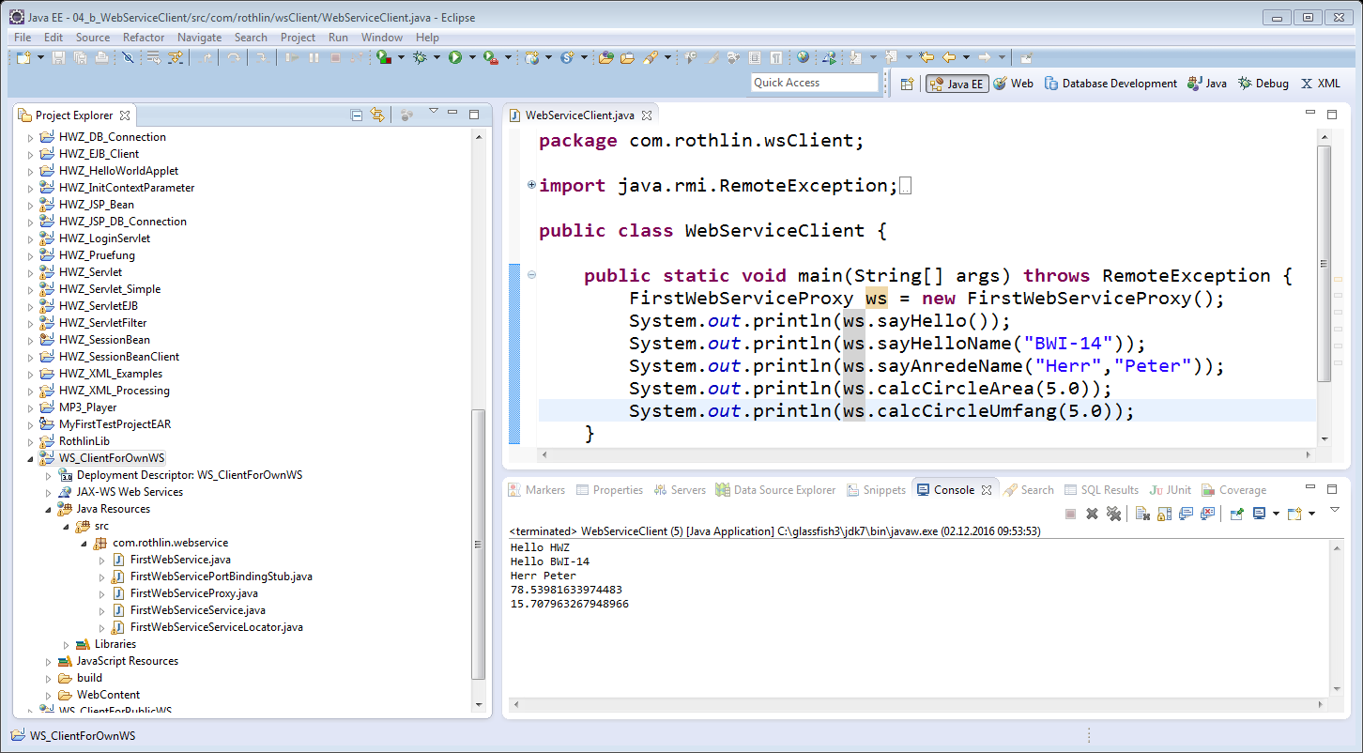

File -> New -> Java Project

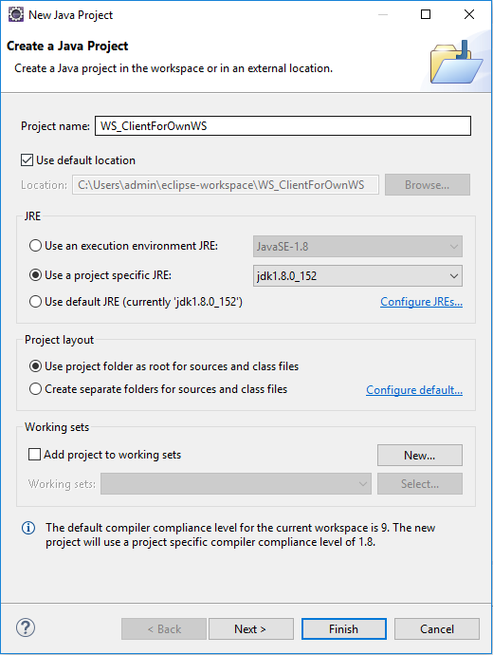

File -> New -> Package

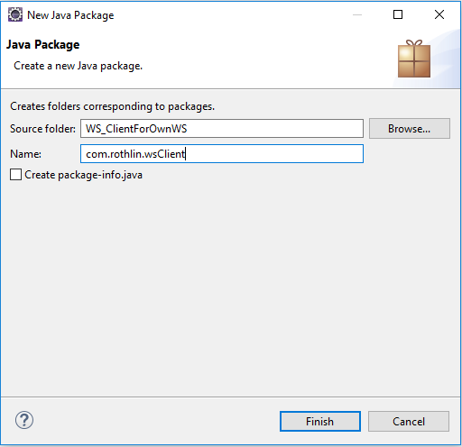

Create client:

File -> New -> Class

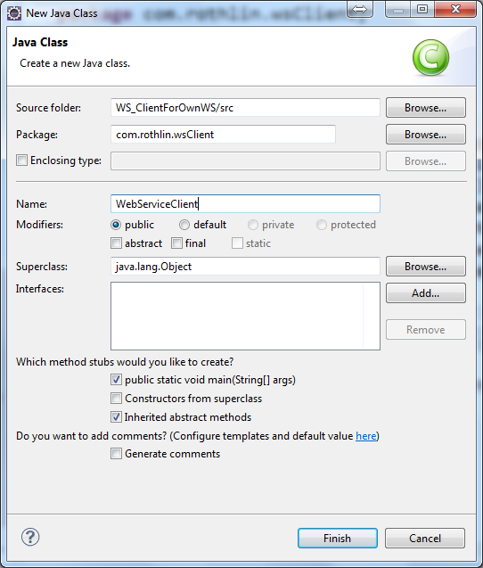

**package** com.rothlin.wsClient;

**import** java.rmi.RemoteException;

**import** com.rothlin.webservice.FirstWebServiceProxy;

**public** **class** WebServiceClient {

**public** **static** **void** main(String[] args) **throws** RemoteException {

FirstWebServiceProxy ws = **new** FirstWebServiceProxy();

System.***out***.println(ws.sayHello());

System.***out***.println(ws.sayHelloName("BWI-14"));

System.***out***.println(ws.sayAnredeName("Herr","Peter"));

System.***out***.println(ws.calcCircleArea(5.0));

System.***out***.println(ws.calcCircleUmfang(5.0));

}

}

## Create a Java Client which calls a public Web-Service

Used Web-Service (Converts an IP-address to a country name): <http://www.webservicex.net/geoipservice.asmx?WSDL>

## Create TCP/IP Server-Client

**package** com.rothlin.wsClient;

**import** net.webservicex.GeoIP;

**import** net.webservicex.GeoIPService;

**import** net.webservicex.GeoIPServiceSoap;

**public** **class** WebServiceClient {

**static** **public** String getCountryNameForIP(String ipAddress) {

// from WSDL: <wsdl:service name="GeoIPService">

GeoIPService ipService = **new** GeoIPService();

// from WSDL: <wsdl:port name="GeoIPServiceSoap">

GeoIPServiceSoap geoIPServiceSoap = ipService.getGeoIPServiceSoap();

GeoIP geoIp = geoIPServiceSoap.getGeoIP(ipAddress);

**return** geoIp.getCountryName();

}

**public** **static** **void** main(String[] args) {

**if** (args.length != 1) {

System.***out***.println("You need to pass one IP address!");

System.***out***.println("\nSome test cases:");

String ipAddress = "193.134.255.237";

System.***out***.println(ipAddress + " --> " + *getCountryNameForIP*(ipAddress));

ipAddress = "212.58.246.103";

System.***out***.println(ipAddress + " --> " + *getCountryNameForIP*(ipAddress));

} **else** {

String ipAddress = args[0];

System.***out***.println(ipAddress + " --> " + *getCountryNameForIP*(ipAddress));

}

}

}

File -> New -> Other -> Java -> Class

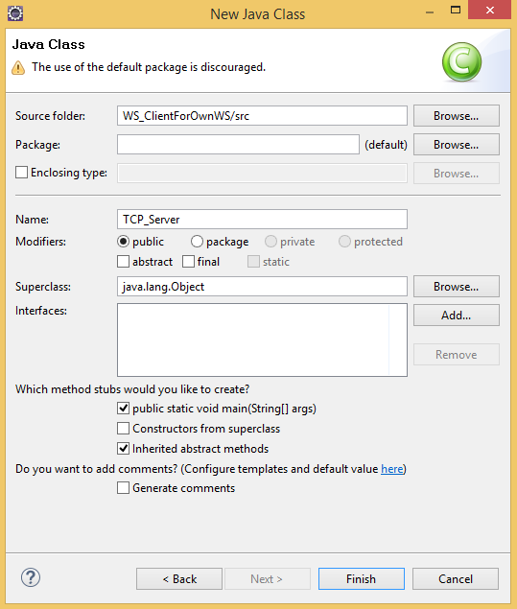

**import** java.io.*;

**import** java.net.*;

**class** TCP_Server {

**public** **static** **void** main(String argv[]) **throws** Exception {

String clientSentence;

String upperSentence ;

ServerSocket **welcomeSocket** = **new** ServerSocket(**6789**);

System.*out*.println("TCP/IP Server started!");

**while**(**true**) {

System.*out*.println("TCP/IP Server waiting to be called....");

Socket connectionSocket = welcomeSocket.accept();

BufferedReader inFromClient =

**new** BufferedReader(

**new** InputStreamReader(connectionSocket.getInputStream()));

DataOutputStream outToClient =

**new** DataOutputStream(connectionSocket.getOutputStream());

**clientSentence = inFromClient.readLine();**

System.*out*.println("Received from Client: " + clientSentence);

upperSentence = clientSentence.toUpperCase() + '\n';

System.*out*.println("Sent back to Client : " + upperSentence );

**outToClient.writeBytes(upperSentence);**

}

}

}

File -> New -> Other -> Java -> Class

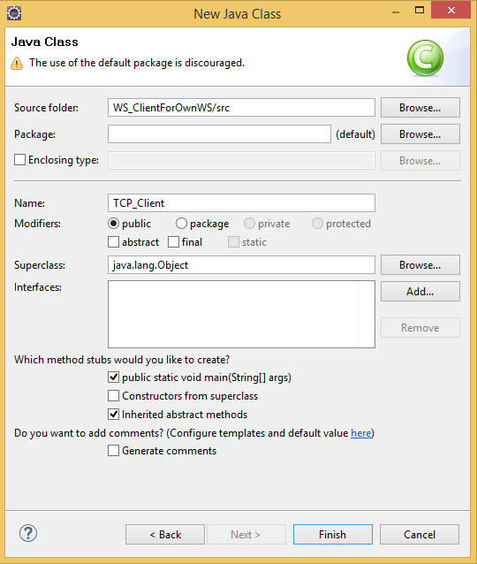

**import** java.io.*;

**import** java.net.*;

**class** TCP_Client {

**public** **static** **void** main(String argv[]) **throws** Exception {

String sentence;

String modifiedSentence;

BufferedReader inFromUser =

**new** BufferedReader(

**new** InputStreamReader(System.*in*));

Socket clientSocket = **new** Socket(**"localhost", 6789**);

DataOutputStream outToServer =

**new** DataOutputStream(clientSocket.getOutputStream());

BufferedReader inFromServer =

**new** BufferedReader(

**new** InputStreamReader(clientSocket.getInputStream()));

System.*out*.print("Enter a String : ");

sentence = inFromUser.readLine();

System.*out*.println("Sent to SERVER : " + sentence);

**outToServer.writeBytes(sentence + '\n');**

**modifiedSentence = inFromServer.readLine();**

System.*out*.println("Received from SERVER: " + modifiedSentence);

clientSocket.close();

System.*out*.println("Client terminated!!!!!");

}

}

## Create TCP/IP Server-Client advanced

File -> New -> Other -> Java -> Class

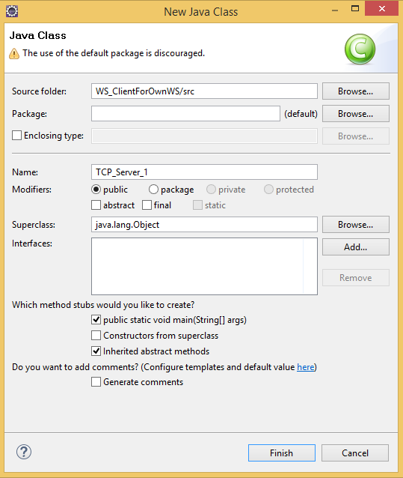

File -> New -> Other -> Java -> Class

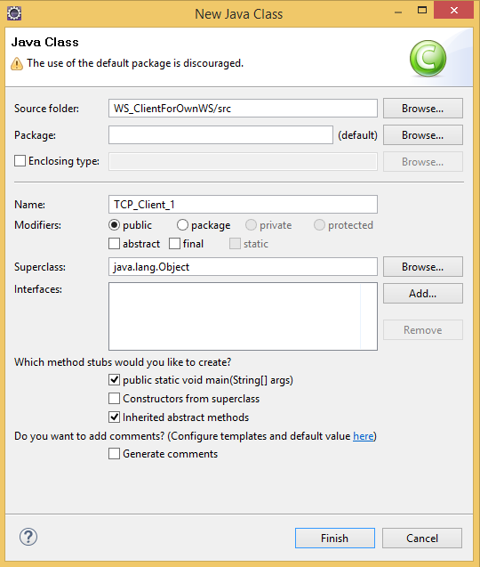

Add the following code to TCP_Server_1:

**import** java.io.*;

**import** java.net.*;

**public** **class** TCP_Server_1 {

**private** **static** String businessFct_A(String msg) {

**return** msg.toUpperCase() + '\n';

}

**private** **static** String businessFct_B(String msg) {

**return** msg.toLowerCase() + '\n';

}

**public** **static** **void** main(String argv[]) **throws** Exception {

String clientMsg;

String replyMsg;

ServerSocket welcomeSocket = **new** ServerSocket(6789);

System.*out*.println("TCP/IP Server started!");

**while**(**true**) {

System.*out*.println("TCP/IP Server waiting to be called....");

Socket connectionSocket = welcomeSocket.accept();

BufferedReader inFromClient =

**new** BufferedReader(

**new** InputStreamReader(connectionSocket.getInputStream()));

DataOutputStream outToClient =

**new** DataOutputStream(connectionSocket.getOutputStream());

clientMsg = inFromClient.readLine();

System.*out*.println("Received from Client: " + clientMsg);

String[] msgParts = clientMsg.split(":");

String fctName = msgParts[0];

String stringMsg = msgParts[1];

System.*out*.println(" Function : " + fctName);

System.*out*.println(" Parameter: " + stringMsg);

**if** (fctName.equals("toUpper")) {

replyMsg = *businessFct_A*(stringMsg);

} **else** **if** (fctName.equals("toLower")) {

replyMsg = *businessFct_B*(stringMsg);

} **else** {

replyMsg = "ERROR: Unknown Function " + fctName + '\n';

}

System.*out*.println("Sent back to Client : " + replyMsg );

outToClient.writeBytes(replyMsg);

}

}

}

Add the following code to TCP_Client_1:

**import** java.io.*;

**import** java.net.*;

**public** **class** TCP_Client_1 {

**public** **static** **void** main(String argv[]) **throws** Exception {

String sentence;

String fctName;

String modifiedSentence;

BufferedReader inFromUser = **new** BufferedReader(

**new** InputStreamReader(System.*in*));

Socket clientSocket = **new** Socket("localhost", 6789);

DataOutputStream outToServer =

**new** DataOutputStream(clientSocket.getOutputStream());

BufferedReader inFromServer =

**new** BufferedReader(

**new** InputStreamReader(clientSocket.getInputStream()));

System.*out*.print("Enter function name : ");

fctName = inFromUser.readLine();

System.*out*.print("Enter a String : ");

sentence = inFromUser.readLine();

System.*out*.println("Sent to SERVER : " + fctName + ":" + sentence);

outToServer.writeBytes(fctName + ":" + sentence + '\n');

modifiedSentence = inFromServer.readLine();

System.*out*.println("Received from SERVER: " + modifiedSentence);

clientSocket.close();

System.*out*.println("Client terminated!!!!!");

}

}

## Create RMI Client-Server

File -> New -> Other -> Java -> Java Project

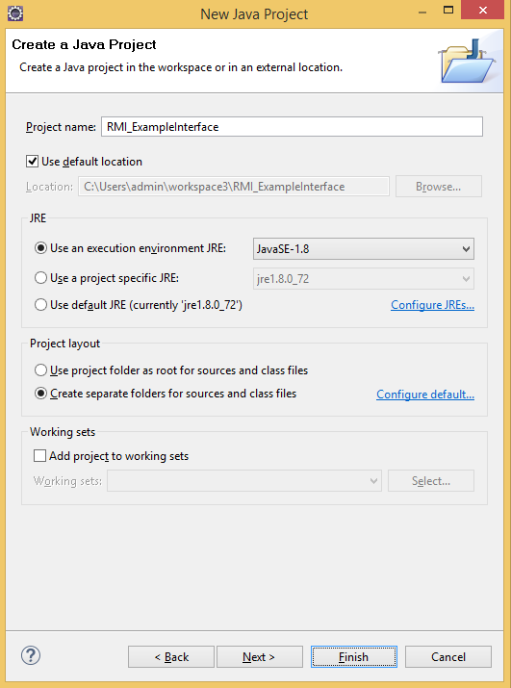

File -> New -> Other -> Java -> Package

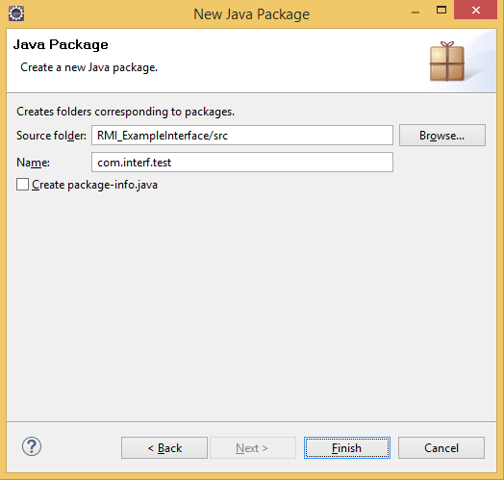

File -> New -> Other -> Java -> Class

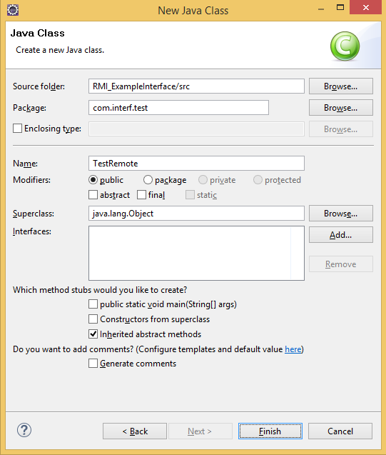

**package** com.interf.test;

**import** java.rmi.Remote;

**import** java.rmi.RemoteException;

**public** **interface** TestRemote **extends** Remote{

**public** **boolean** isLoginValid(String username) **throws** RemoteException;

}

File -> New -> Other -> Java -> Class

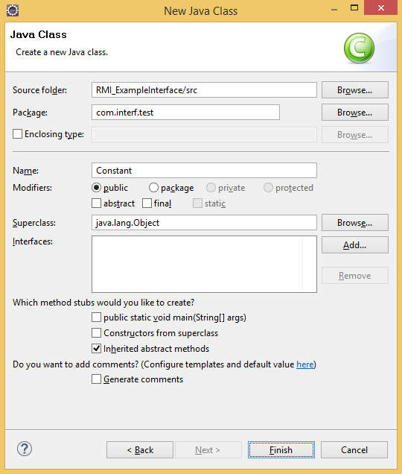

**package** com.interf.test;

**public** **class** Constant {

**public** **static** **final** String *RMI_ID* = "TestRMI";

**public** **static** **final** **int** *RMI_PORT* = 222;

}

File -> New -> Other -> Java -> Java Project

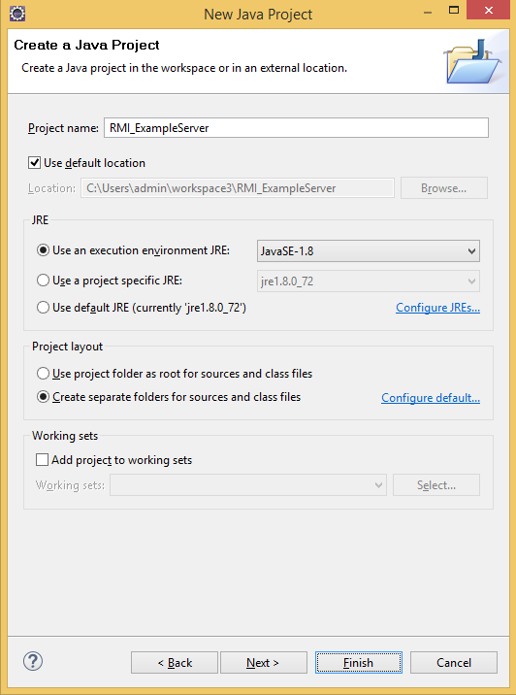

File -> New -> Other -> Java -> Java Package

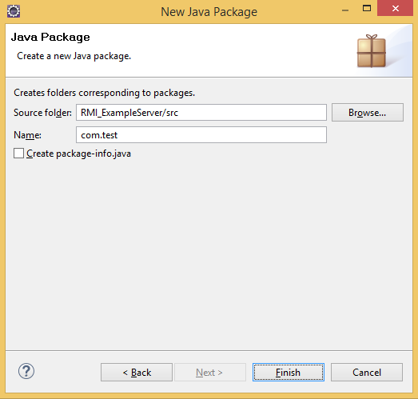

File -> New -> Other -> Java -> Class

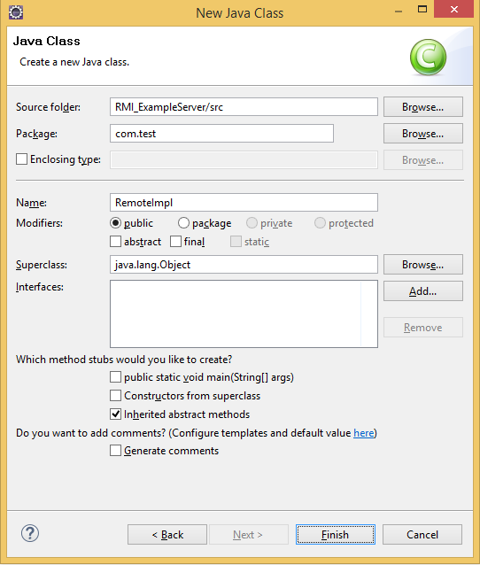

**package** com.test;

**import** java.rmi.RemoteException;

**import** java.rmi.server.UnicastRemoteObject;

**import** com.interf.test.TestRemote;

**public** **class** RemoteImpl **extends** UnicastRemoteObject **implements** TestRemote {

**private** **static** **final** **long** *serialVersionUID* = 1L;

**protected** RemoteImpl() **throws** RemoteException {

**super**();

}

@Override

**public** **boolean** isLoginValid(String username) **throws** RemoteException {

**if** (username.equals("test")) {

**return** **true**;

}

**return** **false**;

}

}

File -> New -> Other -> Java -> Class

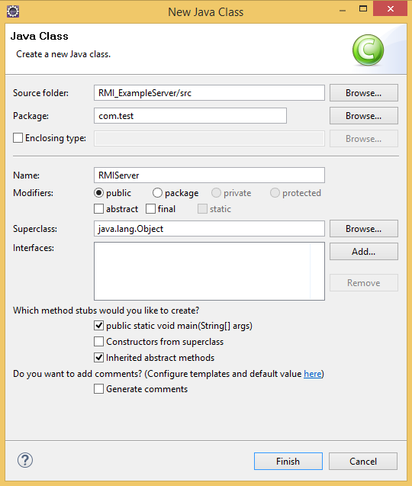

**package** com.test;

**import** java.rmi.AlreadyBoundException;

**import** java.rmi.RemoteException;

**import** java.rmi.registry.LocateRegistry;

**import** java.rmi.registry.Registry;

**import** com.interf.test.Constant;

**public** **class** RMIServer {

**public** **static** **void** main(String[] args)

**throws** RemoteException, AlreadyBoundException {

RemoteImpl impl = **new** RemoteImpl();

Registry registry = LocateRegistry.*createRegistry*(Constant.*RMI_PORT*);

registry.bind(Constant.*RMI_ID*,impl);

System.*out*.println("Server is started!");

}

}

File -> New -> Other -> Java -> Java Project

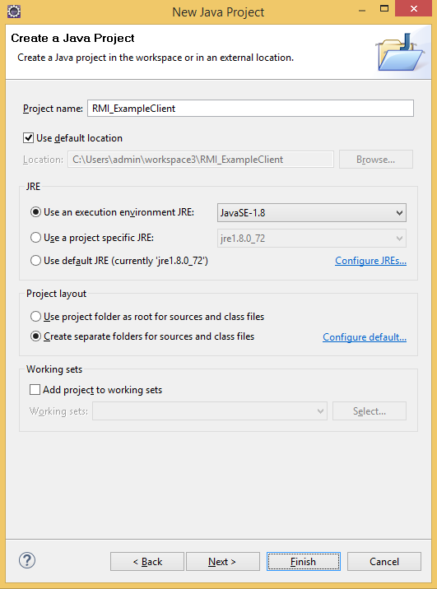

File -> New -> Other -> Java -> Package

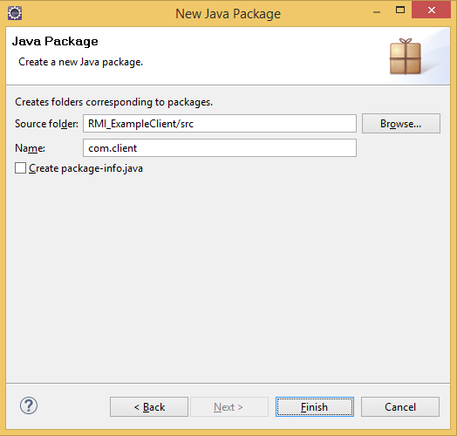

File -> New -> Other -> Java -> Class

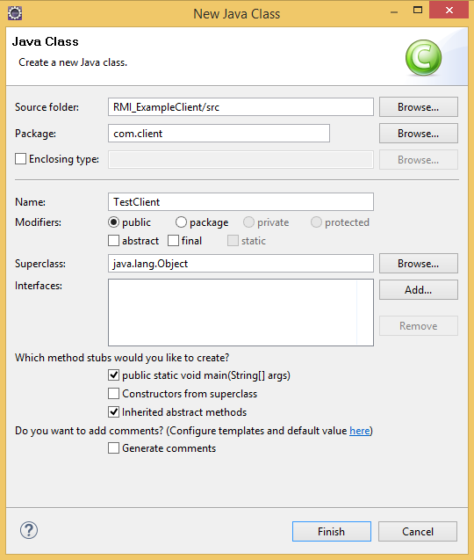

**package** com.client;

**import** java.rmi.NotBoundException;

**import** java.rmi.RemoteException;

**import** java.rmi.registry.LocateRegistry;

**import** java.rmi.registry.Registry;

**import** com.interf.test.Constant;

**import** com.interf.test.TestRemote;

**public class** TestClient {

**public static void** main(String[] args)

**throws** RemoteException, NotBoundException {

Registry registry = LocateRegistry.getRegistry("localhost", *Constant.RMI_PORT*);

TestRemote remote = (TestRemote) registry.lookup(*Constant.RMI_ID*);

System.out.println(remote.isLoginValid("test"));

System.out.println(remote.isLoginValid("TEST"));

}

}

## Troubleshooting “DeploymentException” on Glassfish startup

The problem is discussed [here](https://java.net/projects/glassfish/lists/dev/archive/2014-01/message/11).

Whenever you encounter a “org.glassfish.deployment.common.DeploymentException“ when starting the server, try this:

* Stop the server.
* Navigate to the glassfish installation directory and delete the contents of the “generated” folder.
* Try to restart the server.
* If the error persists, follow with the next steps.
* In the Eclipse Menubar, navigate to Window > Preferences > Server > Runtime Environments and select the Glassfish server and delete it:  
   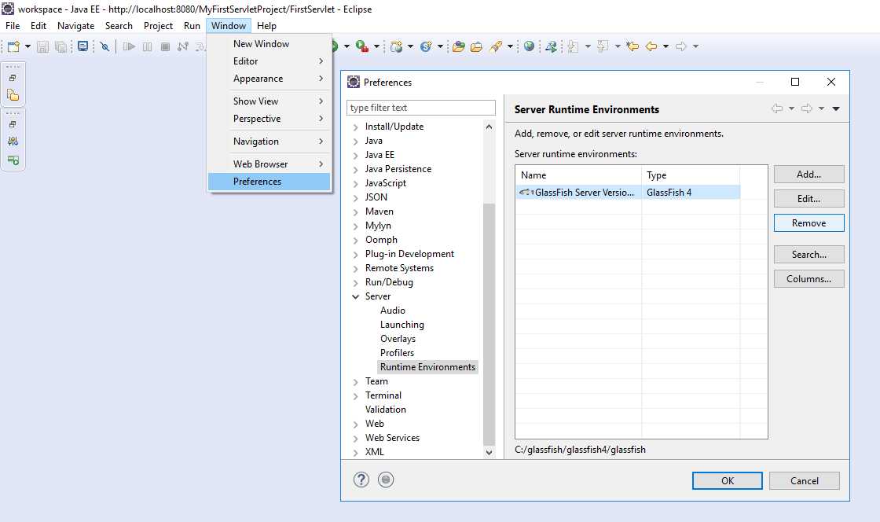  
  Then close eclipse and proceed with the next step.
* Open an Explorer window and navigate to you Glassfish installation folder. Then navigate to /domains/ and delete every file and folder in there.
* Now you can open up eclipse again and navigate to Window > Preferences > Server > Runtime Environments like before. There you click on Add…  
  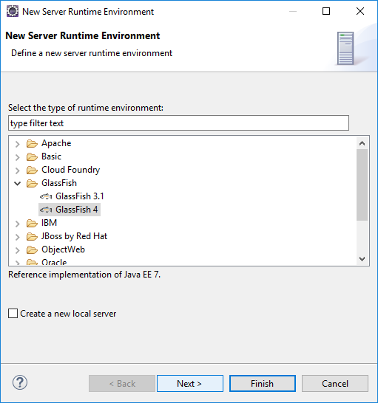   
  Leave the “Create a new local server”-Checkbox unticked! Then click on Next.
* Enter a Name for the server (doesn’t matter) and the path to the glassfish installation in the appropriate box. Then click on finish
* Navigate to Window > Show View and Select “Servers” then click on the blue, underlined text.  
  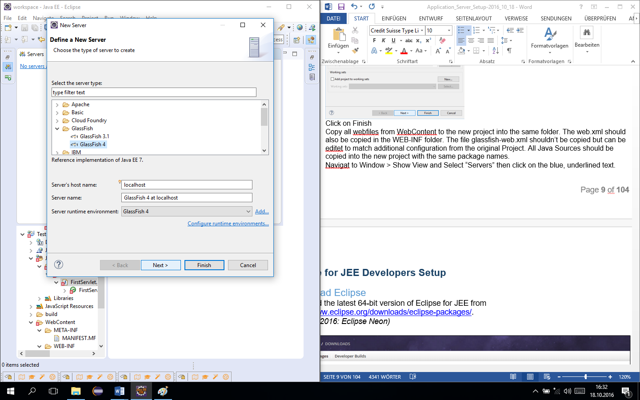  
  Then click on Next.
* Behind the “Domain path” textfield click on the three stars and enter a domainname  
  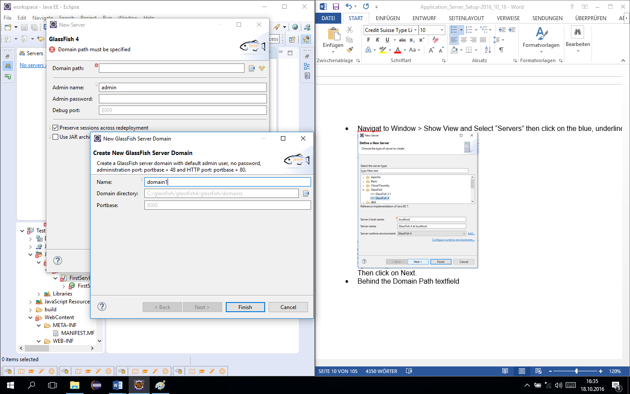  
  Then click on finish and in the other window also on Finish
* Now we have to create a new Eclipse project and copy all files and folders from the old project to the new one. This includes all java source files, webfiles like .html .xhtml .jsf.jsp. This is accomplished by following the next steps.
* Navigate to File > New > Dynamic Web Project. Target Runtime should be the Glassifsh runtime created before.  
  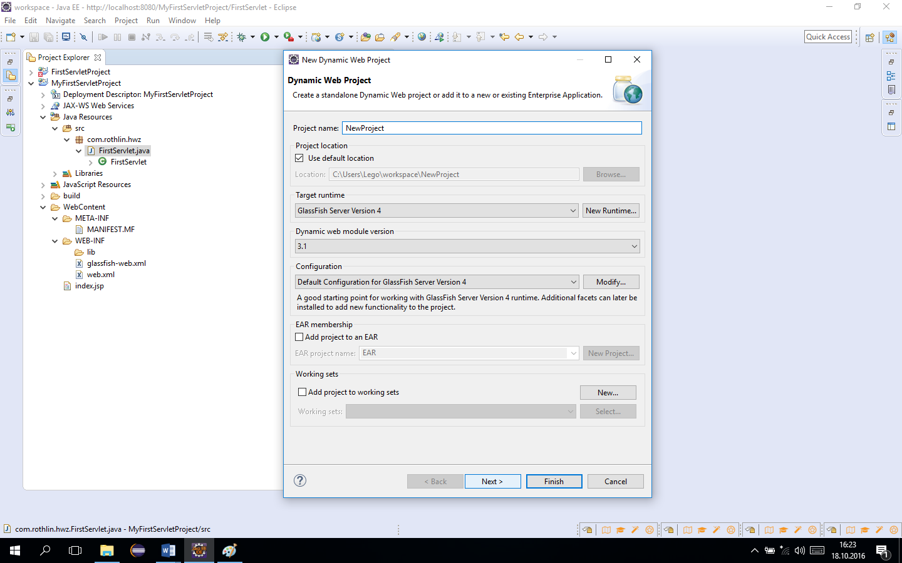  
  Click on Finish
* Copy all webfiles from WebContent to the new project into the same folder. The web.xml should also be copied in the WEB-INF folder. The file glassfish-web.xml shouldn’t be copied but can be editet to match additional configuration from the original Project. All Java Sources should be copied into the new project with the same package names.
* In you newly created project you shouldn’t see any errors related to not finding Servlet classes. This means everything is properly set up and you can launch your application.

# MySql

## Visual C++ 2013 Runtime: Preparation for MySql Installation

In order to use the MySQL Workbench which will be installed in the next step, the Microsoft Visual C++ 2013 Runtime is required. Select the English 32 bit (x86) file and download it by clicking next. After the download execute it.

Download it from <https://www.microsoft.com/en-US/download/details.aspx?id=48145>.

Double-click on the downloaded package and get it installed.

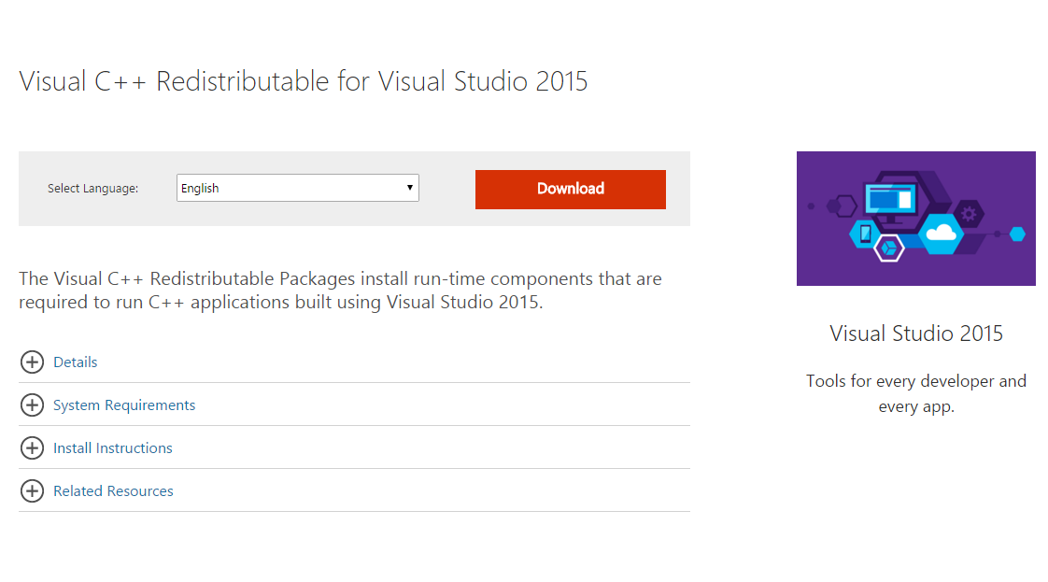

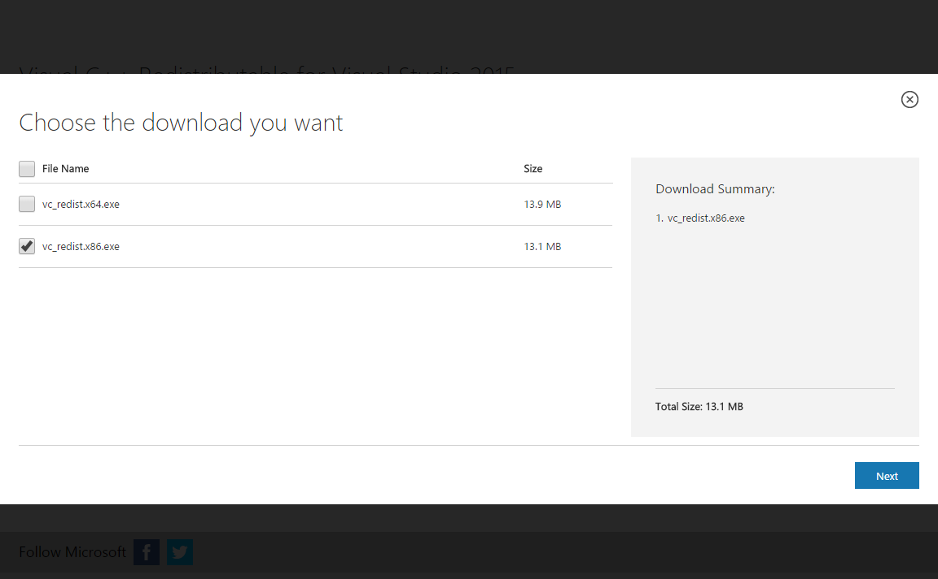

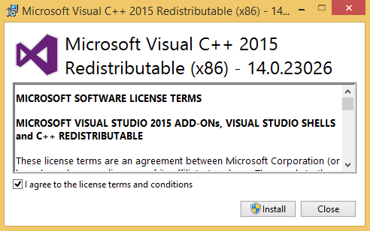

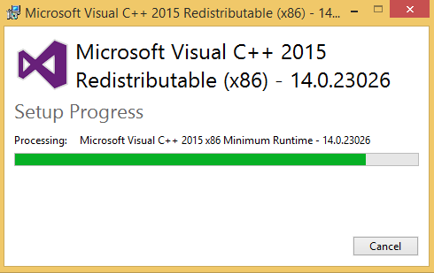

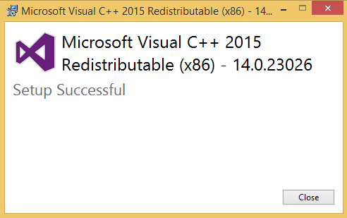

## Tutorials

<http://www.youtube.com/watch?v=Rnq8DS05PwQ>

<http://www.youtube.com/watch?v=4oChG9--iMM>

## Download MySql

<https://downloads.mysql.com/archives/installer/>

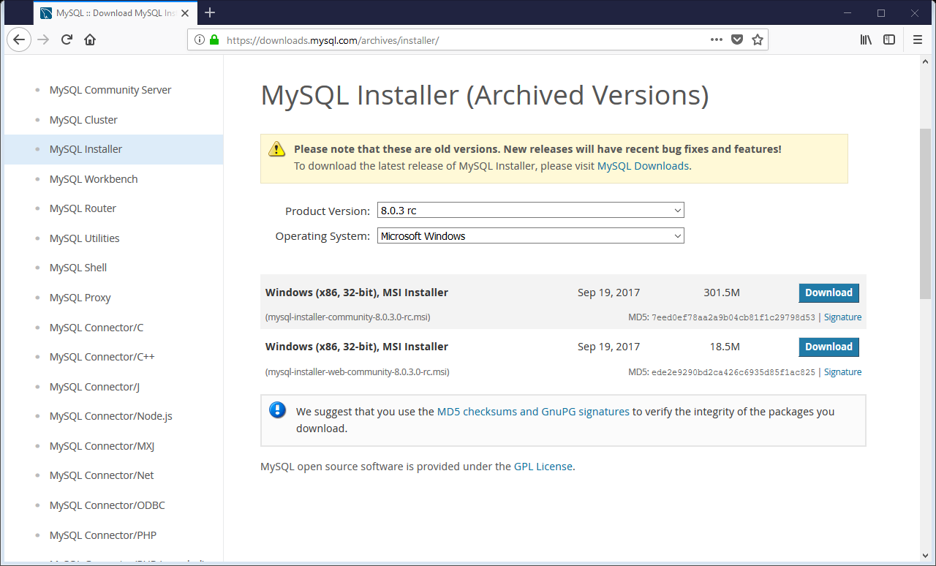

<https://downloads.mysql.com/archives/get/file/mysql-installer-community-5.7.10.0.msi>

*(January 2016: version 5.7.10.0 )*

Order a login from Oracle and get started!

Oracle: [walter@rothlin.com](mailto:walter@rothlin.com) (8ZUqdn007)

## Install MySql

When it is downloaded, go to Downloads and click on mysql-installer-community-5.7.21.0.msi to start the installation.

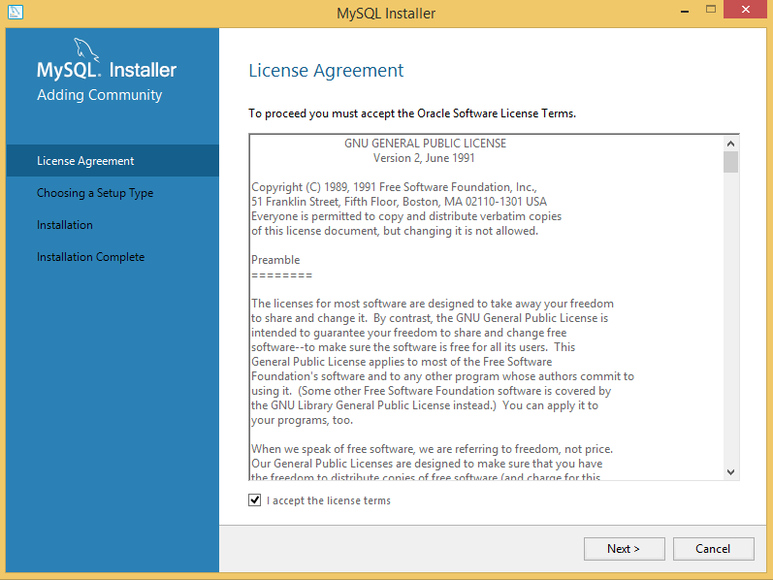

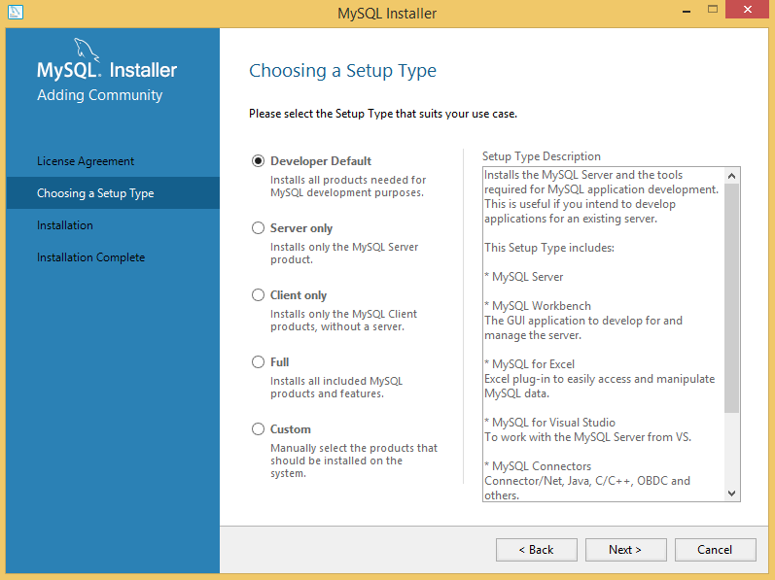

Fix if “Developer Default” doesn’t work:

Choose “Custom” and select the components manually. The specific components are in the second picture below.

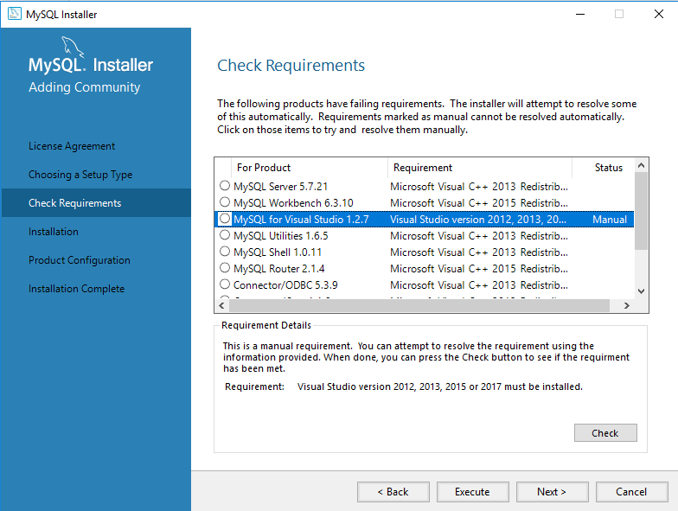

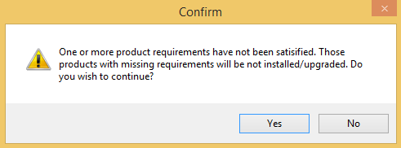

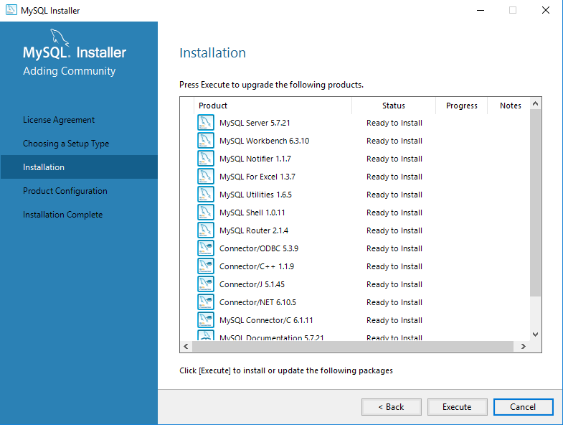

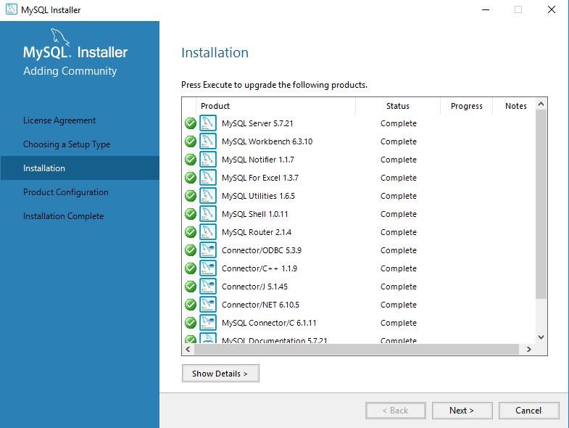

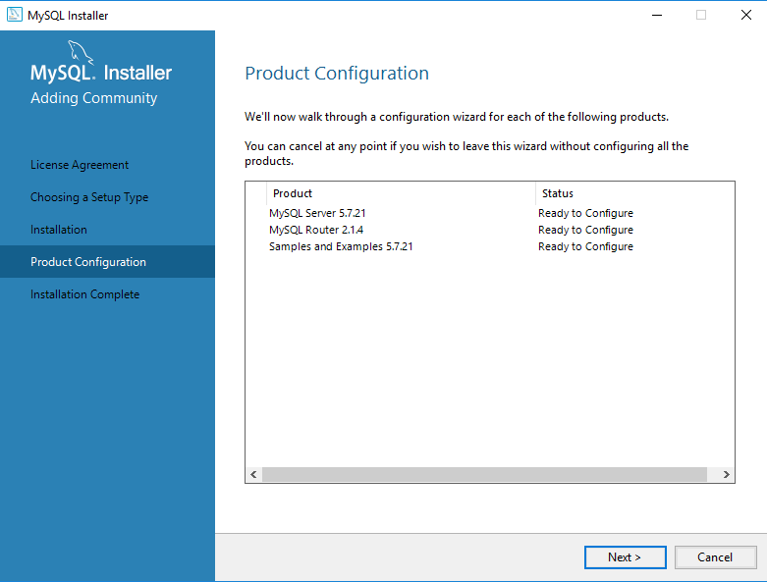

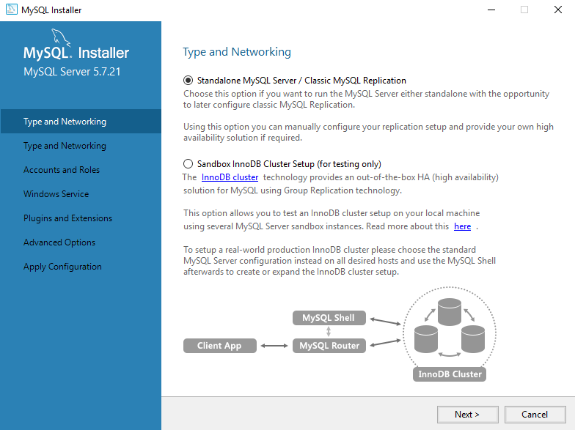

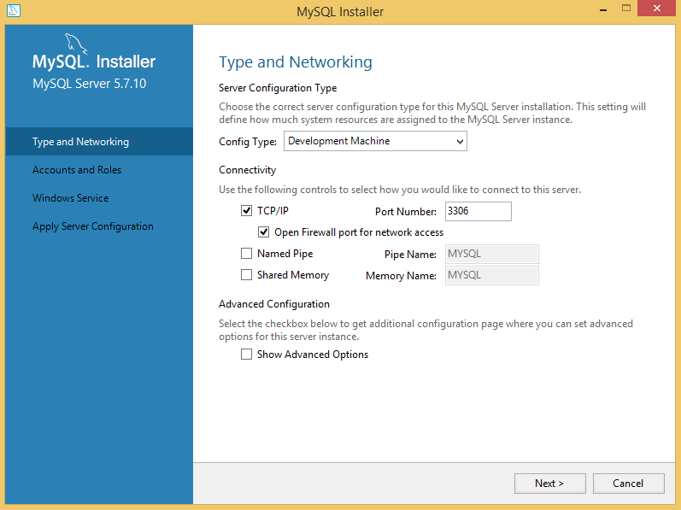

MySQL Root Password: admin

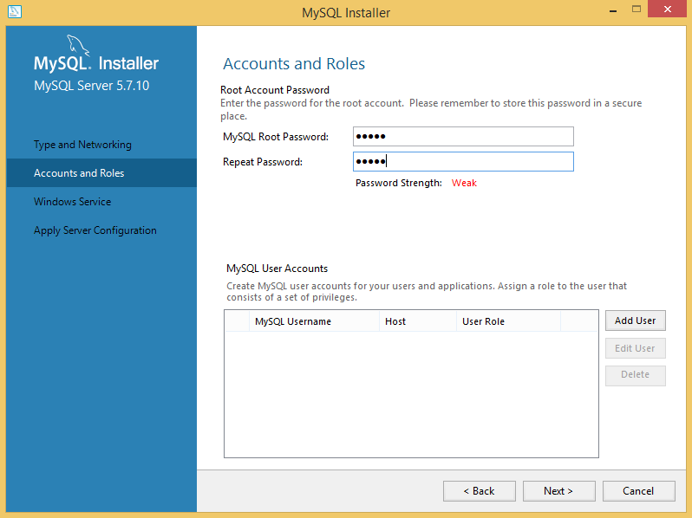

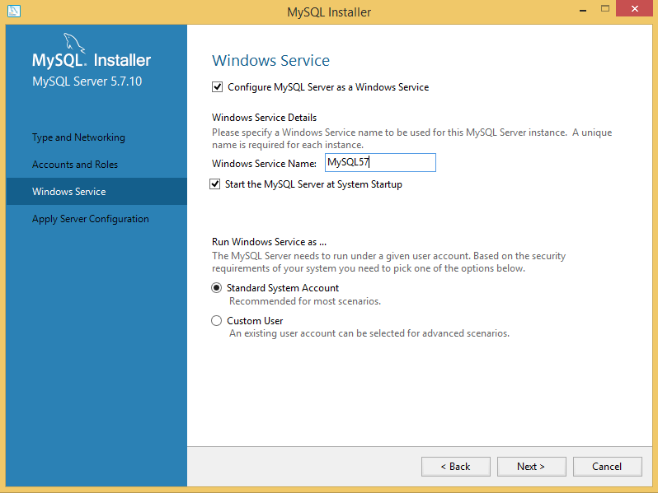

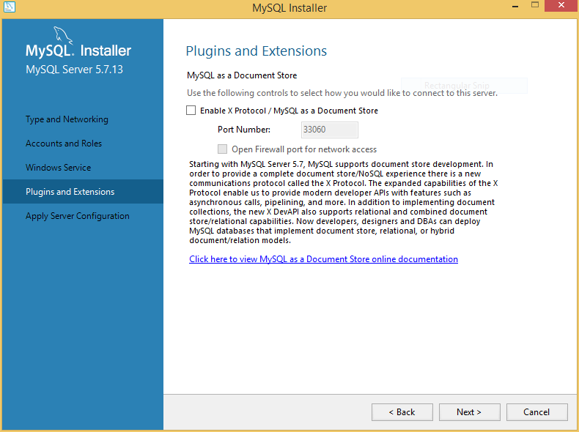

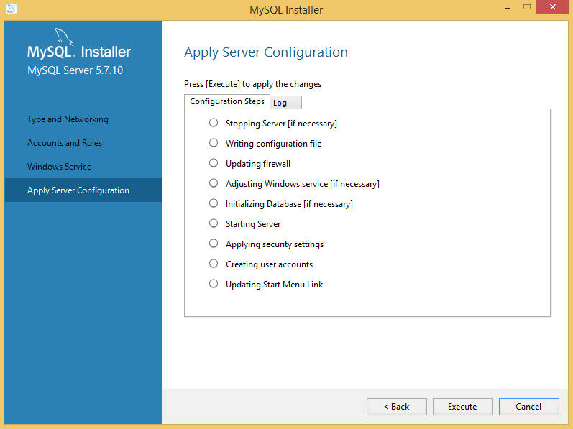

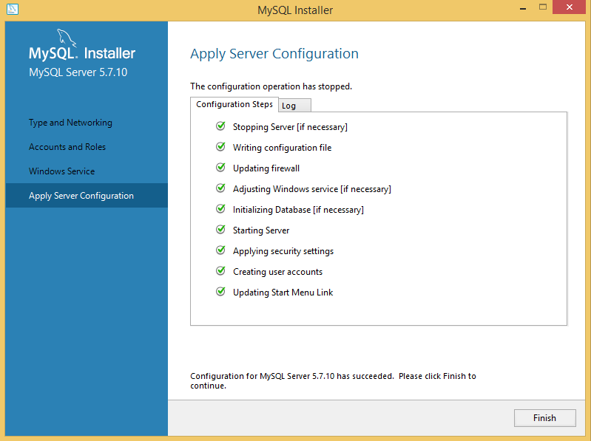

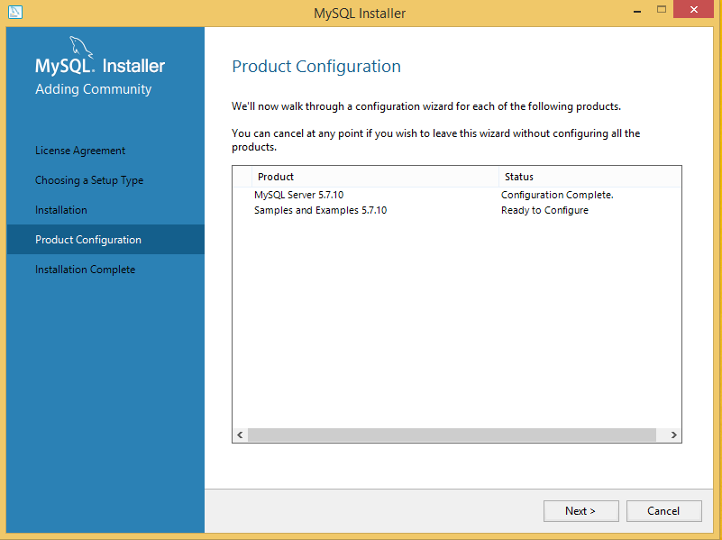

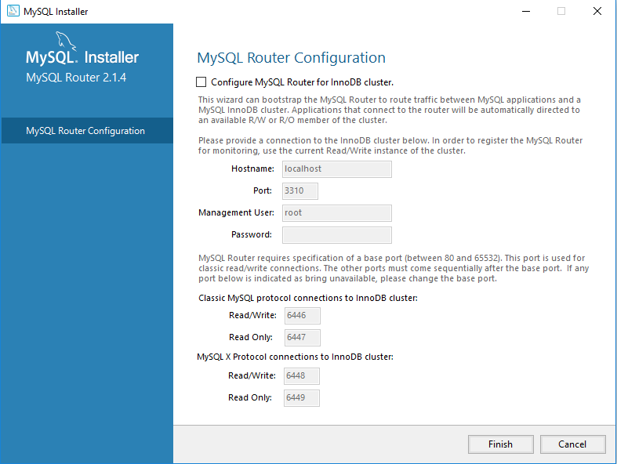

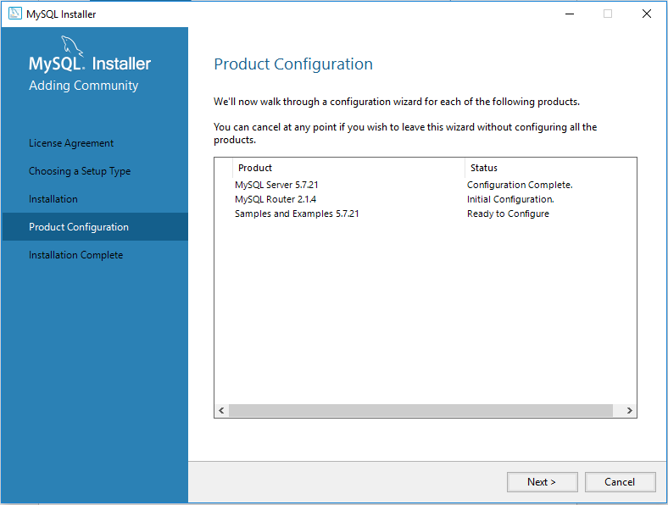

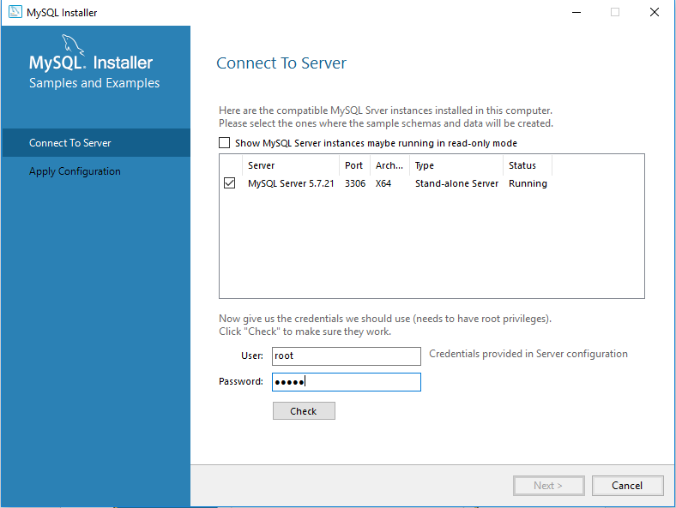

Type admin here

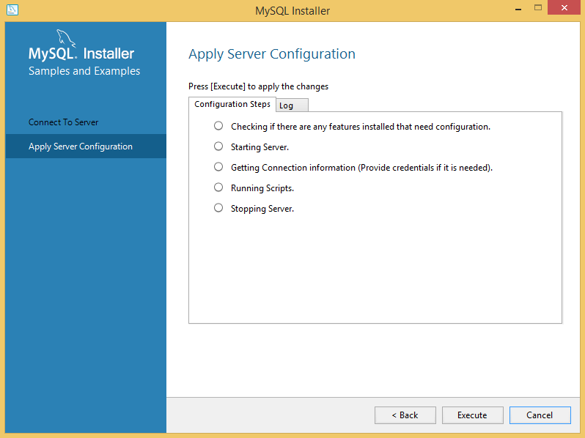

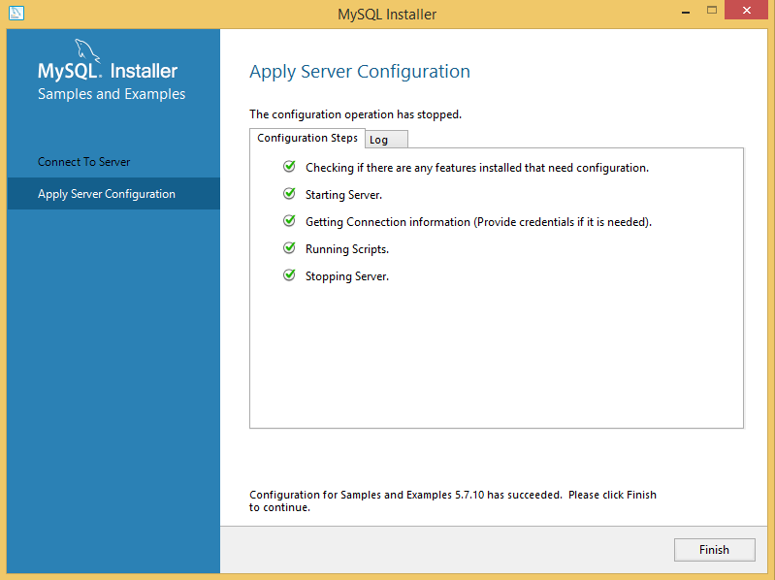

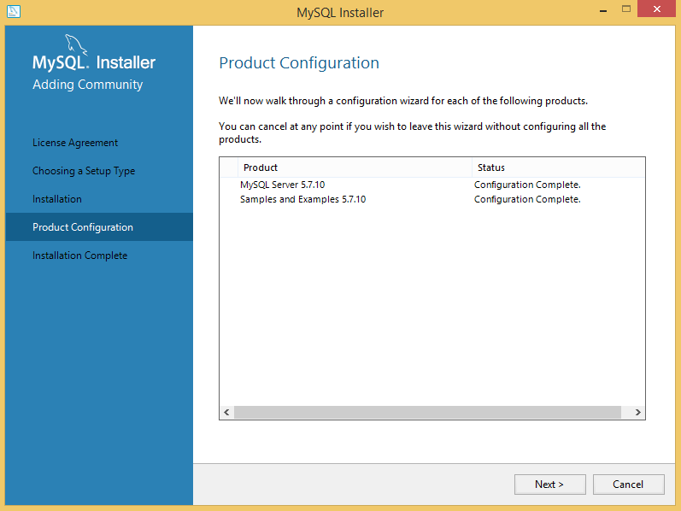

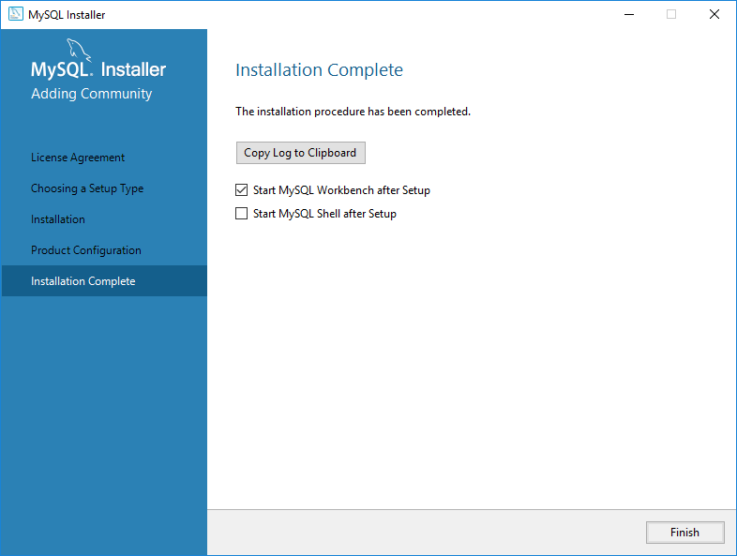

## Create local User in MySQL Workbench

Start -> MySQL Workbench

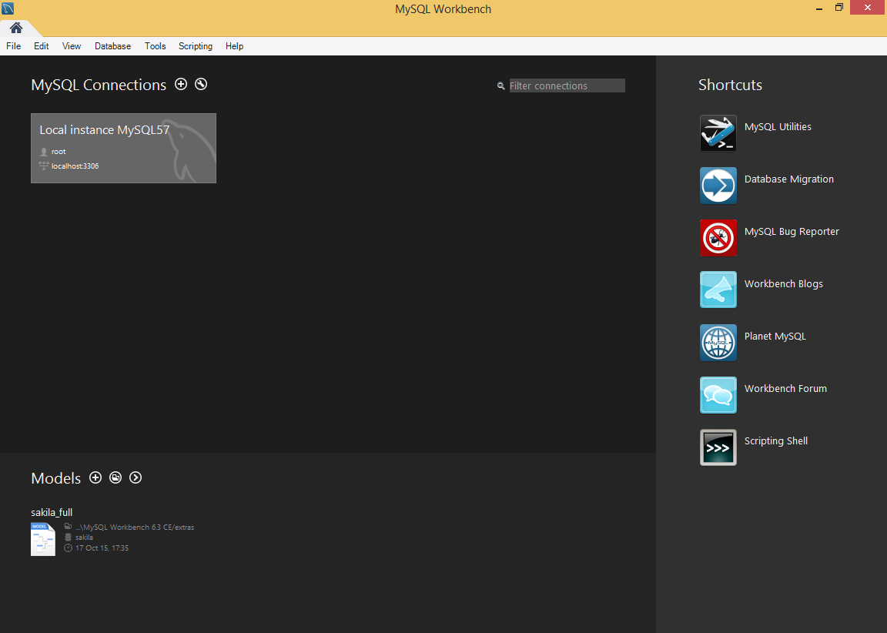

MySQL Root Password: admin

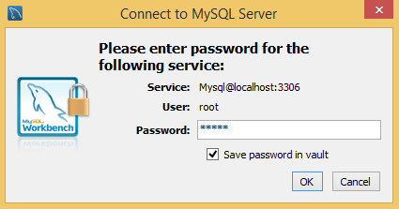

Go to User and Privileges, select root and choose Schema Privileges.

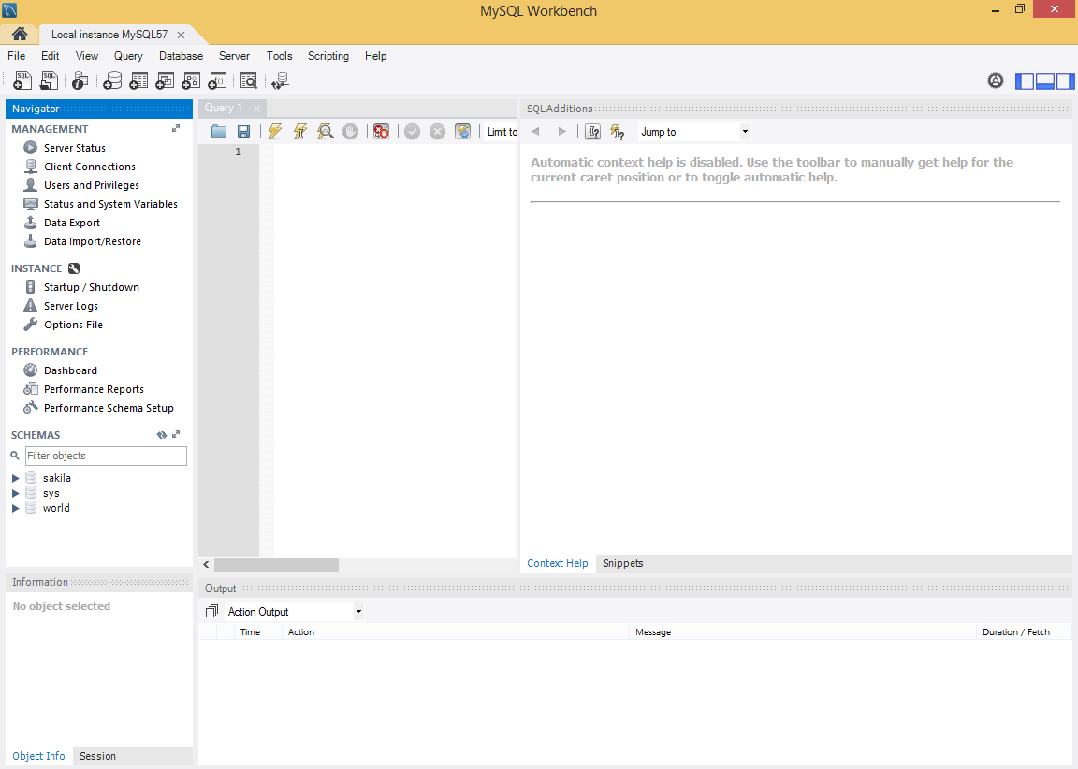

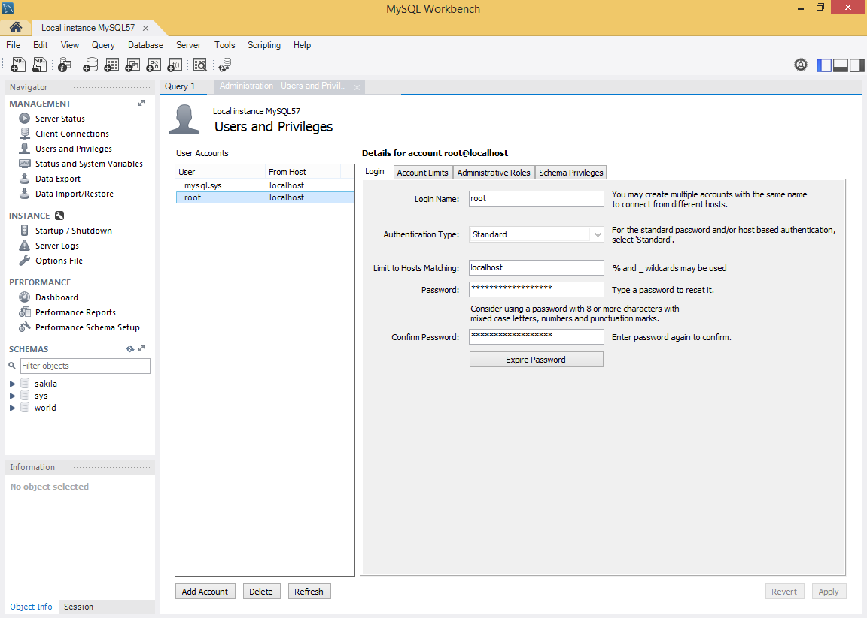

Click on Add Entry button and select All Schema (%).

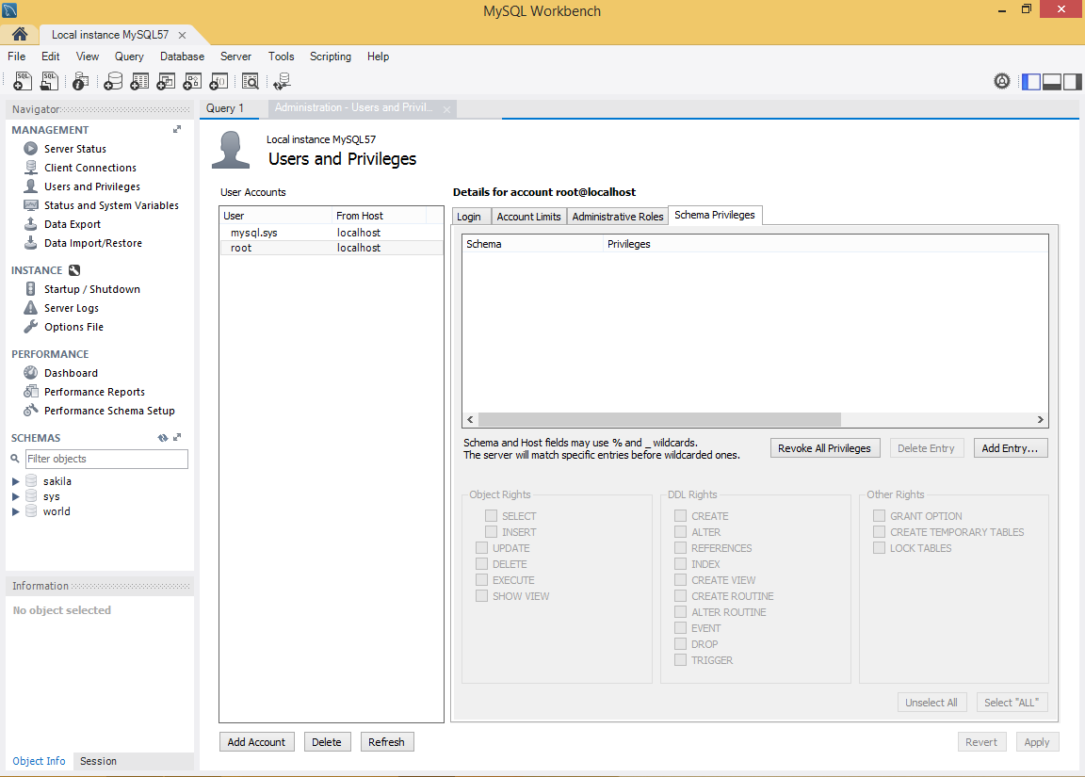

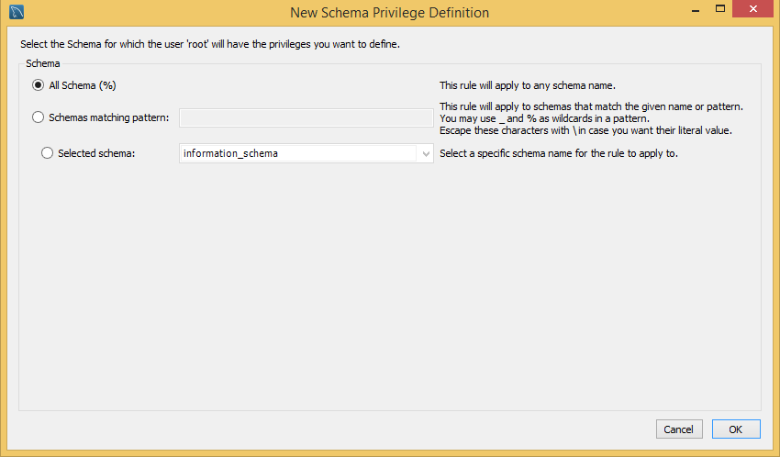

When you have set the Schema Privilege Definition please click on the following page on Select “All” button and apply it.

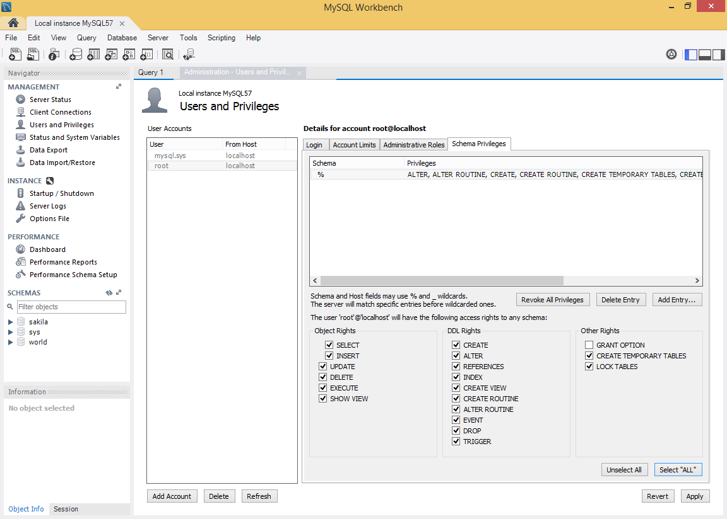

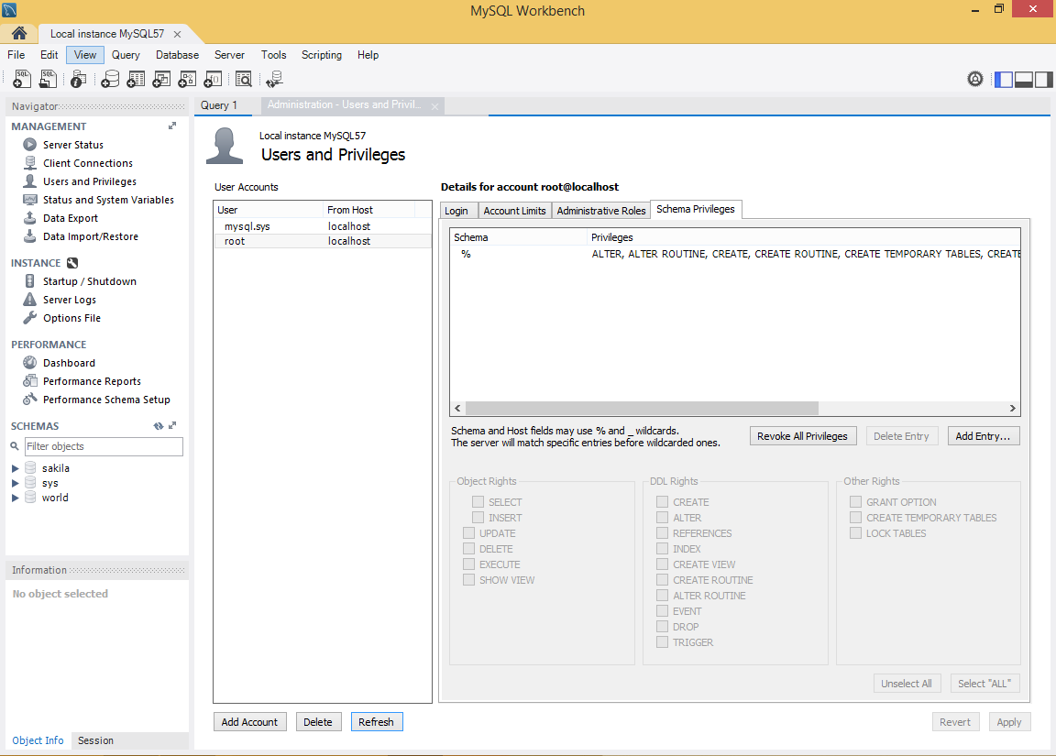

## Test MySQL

Start -> MySql Command Line Client

MySQL Root Password: admin

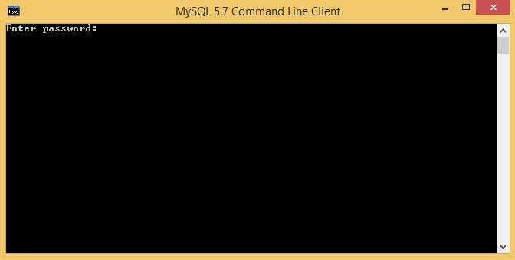

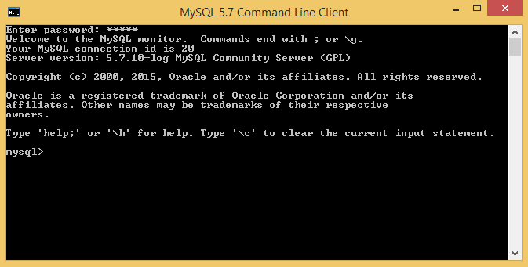

List all defined DBs: show databases;

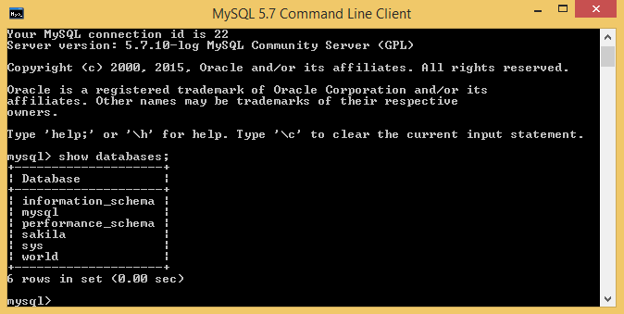

use sakila;

select * from actor;

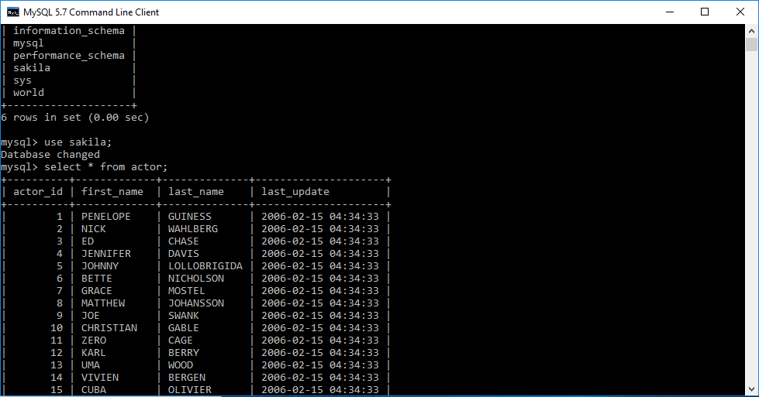

## Give a Remote Computer access to MySQL

To give authorization to another computer to access any DB, please start MySql Workbench. Go to “Users and Privileges”. Click on the “Add Account” Button and fill in the requested data, which is needed to get an access. Leave the password blank.



Login Name: admin

Password: admin

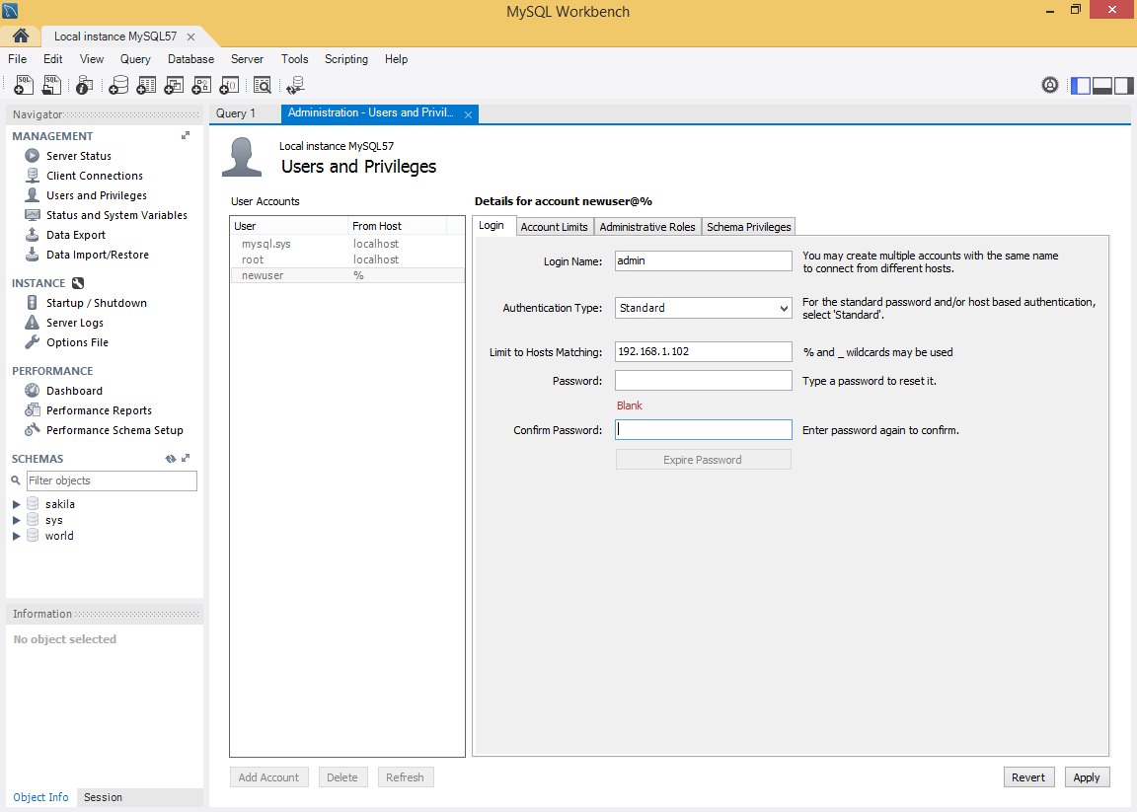

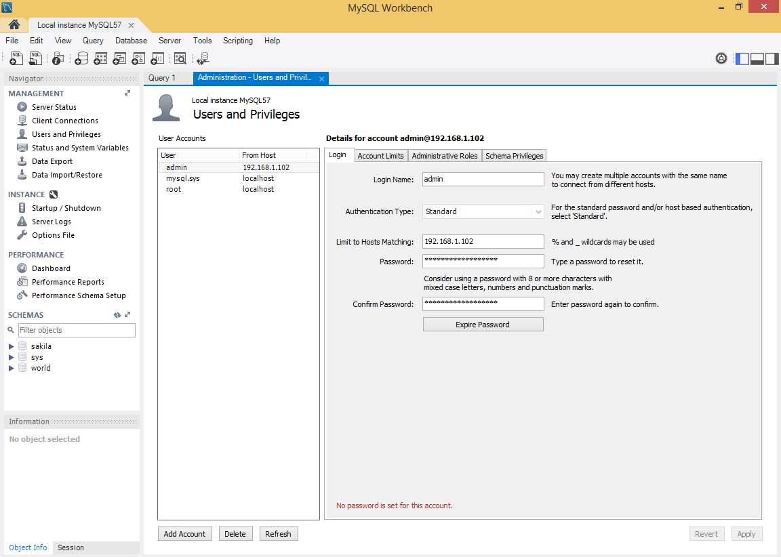

After you have created an account go to “Administrative Roles” and give the account the needed rights.

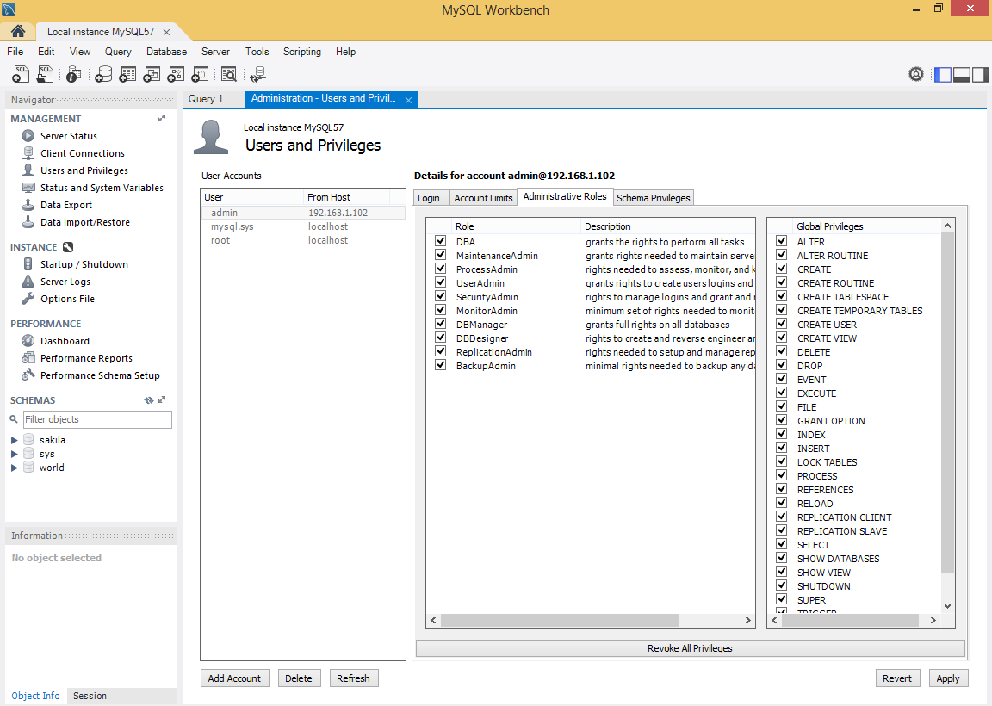

This is the ERD of Sakila, which is one of the default databases from the MySQL Workbench.

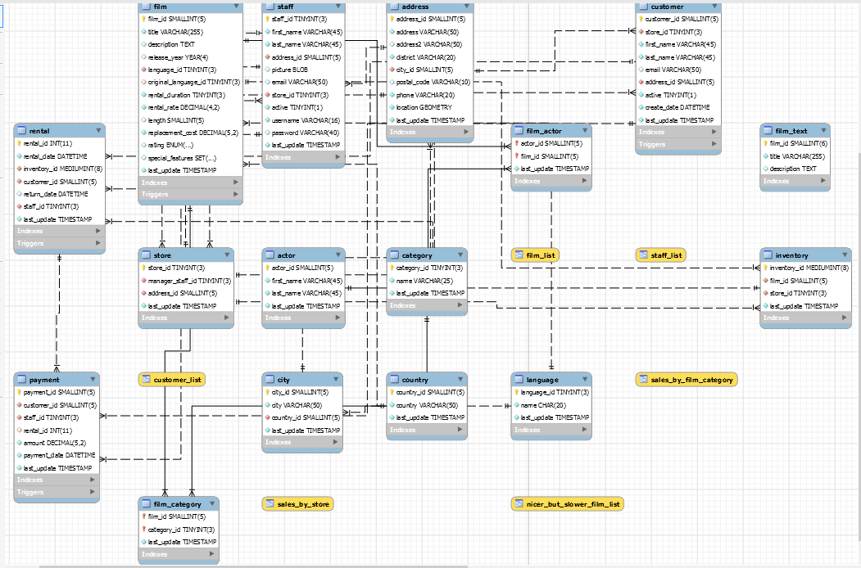

## Download MySQL JDBC driver

<https://dev.mysql.com/downloads/connector/j/>

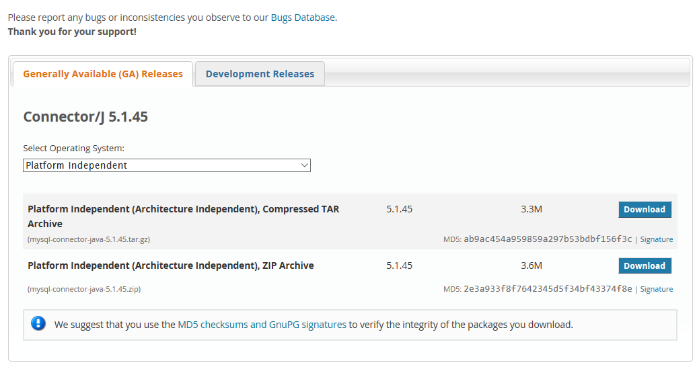

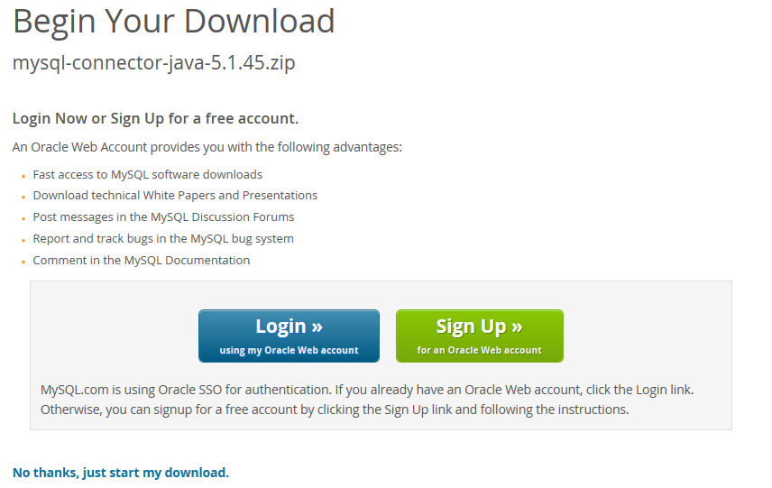

Download the zip file and extract it. Then move the connector (mysql-connector-java-5.1.xxx-bin) to

C:\glassfish\glassfish4\glassfish\lib Otherwise it won’t work.

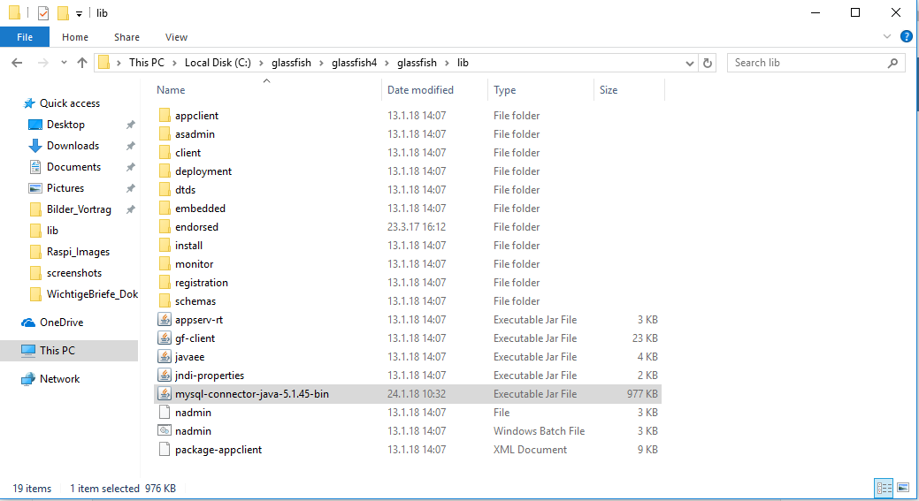

## Create a new MySQL Connection

Go to Database -> New Connection

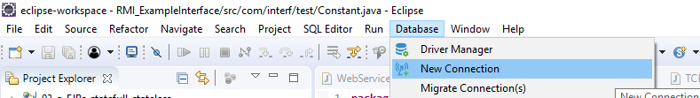

Choose MySQL from the List and press Next

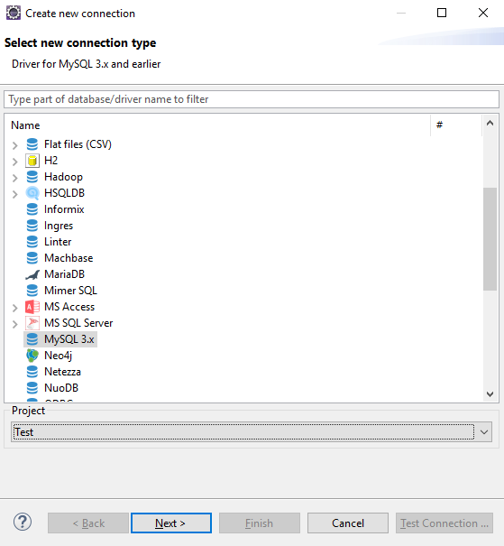

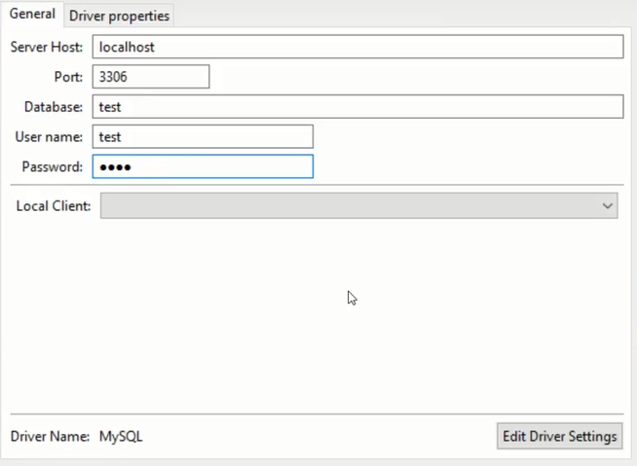

Leave it like it is

root

admin

sakila

Afterwards press Test Connection and Next

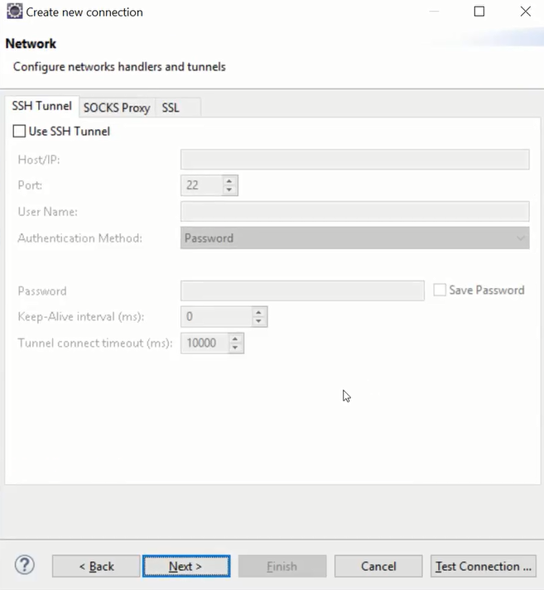

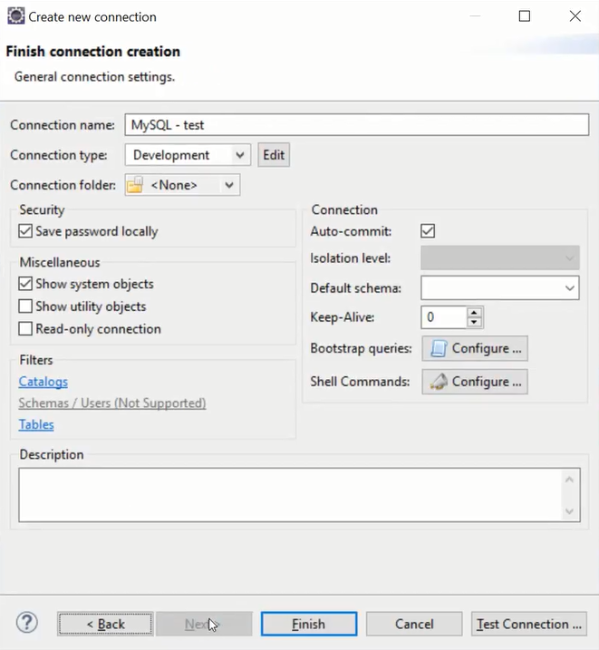

## Create DB-Connection with DBeaver

Add new Database Development Interface

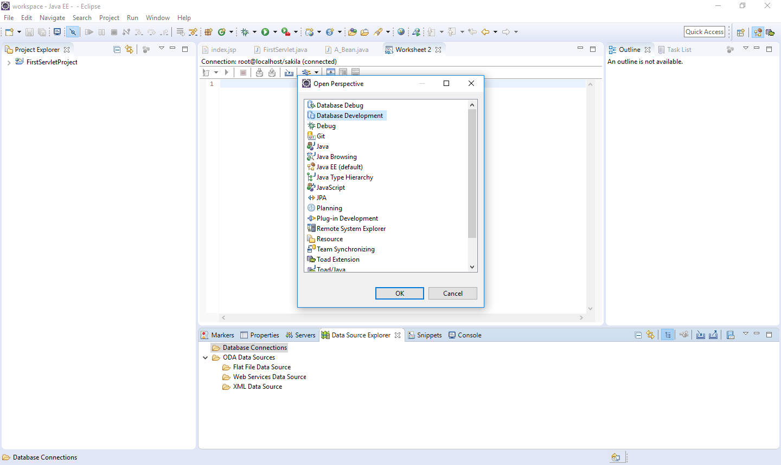

If you can’t find the Database Development perspective, go to Help -> Install New Software

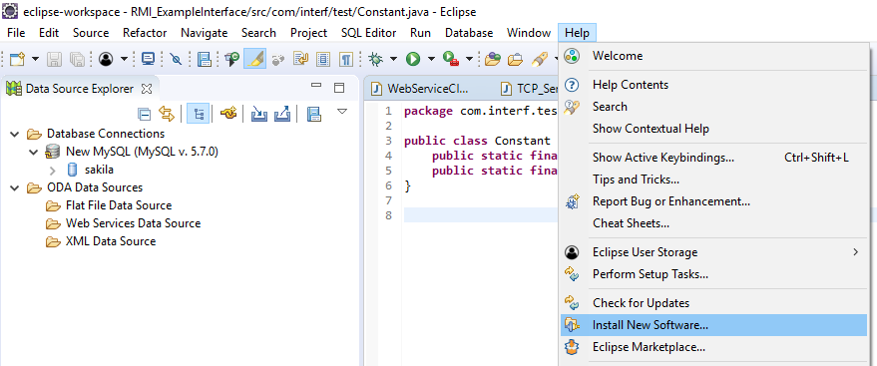

Then choose: “—All Available Sites--” and start the search

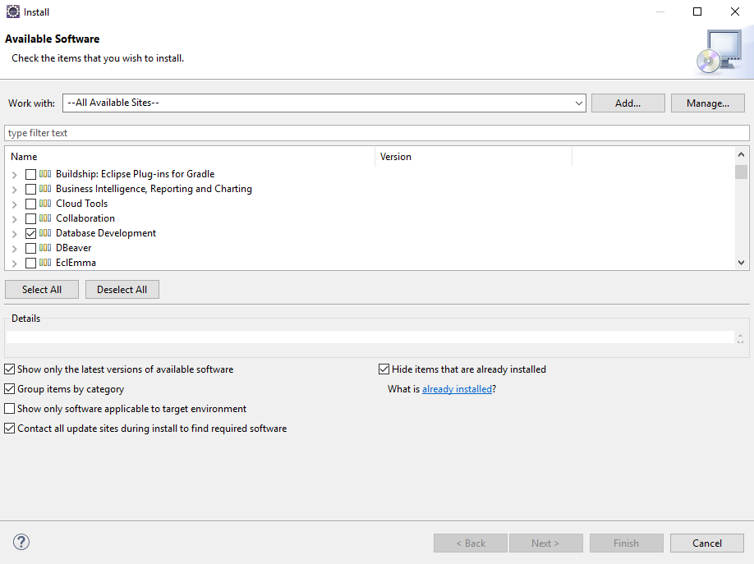

Select Database Development and press Finish

Right Mouse-Click on Database Connections 🡪 new….

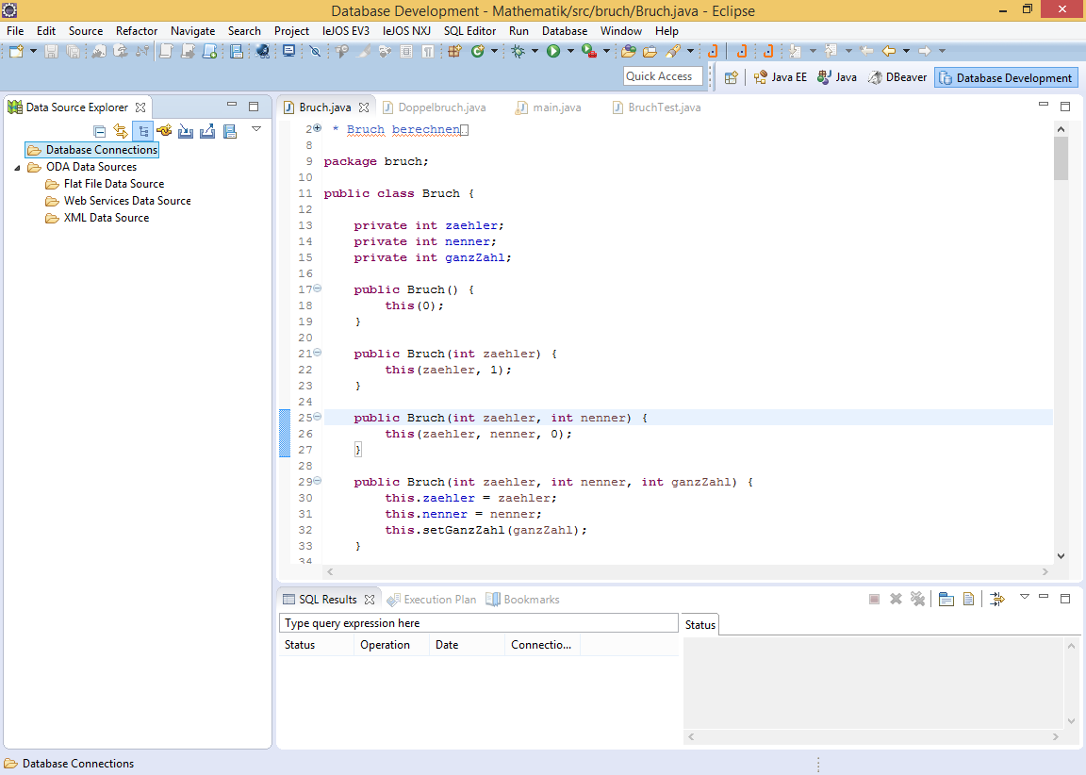

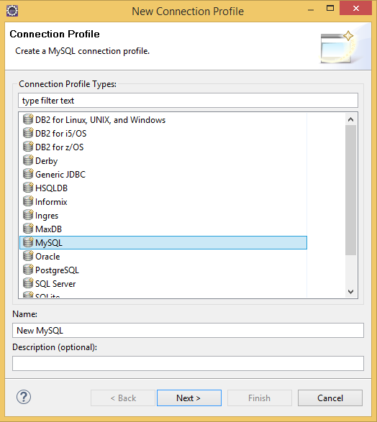 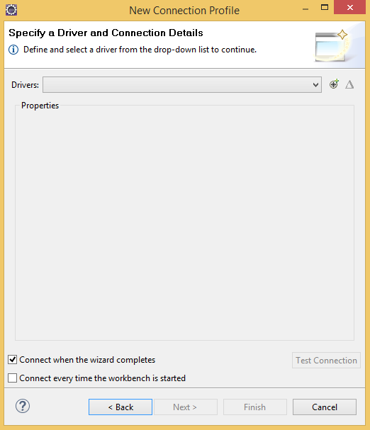

Select the MySQL JDBC Driver with the matching System Version (January 2015: 5.1) and select the «Jar List»-Tab. Remove the current Jar in the list and click on “Add JAR/Zip…”.

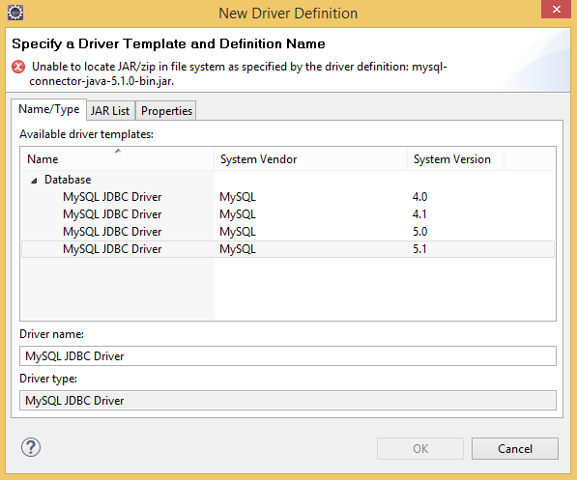

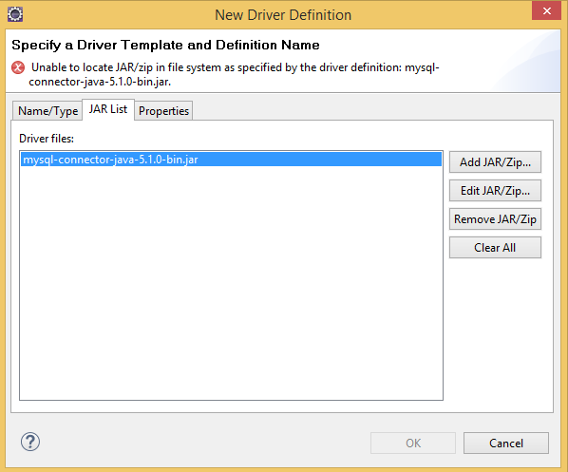

Select “Add JAR/Zip”. Then navigate to the installation directory of the glassfish-server and select the driver in the directory …/glassfish/lib/ select mysql-connector-java-5.1.0-bin and click on “Open”.

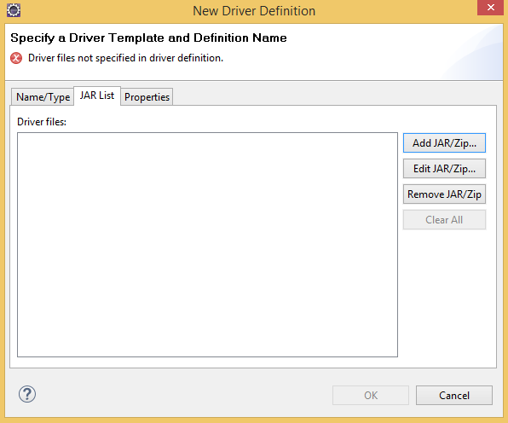

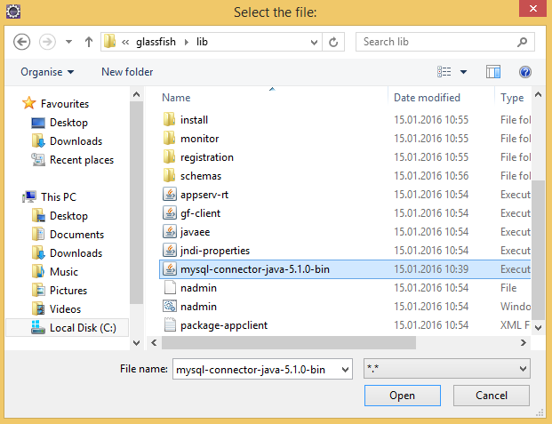

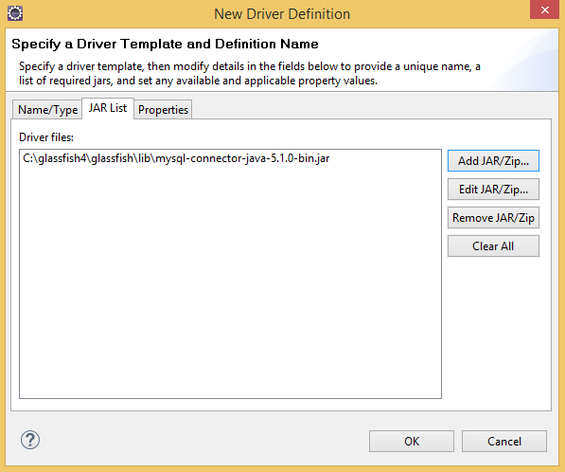

MySQL Root Password: admin

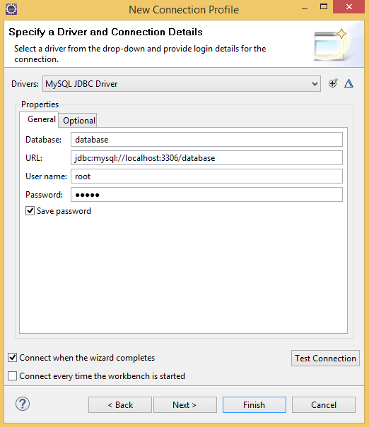

sakila

jdbc:mysql://localhost:3306/sakila

root

admin

## Basic MySql commands

Start -> MySql Command Line Client

|  |  |
| --- | --- |
| **Command** | **Description** |
| *Show databases;* | Shows you the already defined DBs. |
| *Use test;* | To use a DB. |
| *Show tables;* | Shows you all the tables from the using DB. |
| *Create table Classmates (*  *Id int PRIMARY KEY NOT NULL,*  *fname varchar (25),*  *lname varchar (25)*  *);* | It creates a table with the name *Classmates”. The table contains a primary key and to columns for the first- and lastname. |
| *CREATE UNIQUE INDEX PRIMARY ON CLASSMATES (ID);* |  |
| *INSERT INTO classmates (id, lname, fname)*  *VALUES (1, ‘David’, ‘Etter’);* |  |

## Setup a DB Connection via JNDI on the Application Server

Start the Glassfish Admin-Console and go to **Resources** -> **JDBC** -> **JDBC** **ConnectionPool** -> **New…**

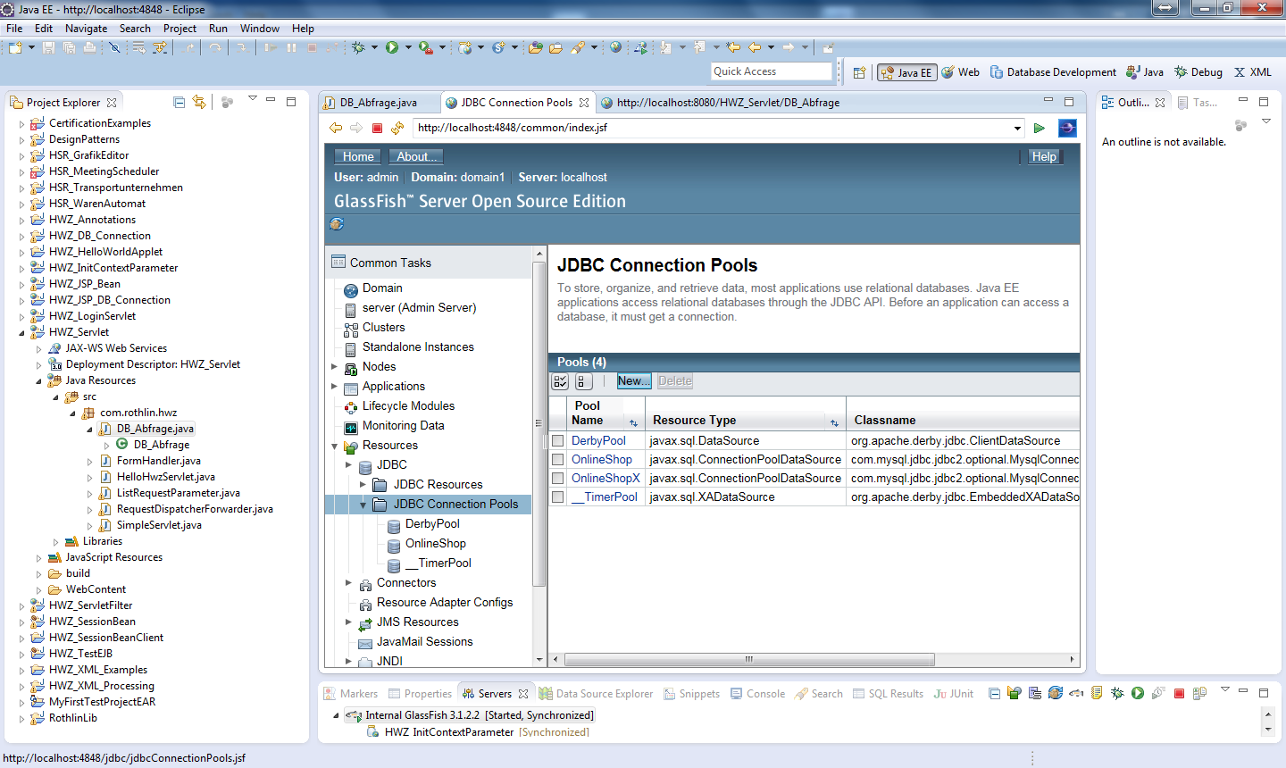

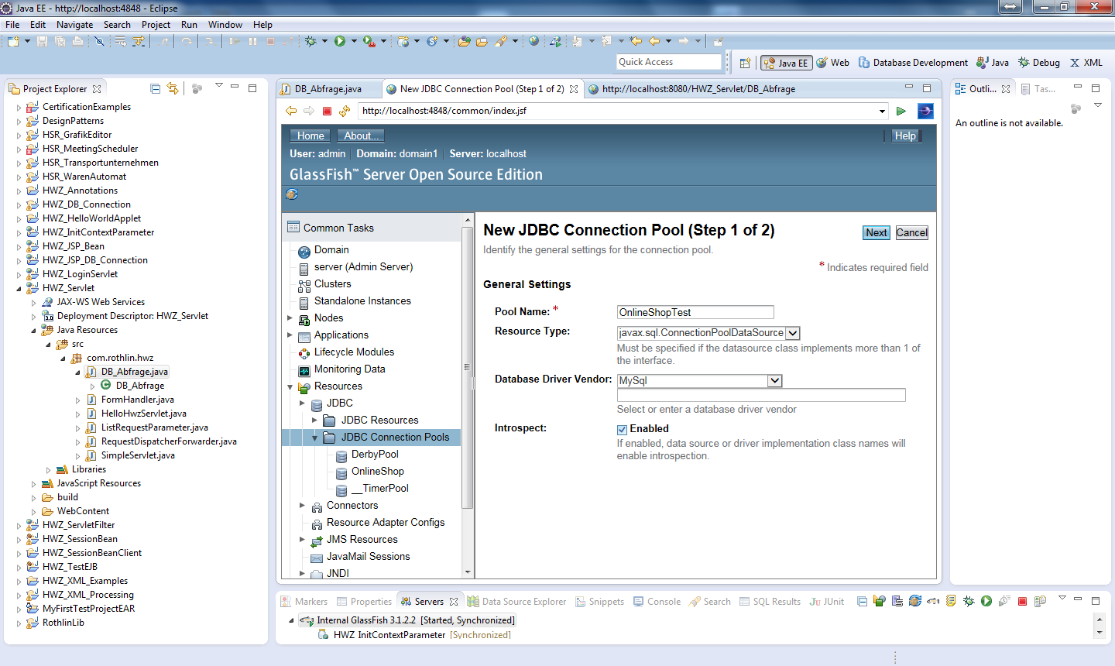

Sakila

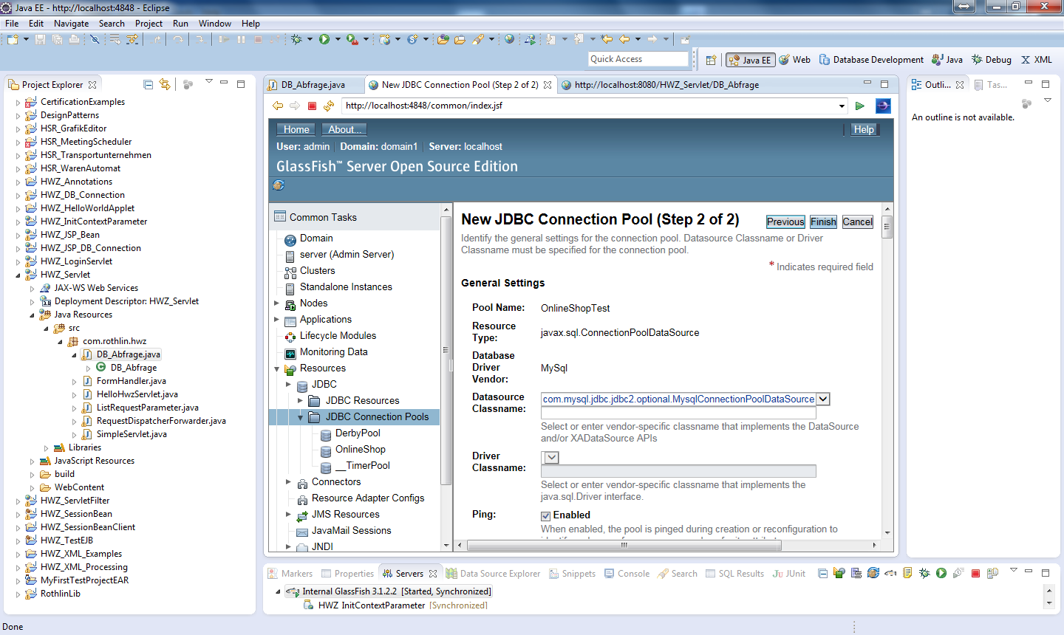

Sakila

Datasource Classname: com.mysql.jdbc.jdbc2.optional.MysqlConnectionPoolDataSource

Scroll to the end of the page and set these propertes:  
User 🡪 root  
Password 🡪 admin  
DatabaseName 🡪 sakila  
Url 🡪 jdbc:mysql://localhost:3306/sakila  
URL 🡪 jdbc:mysql://localhost:3306/sakila

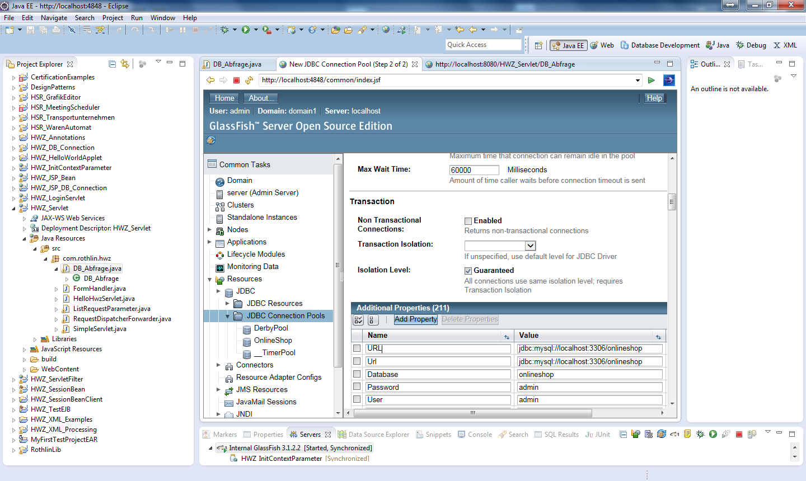

URL jdbc:mysql://localhost:3306/sakila

Url jdbc:mysql://localhost:3306/sakila

DatabaseName sakila

User root

Password admin

Simply press Finish at the end of the page.

(Die Werte der Properties können in der DB Perspective gefunden werden)

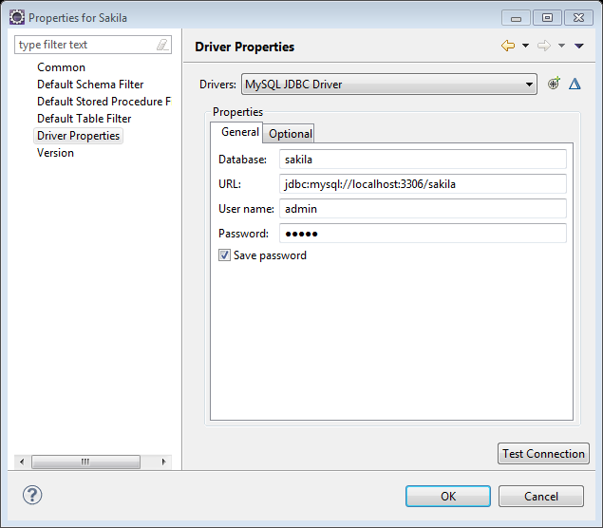

Define a new JNDI, that references our DB Connection:

JDBC Resources 🡪 New….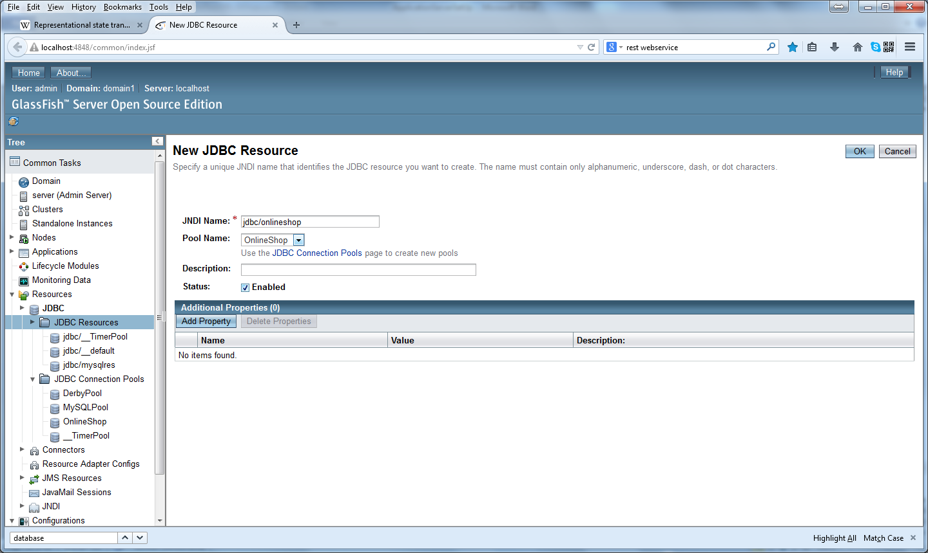

Sakila

jdbc/sakila

Simply press OK when you are done

# Javadoc

## Generating Javadoc

Click on *Project 🡪 Generate Javadoc…*

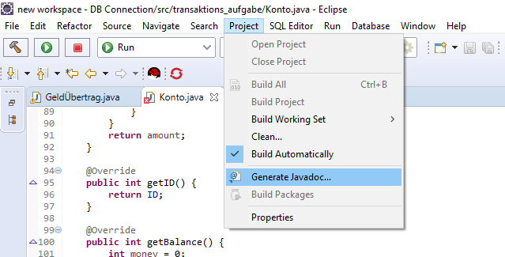

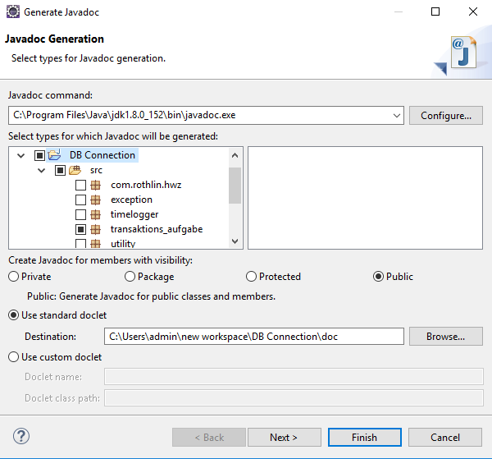

On the Javadoc command field, type: *C:\Program Files\Java\jdk1.8.0_152\bin\javadoc.exe*

Choose the project and the package where you’d like to generate the Javadoc.

Be sure to set the visibility to **Public.**

Click *Finish* when you are done.

# Junit

## Create Junit Test

open project -> right click on class -> New -> JUnit Test Case

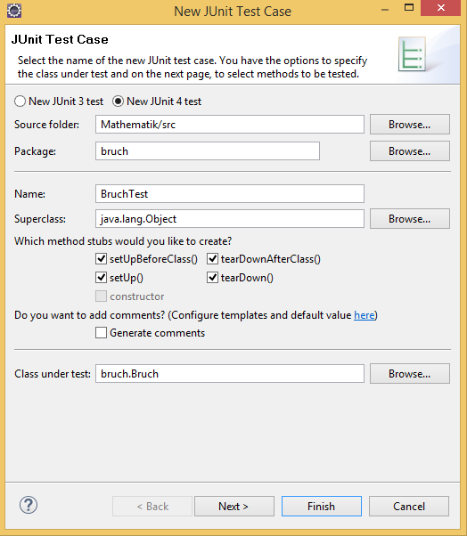 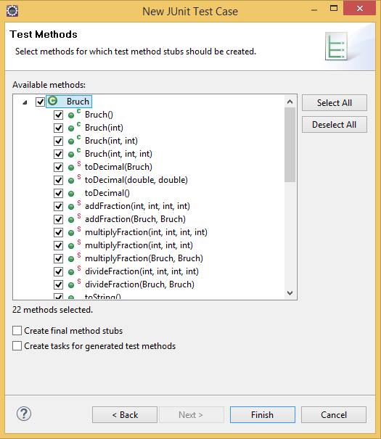

When JUnit 4 is not on the build path follow these steps:

click on project -> press Alt + Enter -> Java Build Path -> Libraries -> Add External JARs -> JUnit 4

Implementing Tests and run it as JUnit Test

## Coverage - Install EclEmma Plugin

Help -> Marketplace -> EclEmma

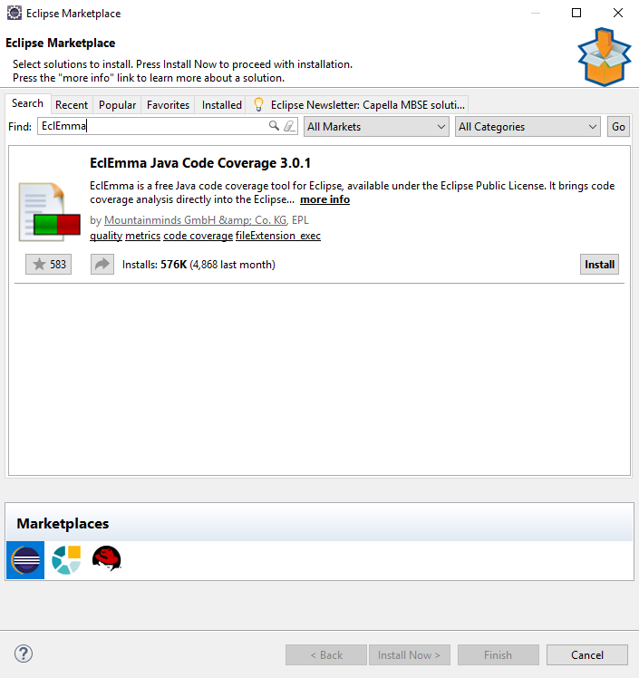 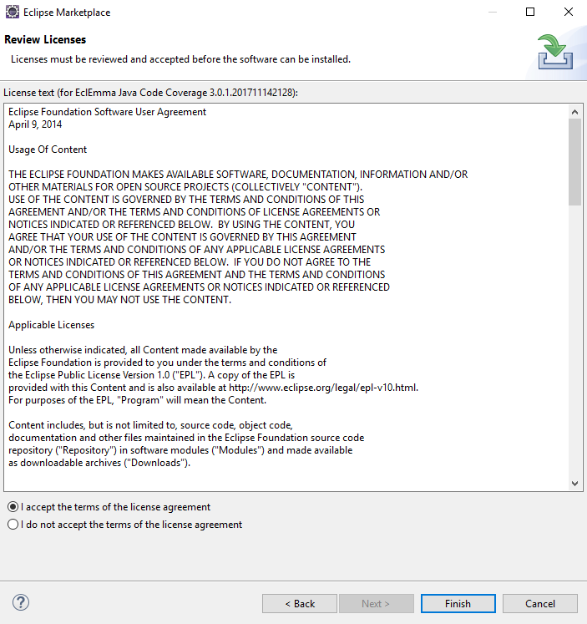

## Coverage - Run Test with coverage report

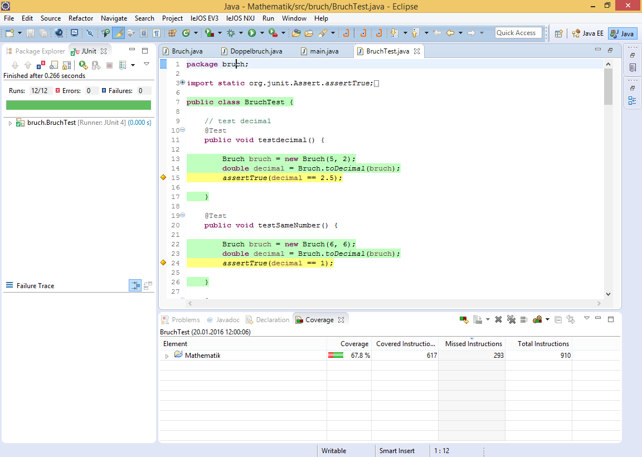

# Common Help

## Finden der aktuelle IP eines Computers

start -> cmd -> ipconfig

(Example: The Computer is connected via WiFi)

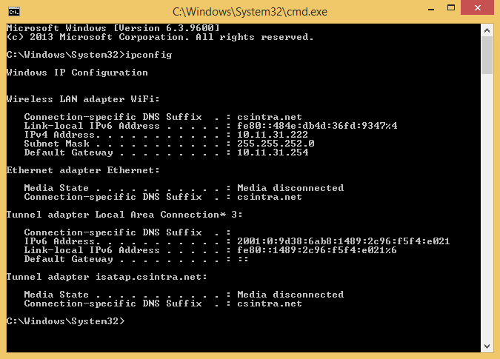

## Helpful Links for EJB / Web-Service

|  |  |
| --- | --- |
| <http://www.youtube.com/watch?v=9Kf5m7bMu74> | Part 1 – Installation |
| <http://www.youtube.com/watch?v=ppGqtOeHm-g> | Part 2 – Servlet calling EJB, JSP, timer-EJB |
| <http://www.youtube.com/watch?v=CuLYhkqt0V0> | Part 3 – JPA |
| <http://www.http://www.youtube.com/watch?v=1epUpQlKwME> | Part 4 Facelets / JSF 2 |
| <http://www.youtube.com/watch?v=on557289GzA> | Part 5 |
| <http://www.youtube.com/watch?v=aBjlR9HoR50> | Langes vollständiges Beispiel von JSP, Servlet, DB-Connection, JPA, EJB, Web-Services |

|  |  |
| --- | --- |
| * SOAP (JAX-WS) |  |
| <https://www.youtube.com/watch?v=mKjvKPlb1rA> |  |
| <https://www.youtube.com/watch?v=C53G6R5EVys> |  |
| <https://www.youtube.com/watch?v=6hqDMS-oJ9k> | (Creating stub for a public WSDL) |
| <https://www.youtube.com/watch?v=KFlDdb65w3U> | (Call the stub) |
| <https://www.youtube.com/watch?v=Zx6NuO6niFI> | (Set up J2EE) |
| <https://www.youtube.com/watch?v=S0zdMGNrxr0> | (Theorie Service first vs contract first) |

|  |  |
| --- | --- |
| * REST (JAX-RS) |  |
| <https://www.youtube.com/watch?v=gKBiIWY7FYw&list=PLu47tUtKqNlwfR-nqjiWUaIWOYEi9FyW0> |  |
| <https://www.youtube.com/watch?annotation_id=annotation_401609&feature=iv&src_vid=gKBiIWY7FYw&v=4DY46f-LZ0M> |  |
| <https://www.youtube.com/watch?v=xkKcdK1u95s> | REST Web Services 01 – Introduction: |

|  |  |
| --- | --- |
| * Web-Service |  |
| <https://www.youtube.com/watch?v=9kb0iLpqKY4> |  |
| <https://www.youtube.com/watch?v=u5cQkVgq6jE> |  |
| <https://www.youtube.com/watch?v=HLzM92ZnisY> |  |
| <https://www.youtube.com/watch?v=dbxASThtC_g> | Web-Service lecture |

# Tips and Tricks for Eclipse

## Obsolete: Download and Install MySQL Eclipse Plugin – Toad extension

This part of the guide is obsolete, since Toad Extension for Eclipse is no longer available.

Eclipse -> Help -> Eclipse Marketplace -> Toad Extension

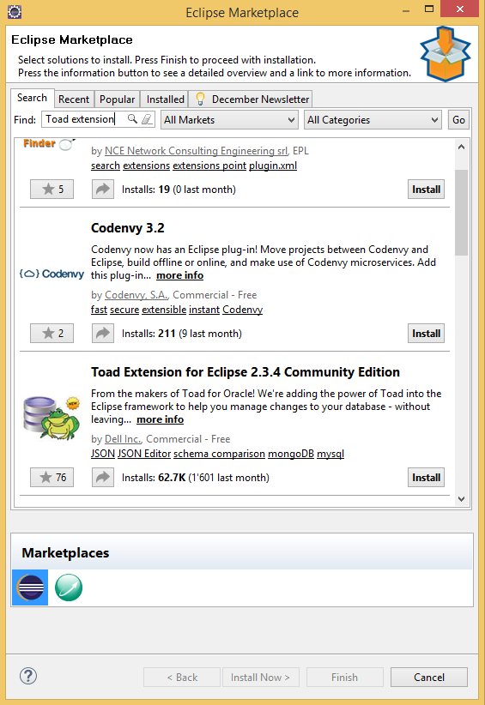 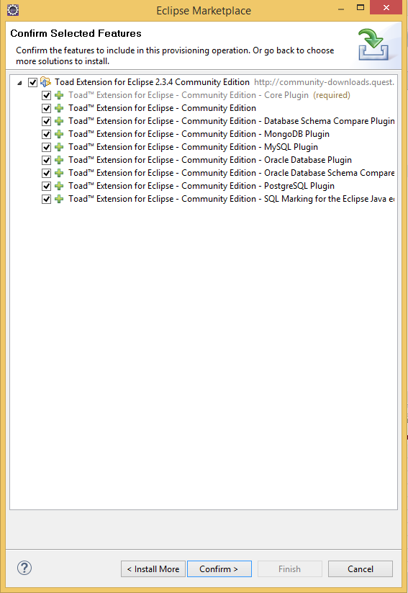

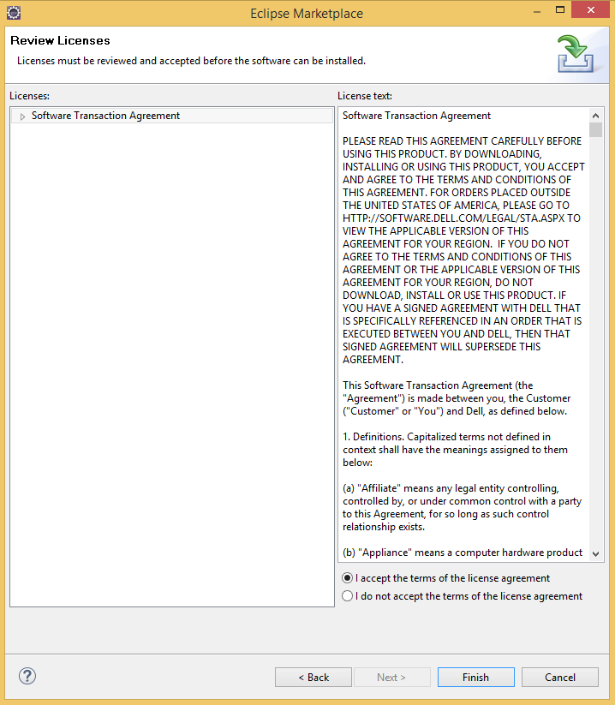

## Add MySQL JDBC driver

After restarting Eclipse…

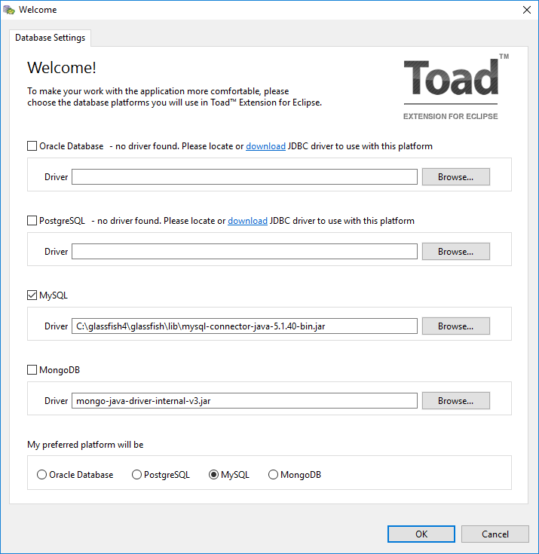

If the window doesn’t show up on restart:

Eclipse -> Window -> Preferences

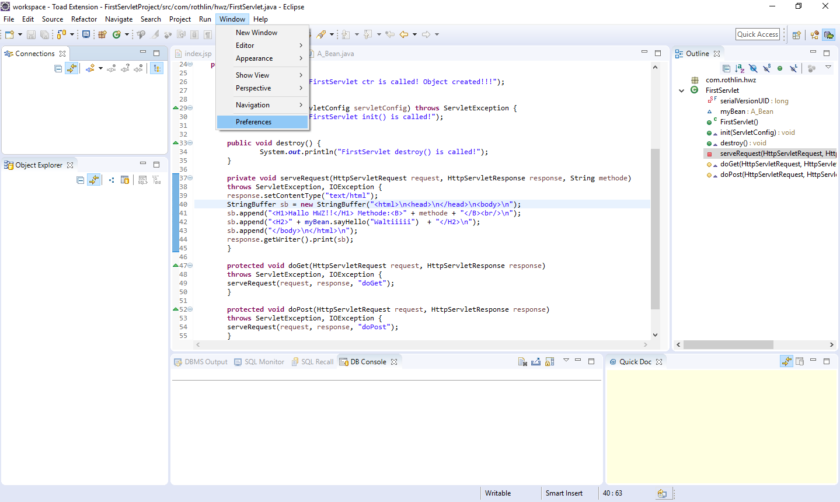

Toad Extension -> Database Settings -> MySQL -> Add

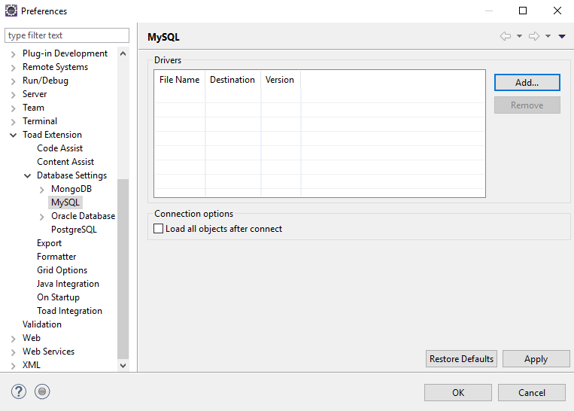

Add the MySQL JDBC driver, which is located at C:\glassfish4\glassfish\lib.

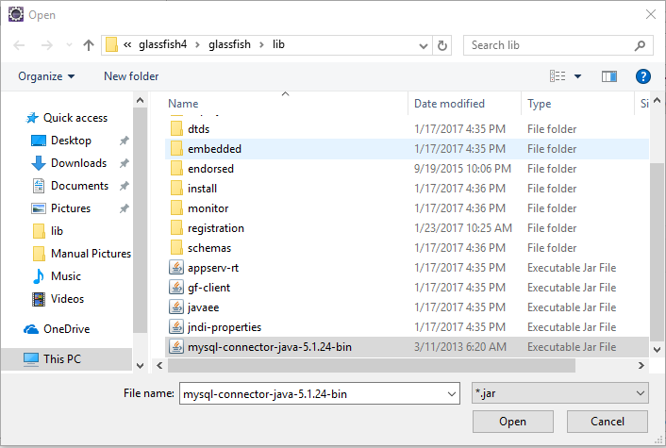

## Add MySQL connection

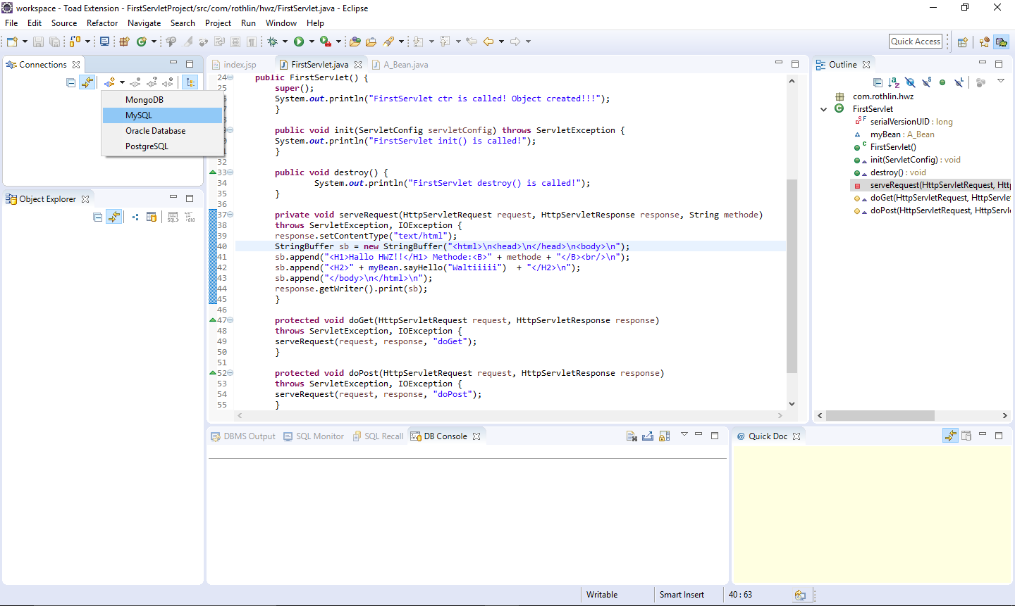

MySQL Root Password: admin

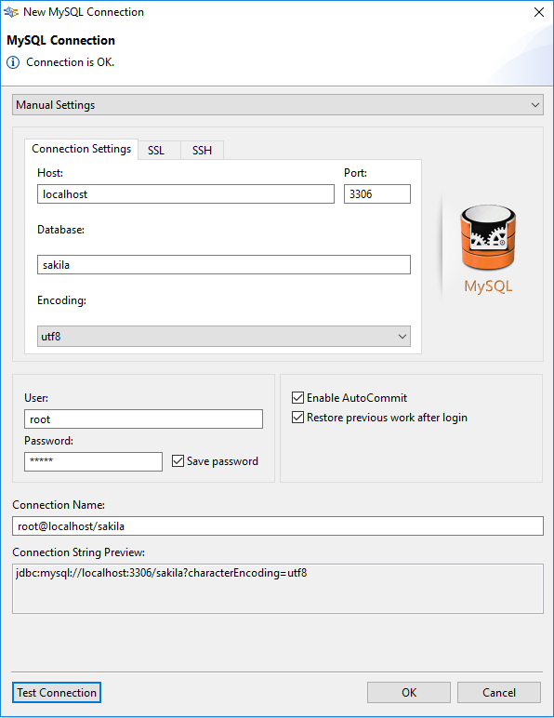

## New jar to eclipse project

Right click -> Properties -> Java Build Path -> Libraries

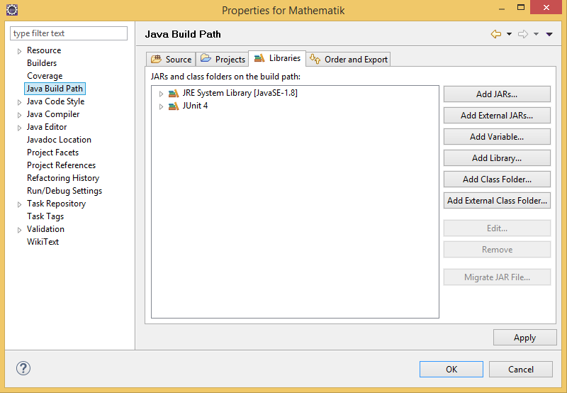

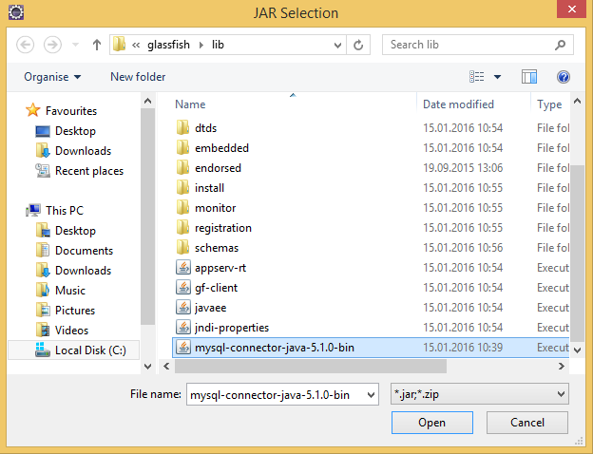

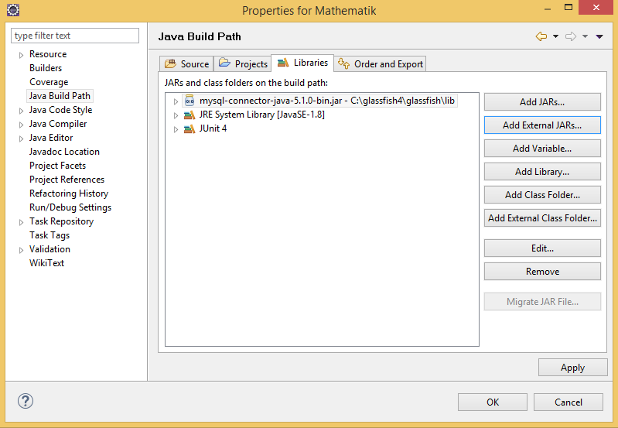

## Shortcuts in Eclipse

|  |  |
| --- | --- |
| **Combination** | **Description** |
| left mousepad | open declaration |
| ctrl + F11 | run application |
| ctrl + space | auto complete |
| Type:”sysout” ctrl + space | system.out.println(); |
| select string + F2 | show tooltip in box with scrollbar |
| shift + F2 | open java doc in browser |
| ctrl + shift + O | Add and removes (un)used imports |
| ctrl + shift + F | format the source code |
| ctrl + shift + C | comment |

## Automated publishing when source has been saved

Double click on Glassfish 4 at localhost {domain} {Started, Republish}.

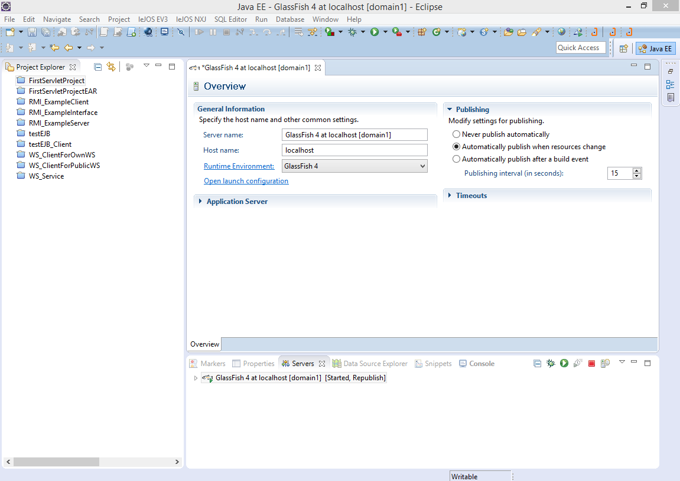

## Import Project in eclipse

Nach import ist alles rot!!!

Build-Path -> configure Built path

Alle Libraries die gefunden wurden -> remove

Add Library -> JRE System Library -> Workspace default